UK Prime Minister Appoints Task Force to Tackle Child Poverty
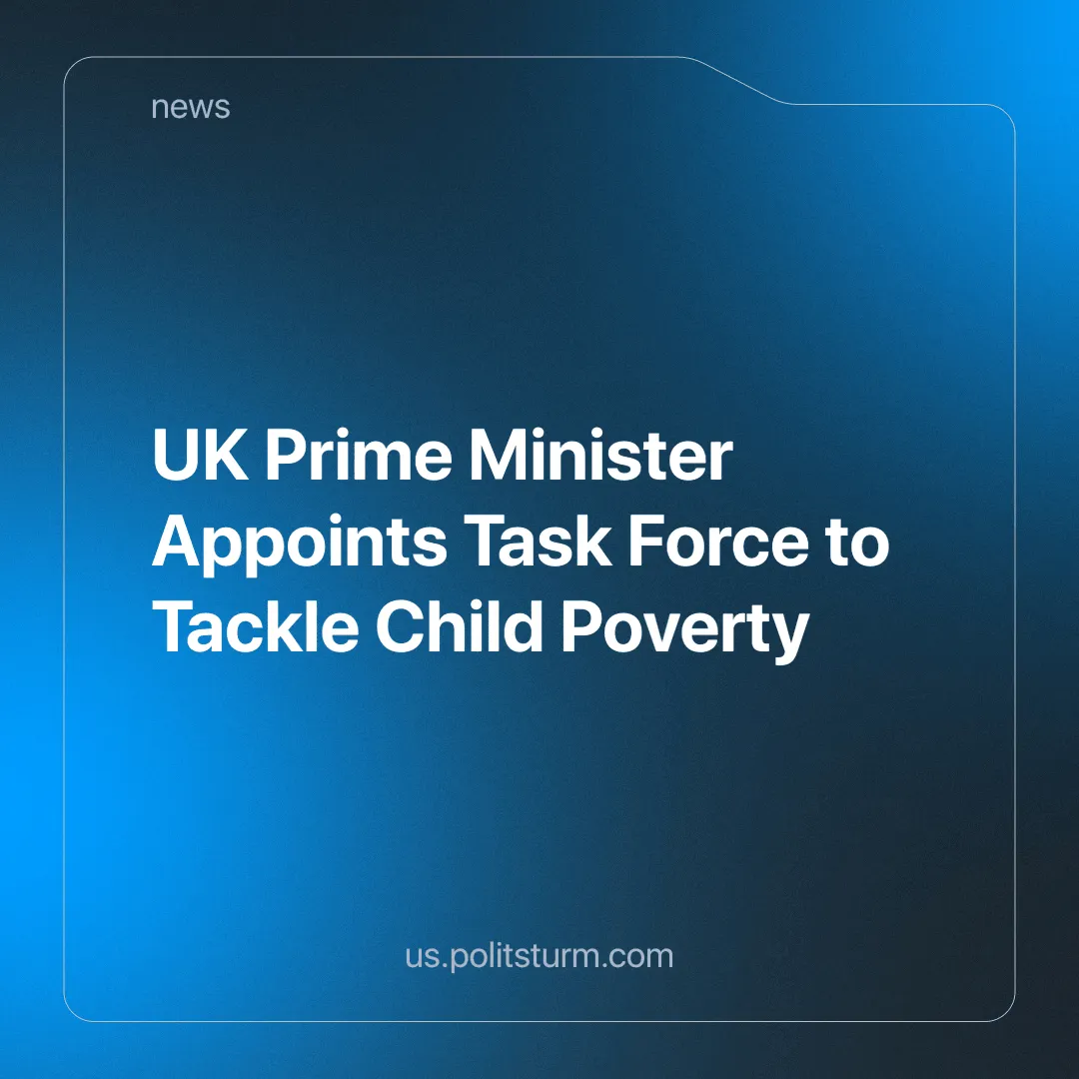

Original article
2024-07-26
5 min read

On 17 June, in his first King's Speech, the newly elected British Prime Minister, Keir Starmer, announced, among other things, the creation of a task force to tackle child poverty in the UK.
20% of children were living on an income less than 60% of the median household income of 2023 before housing costs (BHC), i.e. before paying for rent, bills and essentials, and 30% after housing costs (AHC) in the UK is 30% [1]. That means that one in five children live on a low income BHC and almost one in every three AHC.
The median household income in 2023 was just under £35,000 a year, meaning they were living on less than £14,000 a year. A person without children on this salary would struggle to pay rent, bills and buy food each month, and would likely have to rely on universal credit and food banks, let alone those with one or more children (who in many cases are also single parents).
Pressure is mounting from some backbench Labour MPs and opposition parties to scrap the two-child benefit cap. With initially a vague remark that he is “not immune to the powerful argument for scrapping the policy”[2], Starmer has now suspended seven Labour MPs for voting in favour of the Scottish National Party’s movement to end the policy. With more than 40 Labour MPs recording no vote after being instructed to do so, the two-child benefit cap has not been scrapped and its opposition within Parliament was soundly defeated [13].
Even if the two-child policy were abolished, it would not be enough to solve the problem of child poverty. It can help alleviate some immediate misery, but it cannot truly solve the issue. Even those countries that have had a strong welfare state cannot fully deal with the problem; capitalism is still a system that requires a dispossessed class of people to accept low-paying jobs with often miserable working conditions and health risks.
While the government states that getting parents into work is one of the ways to tackle the problem, the fact is that employment does not guarantee that a person will not live in poverty, with many working people still relying on food banks [3]. We must also remember that 44% of children in single-parent families live in poverty [4]. This means that in order for these parents to be in work, they need to be able to place their children in a good quality and affordable nursery, daycare or school.
This was a staple in former socialist countries. East Germany, for example, provided high-quality public childcare (crèches, nurseries and after-school care) for all its citizens. The crèches opened from 6am to 6pm and were staffed with professionals with age-specific training. Schools finished at lunchtime but remained open for children while parents were still at work. They offered nutritious free meals and during the holidays the schools organised supervised activities.
Compared to the UK, where there still is free child care but its availability has been declining and is only offered for up to thirty hours a week, while most working adults have shifts of over forty hours [5].
State schools are underfunded and facing bankruptcy [6] (we have previously written about the lack of funding and dangerous and poor build quality), and teachers went on strike over a pay rise in 2023 (we also have written previously about) and are considering doing so again [7]. Children have to qualify for free school meals, and the meals themselves are highly processed (and unhealthy) [8] and could further decline in quality due to rising food costs [9].
The added benefit of free and good-quality childcare is that it gives mothers more freedom. In West Germany, women were relegated to housework and childcare. The (sadly now declining) legacy of this is still being felt today. As of March 2018, 51.5% of children aged 0-2 in East Germany were in childcare, compared to just 29.4% in West Germany[10]. This is further explored in 'Stasi State or Socialist Paradise' by John Green.
It's also important to remember that the problem of poverty is growing and affects a significant proportion of Britain as we have previously written about - especially so for migrants and ethnic minorities. According to the Migration Observatory, based at the University of Oxford, 46% of children of non-EU migrant families experienced material deprivation in 2022 [11]. And according to another source, 53% of children in Black African/Caribbean and Black British families live in poverty [4].
Immigrant families are often exposed to poorer working conditions and lower wages (although this is not a rule, as 32% of children of UK-born families also experience material deprivation [11]), due to the vulnerable situation they often find themselves in, their possible unfamiliarity with the language or culture, as well as racism and prejudice they may experience.
It is therefore not enough to offer these parents a job. Society as a whole has never been richer, but this social wealth is increasingly more and more concentrated within the hands of fewer people. This is because the means of production are privately owned. The employer will try to pay the worker the bare minimum for survival and in many cases, less than that, with little consideration towards living standards, in order to increase exploitation and thus profit. Workers have never been so productive and yet the little that they receive back is increasingly insufficient to cover their basic necessities for life.
When Starmer says that "Labour is the party of business" [12] he makes it clear whose interests the party really serves. With the Tory party in disarray, business owners needed a new party that would work for them. The state is run by the capitalist class and will ultimately defend their interests. Changing parties merely changes the superficial image of the state and offers minimal substantive change.
Even if the Labour Party does implement some social programs to tackle or slightly ease child poverty, these measures’ purpose is only to appease the struggling working class and to keep them from looking for more permanent and independently won answers to their problems.
These measures could also easily be reversed by a future government, whether conservative or social democratic. This, along with inflation, crisis and war, perpetuated by capitalists, clearly shows that poverty, deprivation and exploitation would remain under a capitalist system.
Child poverty benefits big business. A class of people who have no other means of living than by selling their ability to labour to a capitalist is an essential feature of the capitalist system. The more deprived these people are, the more desperate they are, and the more willing they are to work for less pay. And as a result, capital enjoys higher profits.
Tackling child poverty in a lasting and effective way requires a system that doesn't require the exploitation of workers to generate profit for the capitalist class. One that doesn't even leave the very creators of the social wealth enough to support a family or themselves.
Only in a socialist economy, under the leadership of a communist party, where the means of production are owned by the workers and society is planned to work towards its people's prosperity, can the seemingly permanent problems of society finally be eradicated. Join Politsturm and help us work towards the foundation of such a party.
Sources: 1/2/3/4/5/6/7/8/9/10/11/12/13

Original article

