UK PM Announces 100 New Oil and Gas Licenses
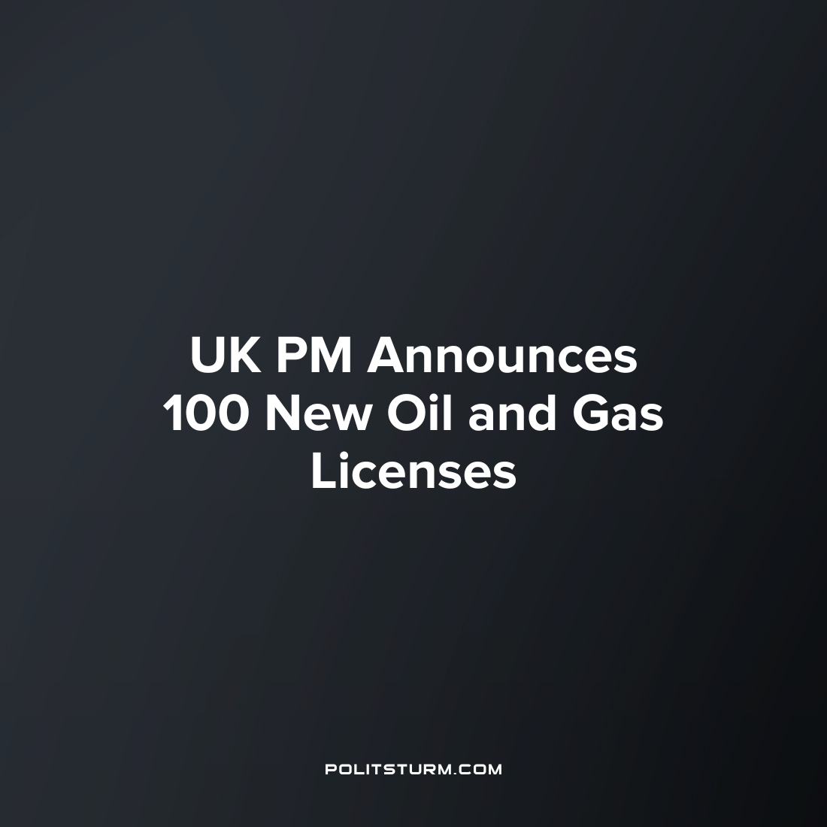

Original article
2023-08-17
2 min read

The British Prime Minister, Rishi Sunak, has announced that the UK will be issuing 100 new oil and gas licenses. This is despite the British government’s pledge to achieve net zero emissions by 2050. The Prime Minister claims that these new licenses are in fact key to meeting the climate targets. His logic is that if the UK has enough domestic oil and gas production then the country doesn’t have to rely on imports, especially from Russia. He said,
“We have all witnessed how Putin has manipulated and weaponised energy – disrupting supply and stalling growth in countries around the world. Now, more than ever, it’s vital that we bolster our energy security and capitalise on that independence to deliver more affordable, clean energy to British homes and businesses. Even when we’ve reached net zero in 2050, a quarter of our energy needs will come from oil and gas. But there are those who would rather that it come from hostile states than from the supplies we have here at home.”
However, his logic falls apart when subjected to the most basic scrutiny. Firstly, the UK doesn’t import oil from Russia; most the oil imports come from Norway. Secondly, in 2021 Britain exported nearly 32,000 GWh of natural gas and continues to export gas, very clearly demonstrating that it is not about self-sufficiency and that he is simply lying. The gas exports happened at a time when domestic energy prices soared and the government borrowed billions in order to subsidise these costs (or more accurately the energy company’s profits) which we have previously written about.
So why is the Prime Minister doing this if it’s not for the reasons he is saying? It is simply to protect the bottom line of the capitalists (in this case the oil monopolies) that his government works for. The capitalist system incentivises capitalists to have an unquenchable thirst for surplus-value, and the tendency to accumulate every yet greater wealth. The surplus value is extracted from the working-class and the social wealth produced appropriated by each individual capitalist. British Petroleum (BP) saw record profit last year during the energy crisis and both BP and Shell have announced multi-billion-pound profits just for this latest quarter in 2023. And now that Saudi Arabia has recently extended their oil production cut, the price of oil on the world market is high and increasing, the British energy capitalists are clamouring to grab a slice of this very lucrative pie. Furthermore, as is very characteristic of the British Conservative party, there is a lot of corruption involved more colloquially known as “Tory sleaze”. Sunak’s wife’s IT company Infosys had signed a $1.5 billion deal with BP for application services just a few months before the PM’s announcement, while Shell is already a major client of Infosys. Sunak is not just making this decision as a representative of the capitalists, but also as a capitalist himself.
Despite the increasing global temperature, more frequent and intense heatwaves and freak weather events, capitalists will continue polluting our planet for as long as it is profitable. Any reformist tax or market-based solution will not achieve the required results in a short enough time span – only a socialist planned economy is capable of this. The current mainstream resistance against the expansion of fossil fuel production (namely Just Stop Oil) is characterised by adventurism and we have previously analysed and criticised this. Only a communist party is truly capable of leading the working people to victory over the capitalists that are damaging our biosphere, and ushering in a socialist society where development is done along planned and rational lines according to human needs and interests and not the enigmatic whims of the market.
Sources: 1 2 3 4 5

Original article

