New Deal Signals UK Pivot Towards EU Bloc
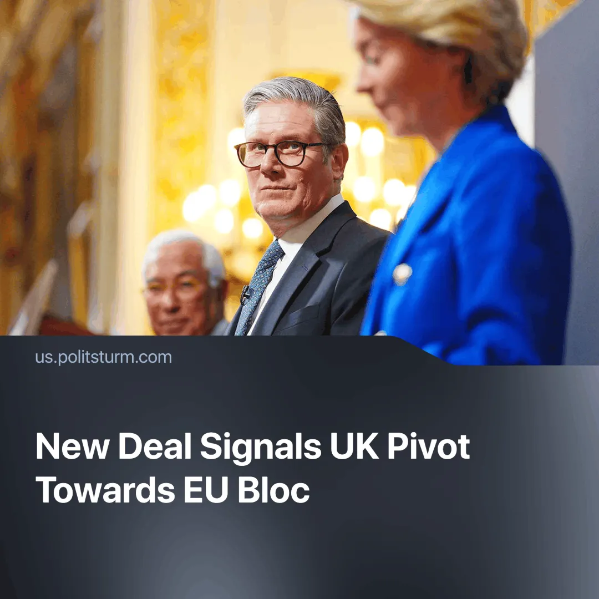

Original article
2025-05-25
2 min read

Having attempted to remain neutral in the current trade war, the UK is now shifting toward the EU, as Trump’s tariffs have hurt its economy and the long-promised US trade deal has proven to be lacklustre.
Details. UK Prime Minister Sir Keir Starmer has negotiated a new deal with the EU affecting trade, travel, energy and the military. This marks a significant attempt at rapprochement with the bloc ever since the UK voted to leave the EU in 2016, finally doing so under Conservative leader Boris Johnson in 2020.
►Paperwork and bureaucracy around imports and exports will now be reduced, facilitating trade between the two economies. Additionally, by agreeing to follow the EU’s food standards, the UK will now be able to export raw meat to the bloc — this had been prohibited ever since its departure from the EU.
►The UK and the EU will now link their Emissions Trading Systems (ETS), meaning UK businesses will avoid being hit by the EU’s carbon tax due to come in next year. Pairing this to the EU improving UK-specific steel production quotas means that this deal could revitalise the struggling industry, as the EU currently already accounts for 75% of the UK’s steel exports.
►A major point of contention was the renewal of the EU’s allowance to continue fishing in British waters for the next 12 years. Though often dismissed due to its 0.04% share of GDP, fishing became a powerful site of political conflict and nationalist mobilisation during Brexit, far exceeding its monetary weight. Previously, the EU's access to British fishing waters was due to expire in 2026.
►Travel will now be made easier, as EU countries will be allowed to decide whether to allow British travellers to use their e-Gates. A youth mobility scheme for people aged 18 to 30 might be created to allow young people to live, study and work abroad for a limited time.
►A new Security and Defence Partnership has been agreed and will continue to develop over the coming years. This will primarily pave the way for the UK to participate in the EU's proposed £150 billion Security Action for Europe (SAFE) defence fund, which could allow EU firms to purchase equipment from the UK. The extent to which the two economies will cooperate in defence remains vague, but the way is paved for greater military integration. The UK’s defence industry is large relative to many EU states, employing about 164,000 people.
Context. We previously covered how Trump’s tariffs severely impacted the UK — forcing the government to take control of the last virgin steel-making plant — and how the resulting deal, though lifting tariffs, reinforced Britain’s dependency on the US. Meanwhile, the EU has responded to the tariffs by moving to consolidate itself as an independent imperialist bloc. Some UK capitalists — including the head of the Bank of England — disillusioned with limited US gains, are now pushing to pivot back toward Europe.

Original article

