UK Prepares for Imperialist Conflict by Taking Control of Steel Production
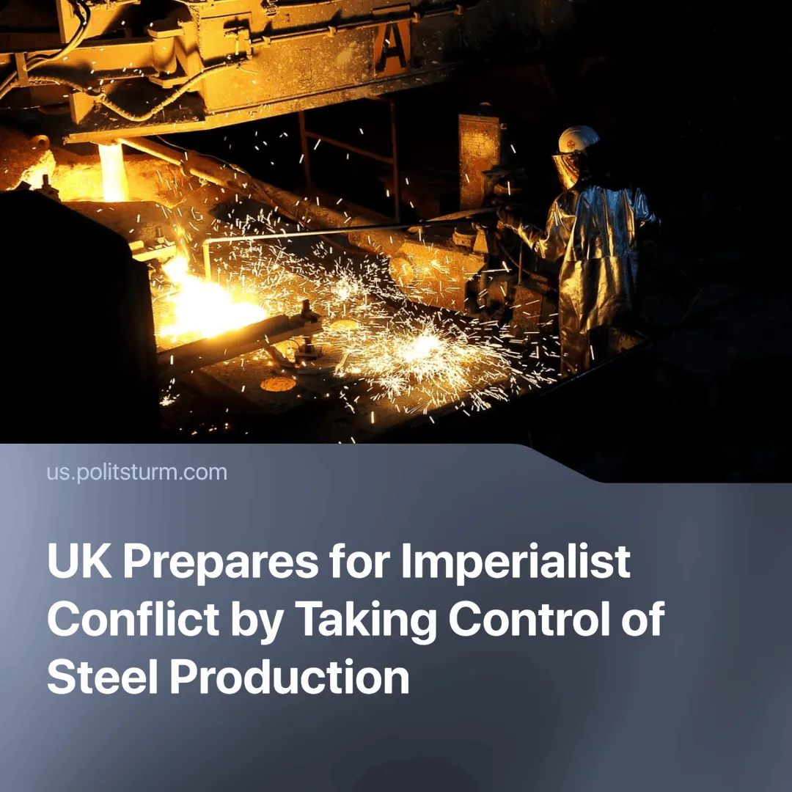

Original article
2025-04-16
2 min read

In a rare event, a bill was passed unanimously through both Houses of Parliament in a single day, giving the government emergency powers to take control of British Steel's Scunthorpe plant. The owners had been considering closing the UK's last virgin steel plant, leaving the UK as the only G7 country without such a capacity.
Details. The Chinese owner, Jingye Group, was losing around £700,000 a day and struggling to buy the materials needed to keep the furnaces running. The UK government had offered to buy the materials for Jingye, but the company rejected the offer.
► The Act gives emergency powers to order raw materials and take control of the workforce and management at the Scunthorpe site. It also allows for the reinstatement of workers dismissed by Jingye.
► The bill faced no opposition, not even from the far-right Reform UK. Full nationalisation is now seen as a likely next step across the political spectrum.
Context. Steel is considered a 'strategic industry' by the major powers because of its importance to military production and infrastructure. The Scunthorpe plant, the last virgin steel plant in the UK, is responsible for supplying 95% of the country's railways. The UK's train operating companies are also due to be nationalised by 2027.
► Jingye has said that unfavourable market conditions, Trump's 25% tariffs on British steel and high electricity costs—UK steelmakers pay up to 50% more for electricity than in Germany or France—are some of the reasons why the company is losing so much money.
► Other large plants have also closed. The Port Talbot steelworks, owned by Indian company Tata Steel, was closed to modernise and switch to green energy, but this led to the loss of over 2,000 jobs. A strike was called off after the owners said they would negotiate with the workers over future funding.
► But the escalating trade war, greatly accelerated by Trump's "Liberation Day", and rising tensions between the imperialist powers are forcing the steel market to change. The neighbouring EU, for example, has adopted protectionist methods.
Important to Know. While many will hail this as a victory for Britain and the British working class, it is important to note that this is not a step towards socialism. When individual capitalist ownership proves insufficient to meet the strategic demands of national capital as a whole, the state is called in to direct enterprises towards a particular goal.
► In this case, increasing imperialist tensions and the growing likelihood of armed conflict, as well as general unprofitability in a strategic industry, have made it necessary for the state, representing the capitalist class, to intervene. All the imperialist powers are increasing state intervention and militarisation—a hallmark of war preparation.
► Nationalisation under capitalism means that the losses fall on the workers to support capitalist interests. It is the working class that ends up paying, first through increased taxation and, in the case of armed conflict, with their lives. Additionally, the previous owners will be generously compensated.
Conclusion. The Labour government is not taking control of the Scunthorpe plant in the interests of the British working people. The growing contradictions between the imperialist blocs make it increasingly clear that the world is heading for a new inter-imperialist war; the British government is acting in the interests of its own capitalists, preparing itself for the ongoing trade war and future armed conflict.
The trade unions and other organisations are being used to deceive the workers into believing that this pro-war measure will benefit the workers. The working class must not be deceived by the phraseology used and must seek to organise itself into working-class organisations that can fight for its real interests and stand resolutely opposed to the imperialist conflict and capitalism.

Original article

