British McDonald's Used Slave Labor
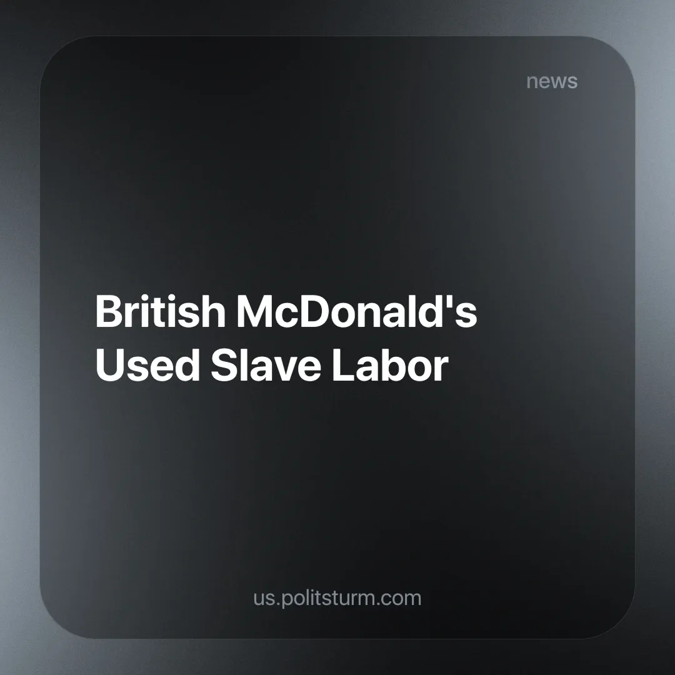

Original article
2024-10-16
2 min read

McDonald's has been paying Czech criminals for at least seven years to supply them with slaves. A total of 16 individuals, some of whom worked at a bakery factory, suffered due to the actions of the mobsters [1].
The criminals targeted homeless people and individuals with addictions in the Czech Republic, confiscated their passports, transported them to the UK, and forced them to work 100 hours a week for a minimal amount of food. The facts about employee exploitation were known as early as 2019, but only now has the broader public become aware of it [2].
It is clear that the company will not face any penalties, except for possibly reputational ones. All the blame will fall on the Czech traffickers. The company turned a blind eye to slave labor, as profit is always the top priority for a businessman: “money does not stink”.
Similar cases are reported year after year. For example, in 2012, Nestlé was caught using child labor. But these reports do not blame large companies, as once again “the suppliers are to blame” [3]. This phenomenon exists even in “socialist” China. According to the UN Human Rights Commission, at least a million members of ethnic minorities are in detention facilities in the Xinjiang Uyghur Autonomous Region of China, this includes the Turkic-speaking Uyghurs. In addition to illegal detention in camps, they are subjected to forced labor [4]. Neither the authorities nor various committees for the protection of all that is good recognize large companies as guilty, since, as usual, slave labor is organized through many suppliers and intermediary firms.
When we talk about class opposition and the division of society, we draw this line to the end. There is no neutral government — there is power that defends the interests of one class or another. By analyzing and synthesizing the news, one can guess that an ordinary person is always at a disadvantage as if the market economy is a casino and they are a player. Therefore, it is unsurprising that everyone except respected businessmen and their companies can be held responsible.
One can endlessly talk about "humanism," but the reality darkens with each passing day. The news is indicative that such horrors occur not only somewhere in the "third world countries," but also in beautiful capitalist Europe and "socialist" China. What exactly are we surprised about here if we know that capital and private property rule the world? Under capitalist conditions, man is turned into a wolf to other men, no matter how hard one attempt to hide this fact behind colorful advertising signs. It is necessary to build a society where there is no exploitation and the rich are not in power, where an individual and their development are held in the highest regard, and this is only possible with socialism.
"The free development of each is the condition for the free development of all." — K. Marx and F. Engels, The Communist Manifesto.
Sources:
[1] BBC — “McDonald’s and supermarkets failed to spot slavery” — October 1, 2024.
[2] Gazeta.ru — “McDonald's has been paying the Czech mafia for years, which supplied slaves for work in Britain” — October 1, 2024.
[3] BBC — “Nestle is accused of using child labor — BBC News Russian Service” — June 29, 2012.
[4] Lenta.ru — "Children are hired because of small fingers": Poor people, women and children sew clothes for fashion brands. Their work is like a concentration camp” — November 24, 2020.

Original article

