UK Considering Lowering Big Tech Tax to Appease the US
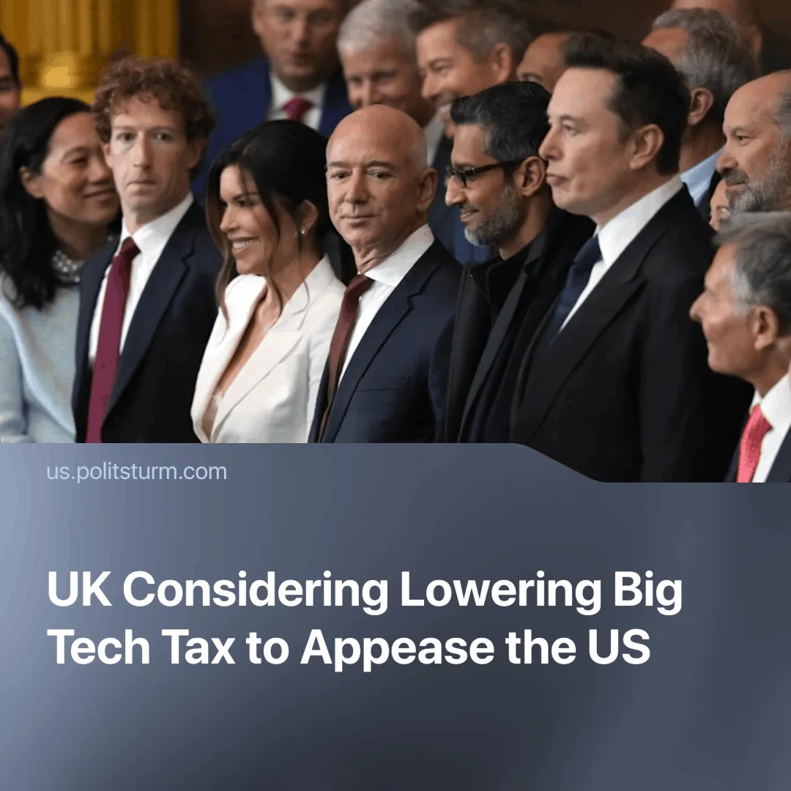

Original article
2025-03-27
2 min read

The Digital Services Tax (DST), introduced in 2020, which affects tech giants like Amazon and Meta, might be tweaked following tariffs on UK steel and aluminium to appease the US.
Details. The 2% levy raises around £800 million a year for the UK, but this could be changed to avoid further import tariffs from the US.
► Nothing has been confirmed yet, but chief financial minister Rachel Reeves — who recently confirmed a 15% cut to the civil service — said that discussions were "ongoing" about changes to DST.
Context. The US has already imposed a 25% levy on UK steel and aluminium. Although the UK exports a small amount of these metals to the US (around £700 million in total), the tariff also applies to products made from them, which amount to a much larger £2.2 billion (or around 5% of UK exports to the US last year).
► While other countries, such as Canada or member states of the EU, have threatened to retaliate with tariffs of their own, the UK's business secretary, Sir Keir Starmer, has said that the country should take a more pragmatic approach.
► The US has threatened further tariffs on those states that retaliate, saying that "whatever they charge us, we'll charge them".
Important to know. Since Trump's inauguration, the US has moved towards a more openly assertive posture towards US “allies” in a gamble to secure better details and force countries to give preference to American capital over growing Chinese capital — revealing the temporary nature of alliances and peace under capitalism.
► In response, the EU has generally begun accelerating efforts to break away from American dependence and attempt to assert itself as an independent imperialist power.
► The UK has tried to keep itself in the middle, as the nation is heavily dependent on both blocs and is not strong enough to be an independent player.
► ​Instead of retaliating against U.S. pressure, the U.K. has acquiesced and is prepared to cut taxes for giant tech companies. Although the government claims it needs to cut costs and save money—such as through recent benefit cuts that will affect over 3 million families—it is prepared to forgo £800 million a year to appease the U.S.
► These welfare cuts that come as the UK economic growth stagnates highlight how the country is not some "special partner" of the US, but simply falling deeper into dependency.
Conclusion. A natural outcome of the imperialist stage of capitalism is the division of the world into different imperialist blocs, which seek to re-divide the world's markets, first by economic means and then by war. The tariffs on the UK are part of this, and now the British capitalists are increasingly being put in the position of having to decide which imperialist bloc they will align themselves with. Labour is still looking for a way out of this situation, but economic factors force the country to enter further into semi-dependency.
Alongside the Labour Party, other parties also represent different capitalist interests — the Liberal Democrats suggesting retaliation against the US whilst Reform UK defends siding completely with the United States (demonstrated by them seeking funding from American billionaires).

Original article

