UK Labour Leader Promises to Reduce Immigration by Training British Workers
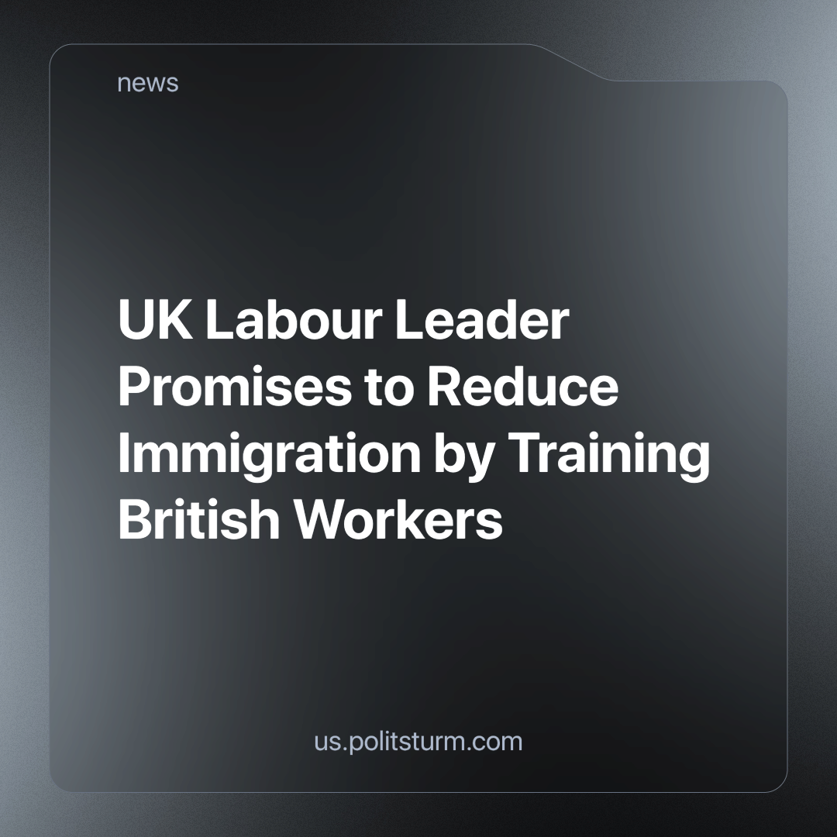

Original article
2024-06-12
4 min read

Keir Starmer has pledged to reduce immigration to the UK by training citizens in sectors where there are high numbers of visa applications to fill domestic shortages [1]. Businesses have expressed concern about the feasibility of these plans.
The Director of Skills at the CBI, one of the UK's largest business lobby groups, said he wanted to see all political parties put forward "credible plans to tackle skills shortages and support growth" [2]. Neil Carberry, Chief Executive of the Recruitment and Employment Confederation, suggested that restricting companies' access to overseas workers would have a negative impact on growth and drive businesses away [2]. It is clear that businesses do not care where their labour is sourced from as long as it "supports growth" - meaning the growth of their profits.
There is abundant fear-mongering from the press and politicians about migrants flooding the UK and causing a 'demographic problem', some going as far as to call the illegal migration an 'invasion of the south coast' [3]. According to the latest data from the 2021 census, people born outside the UK will make up around 14% of the UK population [4]. Also, in 2022 Britain experienced a record net migration of 504,000 [5].
Nations are historically constituted, stable communities of people, formed on the basis of a common language, territory, economic life, and psychological make-up manifested in a common culture. The British nations themselves were formed from the integration of many diverse races and tribes over centuries. However, with modern mass migration, immigrants in the UK sometimes do not integrate into the nation of their residence, making them easier to exploit and easier to use as a tool for fostering division among workers.
The ruling class benefits from this lack of integration as it perpetuates a divided working class, and can (and does) promote chauvinism amongst native Britons towards (mainly Muslim) immigrants, at the same time as pushing immigrants towards religious extremism (many of them are Muslims) and chauvinism of their own to cope with their worse conditions. The British ruling class is good friends with their counterparts in Qatar and Saudi Arabia, who they gladly allow to promote Islamic religious extremism in the UK (and around the world). As a result, if workers are fooled into fighting each other, they cannot unite against their common class enemy.
It's important to highlight that most British Muslims are against Islamist extremism when asked [6], and that most Brits overall do not admit to being prejudiced by race [7]. However, as Britain falls deeper into crisis and fascisation, and in the absence of a strong united workers movement, this could change in the future.
Consequently, there is little interest from the ruling class in genuinely integrating or assisting immigrants. We have previously written about the most extreme of these cases - the asylum seekers. As a result is essential to recognise that the decay of the NHS and public services is not due to immigrants, but rather the result of systematic dismantling by those in power, aiming to erode these social services in the interests of profit. We have never been richer as a world or as a country and there are more than enough resources for everyone to have adequate access to food, water, shelter, healthcare etc., however, they are concentrated in the hands of a few capitalists.
The main concerns of business lobby groups are growth and labour shortages, while their press and political representatives focus on immigration, highlighting that it lowers wages and claiming that it strains tax resources [1]. Why is this the case?
In the stage of monopoly capitalism, the world is completely divided between a few dominant capitalist nations. This "capitalist centre" makes super-profits by keeping dependent nations in subjugation, extracting raw materials from them and creating conditions of poverty, war and instability that drive people to seek a better life abroad. Migration is a fact of life under capitalism.
Whether workers migrate through legal means, such as work visas that allow capitalist centres to attract skilled workers from dependent and semi-dependent nations, or illegal means that allow employers to exploit them for low-paid, insecure jobs [8], the market welcomes such "attractive" employment conditions as long as profits are made. This is clear from the statements of the lobby groups.
The political rhetoric of both Conservative and Labour politicians ultimately serves one purpose: to maintain the system of capitalism. They use various techniques to distract British workers from their rapidly deteriorating conditions caused by the current capitalist crisis and to implicitly or explicitly shift the blame onto migrant workers who have fled conditions caused by the same global market.
The only way to overcome this misery is for workers to cast off bourgeois blindness and propaganda and see the world and our class relations as they really are. The working class has no country; we are all bound together in the same international system. Virtually every modern product is the result of the labour of thousands of people across the world, yet the fruits of their labour and the profits reaped by their sale is appropriated by a handful of the richest capitalists. Workers across the world are united by social production, by common exploitation and hence united in our interest in overthrowing this system. For the workers to take this route they must be led by a Communist Party, however, no such party currently exists in the UK.
Sources:
- Labour's Immigration and Border Policy
- Business warning to Keir Starmer: Britons can’t fill every worker gap
- 'Invasion of the South Coast': Braverman admits illegal migration is 'out of control' as she fights to keep her job
- International Migration, England and Wales: Census 2021
- UK net migration hits all-time record at 504,000
- British Muslims are concerned about Islamist extremism and do trust the police, survey finds
- One third of Britons 'admit being racially prejudiced'
- Migrants in the UK Labour Market: An Overview

Original article

