UK Labour Party Wins Election in a “Landslide”


Original article
2024-07-12
4 min read

On the 5th of July, the Labour Party won a “landslide” victory in the British general election, taking 412 out of 650 seats on a platform of “change”. The election had a turnout of only 59.9%, the lowest since 2001 [1]. Why is this and will the Labour government bring real change?
We previously reported on the mayoral and local council elections held in May. This general election continued the trend of declining turnout¹ at both local and national elections, with a turnout of 59.9%[2].
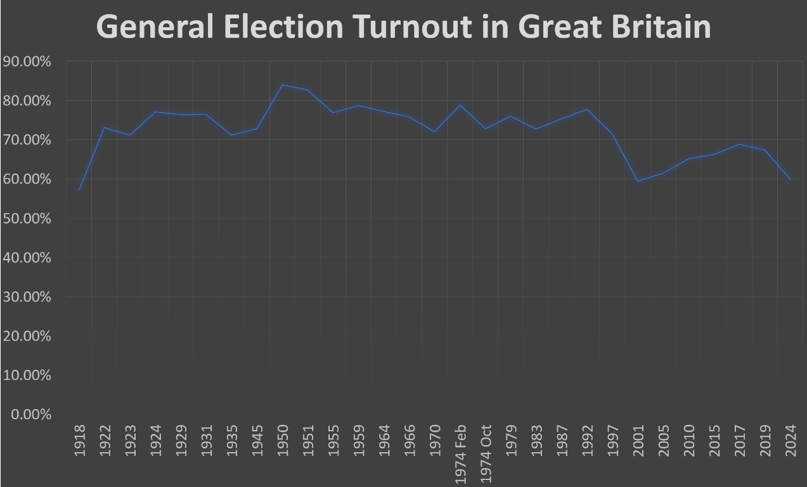
The Labour Party won 63% of the seats in parliament with only 33.8% of the vote, and if you include those who didn't vote, this drops to only 20.21% of the total eligible voters. Moreover, when asked in a recent poll why they voted Labour, 48% said 'to get rid of the Conservatives', followed by 13% who said 'the country needs a change' [3].
It's clear that the new governing party does not represent the majority of Britons, and even still, most of those who did vote for it did not do so enthusiastically. So who does it represent?
In a class-based economic system (e.g. slavery, feudalism and capitalism) the state represents the interests of the ruling class. The current state exists to maintain the basis of capitalism, which is private ownership of the means of production. For the capitalists, it doesn't matter which party does this (they often make up the party leadership themselves) as long as profits are not affected. Consequently, they allow the workers, as Lenin aptly put it in The State and Revolution:
“To decide once every few years which member of the ruling class is to repress and crush the people through parliament”
This is the essence of bourgeois democracy, and it is reflected in the turnout and general apathy of British workers in this election, as they continue to feel neglected by the political system.
To illustrate this, let's look at the Labour government's plans for its first week in office. Recent polls have shown that the cost of living is the top of the two main concerns for voters, followed by the NHS [4].
The new Chief Secretary to the Treasury, Racheal Reeves, who has complained about the small amount of money left for the government, has spoken of using the private sector to make up the shortfall [5]. Keir Starmer has repeatedly stated that they intend to be the 'party of business' [6], after all, he is committed to keeping the billionaire donors who have previously donated to the Conservatives happy [7]. Making Britain more attractive to private investors will require further austerity programmes to reduce the share of social wealth that goes to workers and so as to place it into the hands of investors instead.
Furthermore, the new Secretary of State for Health and Social Care, Wes Streeting, has shown an interest in using the private sector to strengthen the NHS, even going so far as to claim that there is a "mutual" interest between private and public healthcare [8]. This isn't much of a surprise seeing as he's received about £175 thousand from donors with substantial investment in private healthcare [9]. This will only lead to overpriced contracts, as private companies, needing to remain competitive, will seek the highest possible profits. The price will ultimately be paid on the backs of working people through taxes or new payment systems in the NHS.
Under a capitalist mode of production, even state-run health care is still subject to inflated prices because medical care is considered a commodity and, as a result, the equipment and drugs used are usually produced by private companies. State-owned companies also still employ wage-earners and so their wages and rights are subject to the same market forces that determine any other commodity, as the recent increase in junior doctors' strikes in Britain shows.
The new government has also pledged a £500 million military aid package for the inter-imperialist conflict in Ukraine [10]. Britain, the second largest arms donor [11], is sending weapons not out of concern for Ukraine or its citizens, but only in the hope of beating back imperialist rivals and reaping big profits through the continued use of IMF loans, to which Britain is the fifth largest contributor. These loans have kept the Ukrainian economy heavily dependent on debt to the IMF for many years, and the destruction caused by the “special military operation” clears the way for further loans, as much of the economy has been destroyed and will have to be rebuilt.
It is clear that the Labour government is not listening to the wishes of the working public but instead will continue down the same road as the last bourgeois government. More austerity, more poverty.
The parliamentary 'democracy' does not listen to the demands and concerns of workers. Only a working-class democracy can truly represent the working people, This can not be achieved by mere reforms from “Socialists”, even Keir Starmer has claimed to be a socialist and was in fact a Trotskyist in his youth. The previous more “radical” Labour leader, Jeremy Corbyn, also claimed to be a socialist whilst also declaring to be the “party of business” [12], a common trend in the Labour Party.
Working-class democracy can only be achieved by dismantling the present state machine and rebuilding a workers' state firmly based on the principles of Marxism-Leninism. This requires a vanguard party dedicated to leading the working class movement with the most advanced theory. We are committed to building such a party. Join us in this struggle.
Footnotes:
¹Turnout in the UK is calculated as a proportion of only registered voters, There is an estimated 8 million not registered to vote. Including the estimated additional unregistered, 2024 turnout would be approximately 51% of the voting-age population.
Sources:
1.General election 2024 results in maps and charts - BBC News
2.General Election 2024 | Sky News
3.Why are Britons voting Labour? | YouGov
4.Voting intention (moreincommon.org.uk)
5.'There's not a huge amount of money,' says new chancellor Reeves - BBC News
6.Labour is the 'party of business' says Keir Starmer (and every leader before him) | Evening Standard
7.Billionaire UK political donor switches allegiance to back Labour | Reuters
8.Health secretary Wes Streeting gives speech on future of health and social care – watch live (youtube.com)
9.Labour: Wes Streeting takes £175k from donors linked to private health firms
10.Labour defence secretary travels to Ukraine as govt pledges new supplies to Kyiv (msn.com)
11.Why is Britain so strongly behind Ukraine? Does it matter? - British Foreign Policy Group (bfpg.co.uk)
12.Jeremy Corbyn’s message of support to Labour Business

Original article

