UK Economy Set To Be One Of The Hardest Hit By Trade War
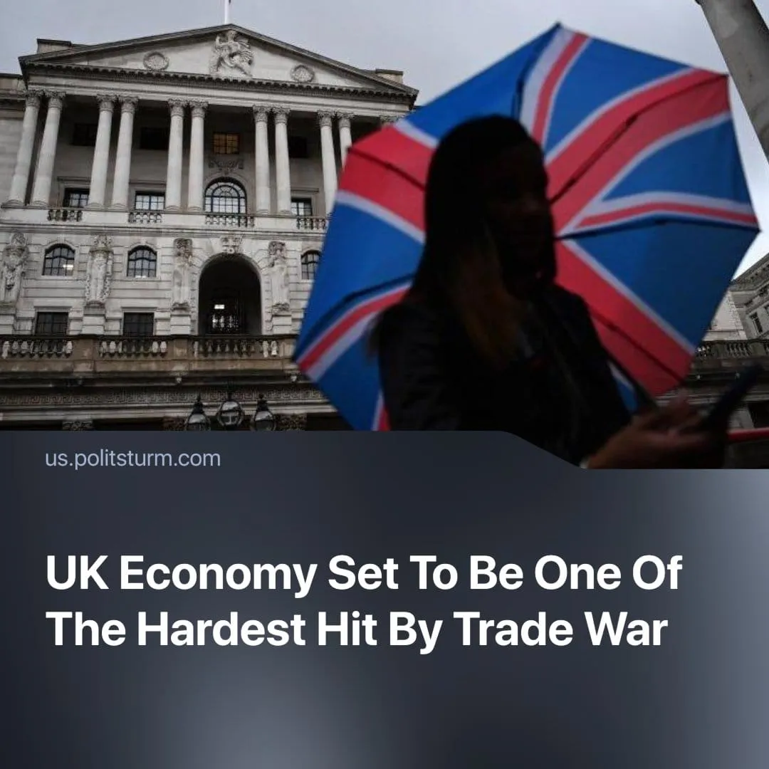

Original article
2025-04-30
2 min read

Despite the UK’s efforts to stay neutral in the trade war, the International Monetary Fund (IMF) projects the UK will be one of the hardest-hit economies. Trump’s tariffs play a major role, but internal issues are also to blame.
Details. While UK growth remains higher than the EU’s 0.8%, the IMF downgraded the UK’s 2025 forecast by 0.5%. Growth is now predicted at 1.1% for 2025 down from 1.6%, and 1.4% for 2026.
► The IMF also raised the UK’s inflation forecast by 0.7% to 3.1%, above the Bank of England’s 2% target, and one of the worst amongst "advanced economies". Salaries grew above inflation, with real wages up by 2.1%, but rising inflation threatens to shrink this gap.
► Tariffs include a baseline 10% on all British goods, with a 25% levy on steel, aluminium, and cars—putting over 25,000 automobile jobs at risk.
► Chancellor Rachel Reeves has travelled to Washington to seek exemptions or reductions. Britain is already considering cutting its tax on US tech giants', to aid negotiations. US Vice President JD Vance has stated the US is "working very hard" for a "great" deal.
Context. The US imposed baseline 10% tariffs globally, exempting only Mexico and Canada, due to their willingness to negotiate and align with the US, with China facing tariffs up to 245%.
► The UK is already grappling with near-zero growth, rising mortgage costs, and post-Brexit trade friction with the EU. In response, Chancellor Rachel Reeves has unveiled planned austerity measures such as a 15% reduction in the civil-service headcount—about 10,000 jobs—together with cuts to the winter fuel allowance and planned reductions to benefits for the disabled. At the same time, the defence budget is slated to rise by a further £2.2 billion.
► The IMF blames high government borrowing costs as a major factor in the UK’s poor performance. Reeves confirmed further “fiscal tightening” such as tax hikes and spending cuts.
Important to Know. Trump’s tariffs expose the true nature of the US-UK “special relationship”: Washington dictates terms favouring its own capitalists, while Britain concedes, deepening economic dependency.
► Despite this, UK capitalists remain wealthy—workers pay the price through higher living costs, slower wage growth, and job cuts, in line with IMF recommendations and Reeves' policies.
► In 2022, the IMF recommended more “targeted support” for low-income households, but now it defends tighter fiscal policies. This pivot is no contradiction, but rather a tactic of monopoly finance capital, which the IMF represents. Each swing—alleviating hardship today, cracking down tomorrow—serves the same aim: to preserve the profitability and systemic stability of capital, never to serve the common people.
► Tariffs are a symptom of sharpening inter-imperialist rivalry. The semi-dependent UK must choose between aligning with the US or the EU. Though historically favouring the US, Britain has hinted at leaning toward the EU, should it prove more profitable for UK capital, calling that relationship “arguably more important.”
Conclusion. Trump’s tariffs highlight British capital’s inability to stand alone, its semi-dependent status, which forces it to seek alignment with larger imperialist blocs. As competition sharpens, it is workers who bear the brunt—already through austerity, and ultimately through war. The redivision of the world serves only imperialist profit, not the working class. The final stage of this rivalry, now approaching, is inter-imperialist war, where workers will pay with their lives.

Original article

