UK Government Strictens Control Over Criticism of the State
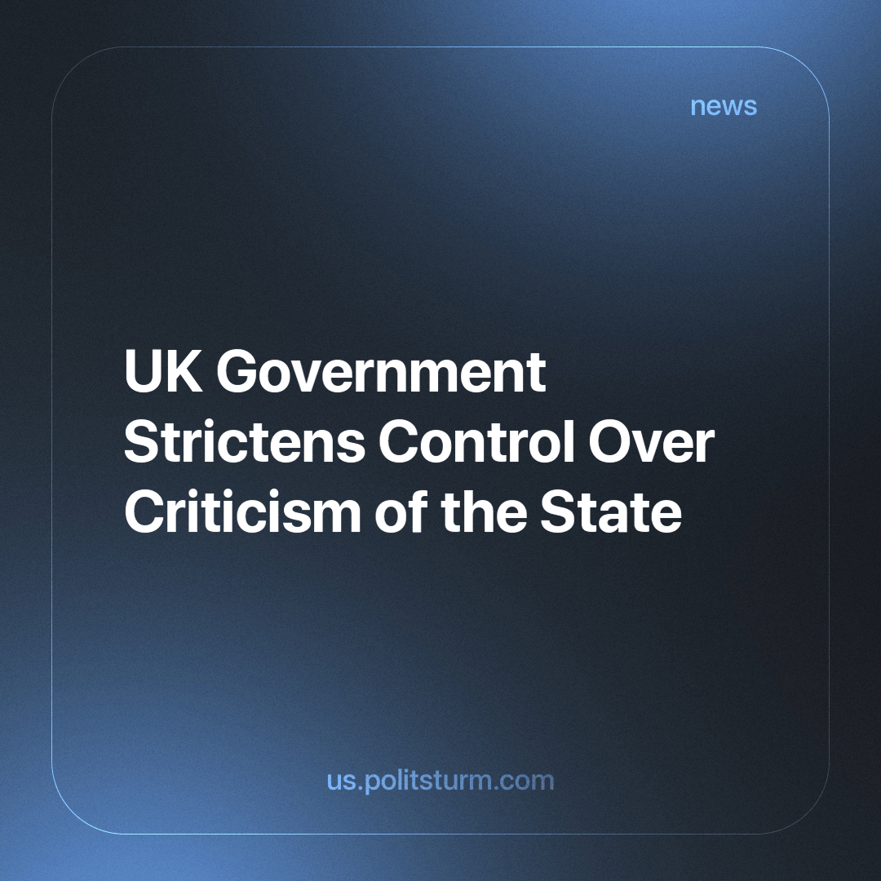

Original article
2023-12-02
3 min read

It has recently come to light that fifteen government departments in the UK have been actively monitoring the social media activities of potential critics, compiling what are being termed as "secret files". The primary purpose of these files is to prevent individuals who have criticised the government in the previous three to five years from participating as speakers at government-organised events.
Guidelines issued across various departments, such as health, culture, media, sport, environment, food, and rural affairs, instruct officials to scrutinise the Twitter, Facebook, Instagram, and LinkedIn accounts of experts. Recommendations include social media checks, Google searches, and maintaining files on individuals with specific instructions to record this information for future reference.
This practice came under scrutiny when it was revealed that the Department for Education attempted to cancel invitations for early childhood education experts due to perceived criticism of government policies. Another case highlighted is that of Dan Kaszeta, a chemical weapons expert, who was disinvited from a defence conference due to his social media posts criticising Tory ministers and government immigration policy.
In addition, an amendment to the Investigatory Powers Bill is currently undergoing due legal process in the House of Lords. The original Investigatory Powers Bill was put into force in 2016 and was more commonly known as the Snoopers’ Charter. It granted the police and intelligence services increased legal electronic surveillance rights. The new amendment seeks to provide a legal framework for the use of AI within surveillance, allowing the government to cast a wider net in order to identify and repress potential critics and threats more effectively.
Under capitalism, labour is a commodity, and is bought and sold by capitalists on a market. If the “free labourer” acts in a manner contrary to the desires of the capitalist, the capitalist can deprive them of the right to work – their only source of livelihood. Similarly, as the state is run by and for the capitalists it is a tool in their hands that acts in their interest. For all the talk about the talk about bourgeois-democratic freedoms; like the freedom of speech, press, expression and assembly, so long as labour is a commodity and capitalist production prevails, they can never be realised. Of course, both rich and poor have equal rights before the law to purchase a media company in order to disseminate their views.
Any trade unionist and socialist knows about the system of illegal blacklisting that the government and companies use to deny the right to work to labour organisers and critics of the employers. This kind of practice has been ongoing since the birth of capitalism. While now officially mediated by various Labour relations laws, it has by no means gone away.
In addition, particularly during the Cold War, the repression and surveillance of communists was especially prevalent. As revealed in “Spycatcher: The Candid Autobiography of a Senior Intelligence Officer” by Peter Wright, the former assistant director of MI5, the (now dissolved) Communist Party of Great Britain (CPGB) was under constant state surveillance. The MI5 in 1949 was split between six directorates, with one of them solely dedicated to monitoring the CPGB and its links in the trade union movement. Methods of surveillance included infiltrating leading cadres’ homes while they were away, photographing party documents and membership files and then placing them back where they were found. For example, over one such raid on a weekend, the MI5 managed to scan 55,000 documents.
In more recent years, the Spycops scandal brought to the fore the scale of illegal police and intelligence service monitoring of political activists. The police have admitted to sending 140 undercover officers to spy on 1,000 political groups since 1968. Many of the officers would deceive women members of these groups into romantic relationships in order to strengthen their cover – some even going so far as to father children with them. The full list of infiltrated organisations is still unknown, however many were destroyed due to the sabotage and wrecking of the police agent-provocateurs. Notably, the organisation that the police sent the most officers into – the Trotskyist group “Socialist Workers’ Party”, remains functional today. We have written about this organisation in our overview of the communist movement in Britain.
However, the expansion of this kind of surveillance and its gradual legalisation is a worrying trend indicative of Britain's long march towards fascisation. Previously this kind and scale of surveillance was illegal, however, emboldened by no significant opposition, the capitalists of Britain can legalise and strengthen these tools that they use to enforce their class dictatorship. This process can not only be meaningfully opposed by a powerful workers' movement led by a Communist party but stopped entirely should the workers be victorious and implement their class dictatorship over the capitalists.
Sources:
https://www.theguardian.com/politics/2023/nov/18/shocking-scale-of-uk-governments-secret-files-on-critics-revealed?ref=upstract.com
https://hansard.parliament.uk/lords/2023-11-20/debates/F933A59A-EA35-48F9-9AF7-6BCEDAE540AA/InvestigatoryPowers(Amendment)Bill(HL)
https://www.spycops.co.uk/the-story/
“Spycatcher: The Candid Autobiography of a Senior Intelligence Officer” by Peter Wright

Original article

