Uber Drivers Earn Less Than 90% of American Workers
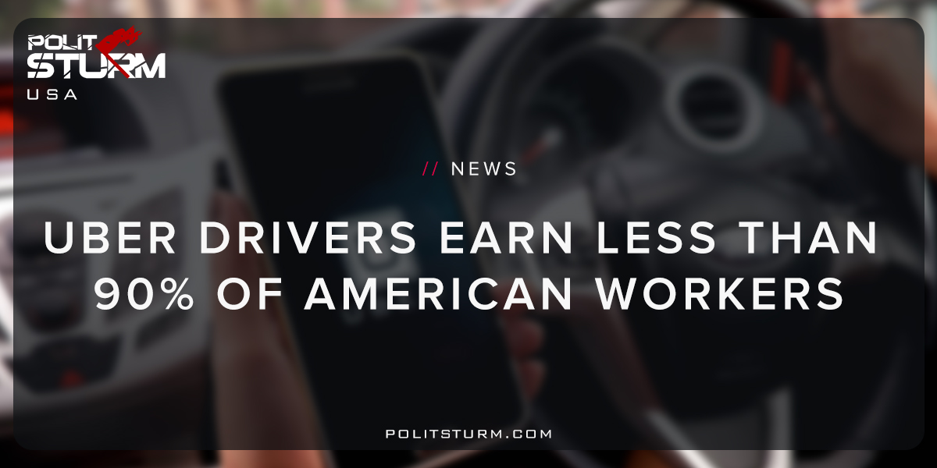

Original article
2018-06-03
1 min read

A new study by the Economic Policy Institute shows that when factoring in commissions, fees, and traditional worker benefits Uber drivers make $9.21 per hour on average. For comparison the average taxi driver or chauffeur, on average, makes $13.21 per hour.
The adjusted wage takes into account the fact that Uber workers are not considered employees, but rather independent contractors. As such, Uber drivers depreciate their own vehicles and do not receive unemployment insurance nor workers compensation like traditional W-2 employees. Uber does not pay a payroll tax towards workers Social Security and Medicare expenses. Nor does Uber contribute to health insurance or pensions for drivers. All of these factors contribute to lower costs for the employer, or capitalist class.
Uber also benefits from the precarious nature of U.S employment, the lack of a healthcare system, and the “generous” legal system that allows the labeling of workers as “independent contractors”. Workers are forced to pay relatively more in taxes and receive fewer benefits. The entire legal, political, and economic systems allows this because it is structured to protect the interests of the capitalist class.
Uber drivers, taxi drivers, chauffeurs, and the rest of the working class are pitted against one another to benefit the capitalist class. The closer the wage is to the bare level of biological substance for workers, the higher the profits are for the capitalists collectively.
The working class loses when wages are depressed and benefits are stripped. The capitalist system allows a class of parasites to benefit from the unemployment, reduced benefits, and destitution of the global working class. Uber’s cost cutting and profit maximizing behavior is merely a reflection of the perverse economic system, capitalism.

https://www.epi.org/publication/uber-and-the-labor-market-uber-drivers-compensation-wages-and-the-scale-of-uber-and-the-gig-economy/
https://www.bls.gov/oes/current/oes533041.htm

Original article

