U.S War Costs to Reach $6.5 Trillion by 2050
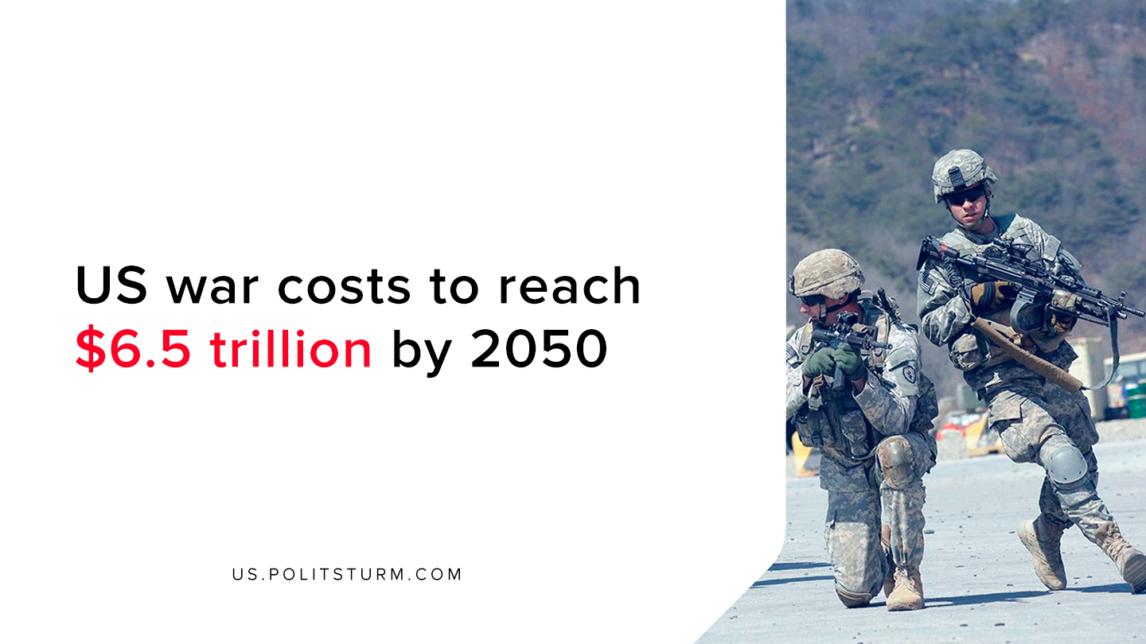

Original article
2020-02-09
1 min read

According to a recent study authored by Heidi Peltier, the Director of the ‘Costs of War Project’ at Boston University, the cost of financing U.S military engagements from 2001 could reach $6.5 trillion in interest expenses alone by 2050. The author detailed that the imperialist wars of the United States from 2001 onward were financed through debt as opposed to tax increases or war bonds.
Congress has appropriated $2 trillion in discretionary spending in what it calls “Overseas Contingency Operations/Global War on Terrorism”. This figure accounts to 9.5% of the entire discretionary spending of the U.S government from 2001 to the present.
Since the government financed war through governmental debt, the holders of the debt will expect to be repaid for the amount borrowed, with interest.
“Much like with a credit card, interest payments must be made as long as there is an outstanding balance, and as new purchases are made with the credit card, the outstanding balance and interest payments continue to grow”, said Peltier.
However, it is also interesting to observe who exactly holds this national debt. 34% of the debt is held by domestic private investors in the form of securities, pension funds, mutual funds, etc. 29% of the national debt is owned by foreign investors.
The facts demonstrate that the majority of U.S debt is owned by domestic and foreign investors who profit off the war spending through their ownership of public debt. Thus, the imperialist war spending that has led to incalculable human suffering and destruction is profitable to the holders of debt, the capitalist class.
War and destruction will always be a profitable endeavor for the capitalist’s benefit. Only under a socialist organization of production will the horrors and destruction of war finally be overcome. However, in order to achieve this end, it is necessary for all workers to master the theory of Marxism-Leninism and organize against the dictatorship of capital.
Source

Original article

