U.S. Unemployment To Remain High Through 2030
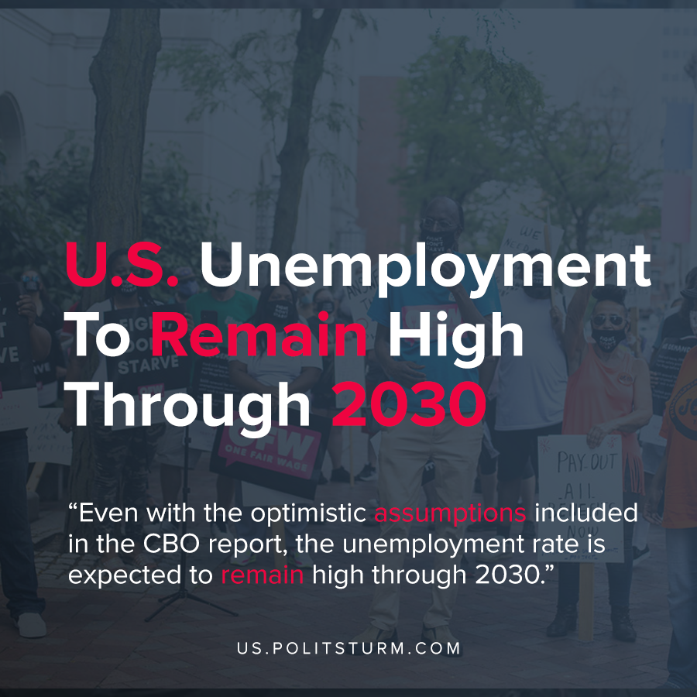

Original article
2020-07-03
1 min read

According to the most recent release of economic projections by the Congressional Budget Office(CBO), the U.S. unemployment rate will remain above the pre-pandemic levels until 2030. The report states that these projections reflect an “unusually high degree of uncertainty”, largely in part to the uncertainty about how the pandemic will unfold.
The report suggests that for workers, the unemployment rate will decrease from 14% to 5.9% by the end of 2024.
The report also has many idealistic projections about the recovery that may not come to pass as the number of coronavirus infections are on the rise across the country. For example, the assumption that the amount of social distancing will decrease by “about two-thirds” in the second half of 2020, which is assumed will lead to an increase in socialization and commerce.
It is also assumed that the amount of social distancing will decrease to 0% by the third quarter of 2021. Even with the rosy assumptions that are included in the report, the unemployment rate is expected to remain high in the United States for the next decade.
The implications of this report for the American working class are quite clear. The workers are thrown out of work and lose their ability to provide for themselves and their families. The objective conditions that the American workers face are projected to be extremely grim over the next decade by any reasonable measure. By contrast, the capitalist class stands to benefit from the increased unemployment and the lower cost of labor power.
Source: 1

Original article

