U.S Unemployment Rate Expected to Reach 16%
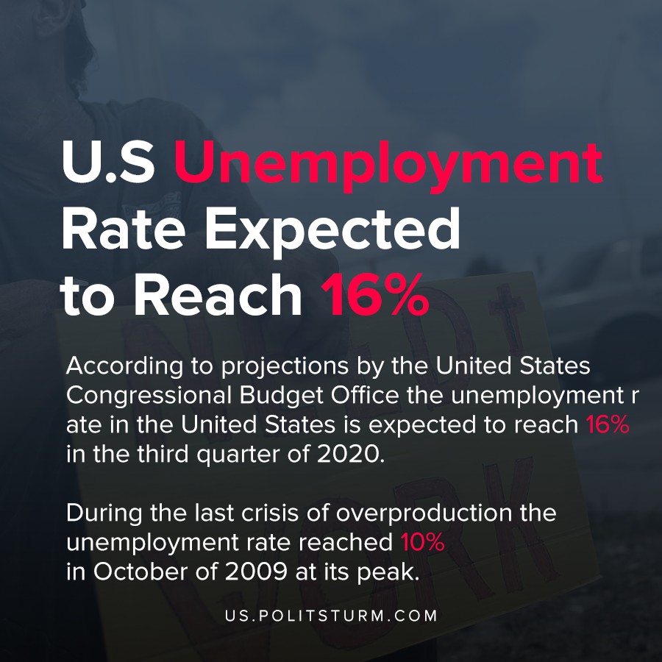

Original article
2020-04-30
1 min read

According to projections by the United States Congressional Budget Office (CBO) the unemployment rate in the United States is expected to reach 16% in the third quarter of 2020. The CBO also projected a 40% annual decrease in inflation-adjusted gross domestic product for the second quarter 2020.
To provide some historical context, during the last crisis of overproduction the unemployment rate reached 10% in October of 2009 at its peak.
However, the future projections about the state of the economy made by the CBO also suggest that the economy will rebound as social distancing restrictions are lifted in the third quarter.
The projections indicate a “rebound in hiring and a significant reduction in furloughs” in the near future, however the projections are made with a disclaimer of great uncertainty. In addition to the high unemployment rate, the projections also indicate that 8 million Americans will leave the labor force altogether.
While the number of jobless claims have dramatically increased over the last several weeks, it is impossible to deny that the unemployment rate will substantially increase as a result. Millions of workers are thrown out of employment and the labor force, lowering the cost of labor to the capitalists.
The lowering of wages, the senseless destruction of commodities, and the mass bankruptcies present opportunities to the capitalists to restore profitability. Insofar as the capitalist system continues to exist, it will continue to exploit workers and create massive wealth for the class of exploiters, the capitalists. Only the institution of a planned economy run in the interests of the working class will eliminate unemployment entirely and not subject workers to periodic unemployment and destitution.

https://www.cbo.gov/publication/56335
https://www.cbo.gov/about/overview
https://www.feedingamerica.org/sites/default/files/2020-04/Brief_Impact%20of%20Covid%20on%20Food%20Insecurity%204.22%20%28002%29.pdf

Original article

