U.S Stock Market Crashes
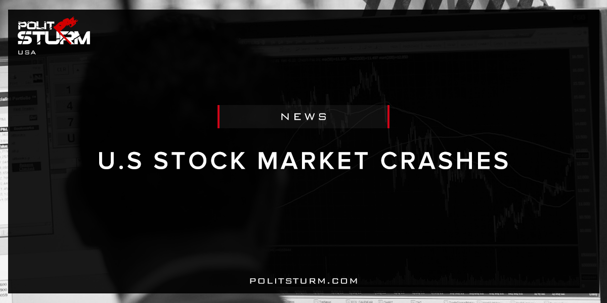

Original article
2018-02-10
2 min read

Investors (and presidents) should be careful what they wish for.
President Donald Trump’s biggest legislative accomplishment may lead to inflationary conditions and the end of the nine-year bull market for stocks.
The Republican tax overhaul, which the self-proclaimed “king of debt” Trump signed into law in December, lowered the corporate tax rate to 21 percent from 35 percent. The Congressional Budget Office estimatedthe tax bill will increase the deficit by $1.5 trillion over the next decade and by $136 billion in fiscal 2018.
Some are concerned adding fiscal stimulus at this late stage of the economy cycle with a jobs markets at or near full employment will spur a rise in inflation.
Former Federal Reserve chairman Alan Greenspan predicted both inflation and interest rates will surge higher as a result of the country’s growing national debt and budget deficit.
Politsturm: As the major stock indices plunged yesterday, bourgeois economists and journalists predictably looked for explanations that are not rooted in the economic system, namely capitalism. The predominant economic theory, referred to as neoclassical theory, presumes that markets always equilibrate and are inherently stable. This unrealistic view of capitalism has led to some truly bizarre theories as to what causes these violent periodic eruptions in the global economy. Early bourgeois economists went as far as to link economic swings with solar activity. To the informed individual, claims that Donald Trump’s tax policy is causing the economic slowdown are just as ridiculous and absurd as sunspot theory.
Since supporters of capitalism do not want to view the economic system as inherently unstable and anarchic, they are forced to accept theories that do not describe the real world. Modern economists are trained in General Dynamic Stochastic Equilibrium (GDSE) models, which are basically idealistic models that view capitalism as the perfect economic system. These models are absolutely useless in describing reality since they abandoned the objective labor theory of value proposed by Adam Smith, David Ricardo, and especially Karl Marx. The majority of economists serve merely as the henchmen and ideological supporters for the capitalists and landlords. The economic theories can be completely absurd so long as they paint capitalism favorably and view profit and rent as “earned income”.
Marx described capitalist crises as the general relative overproduction of commodities. Too many commodities are produced relative to the money needed to circulate them. Roughly every 10 years the economy enters the phase of overproduction. This appears superficially to be only a financial panic, however, it is fundamentally rooted in capitalist production. As markets are glutted with goods and productive and commercial capitalists seek payment for their commodities, the need for money as a means of payment becomes acute. As such, the interest rates begin to rise as the class of money-lending capitalists are able to demand a larger share in the profit. This is the rational and correct theory of economic cycles and interest rates. The idea that Donald Trump’s tax policy is a determining factor in which way the economy goes is idealistic nonsense. When the last failure of capitalism occurred, Alan Greenspan did not see it coming and was left completely discredited in its wake. Intelligent individuals should think for themselves and not listen to the stupidity of mainstream economists.

Original article

