U.S. Real Wages Down 3.8%
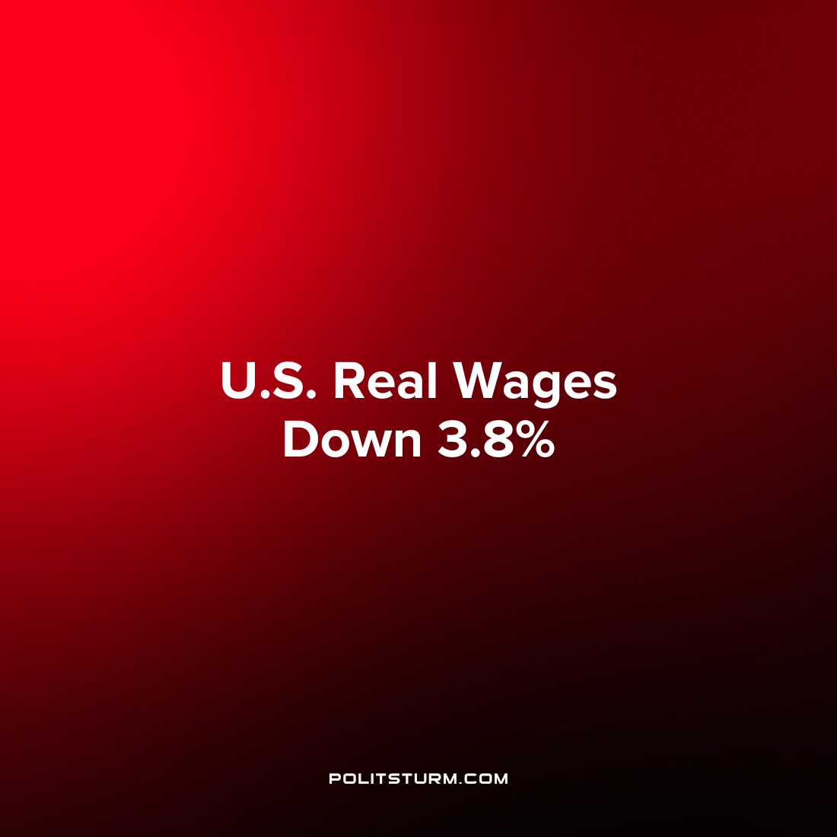

Original article
2022-11-14
1 min read

Hourly earnings fell 3% for workers in the United States from September 2021 to September 2022, according to a release by the Bureau of Labor Statistics (BLS). However, there was also a decrease in the average work week over this period of 0.9% and as a result the agency has determined that real wages are down 3.8% over this time period.
The decline in real wages has been largely affected by the increase in inflation which occurred over this same period. For example, average weekly earnings for U.S. workers was $1,076.02 in September 2021 and $1,119.87 in September 2022. However, the Consumer Price Index increased from 274.214 to 296.761 over the same period meaning that prices have risen and reduced the buying power of the worker’s wages. In essence, prices are increasing at a faster rate than wages which is leading to a decline in the real wage.

Error loading image
While capitalists are increasing the prices of their commodities, the workers only have one commodity which they can sell: their labor power. As a result, there is no guarantee that in periods of inflation the working class can keep their standard of living constant with inflation. As the prices rise, the workers can afford less and less with their wages unless their wages increase at least at the same rate as prices. The capitalist system of production and the anarchy of the market leads to periods of increasing prices, the negative repercussions of which are felt by the working class.

Source: 1

Original article

