U.S. Poverty Rate Highest Among Developed Countries
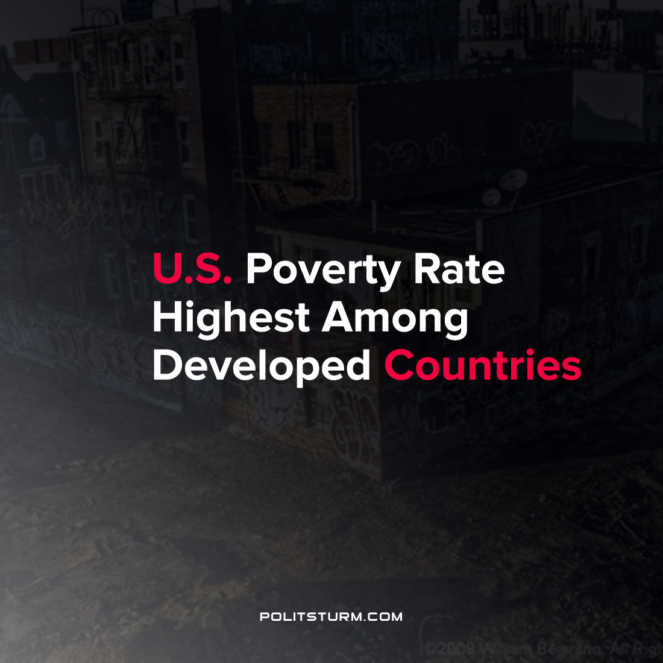

Original article
2021-11-18
1 min read

According to OECD data the United States has one of the highest poverty rates relative to other developed countries. The U.S. poverty rate is double its peers such as France, Germany, Sweden and Switzerland. The rate of poverty is considerably higher among children which currently stands at 16%.
This rate has remained relatively stable over time. The poverty rate of children was 15% in 1970 and is 16% as of 2020. States with the highest poverty rates are largely concentrated in the south with Mississippi (20%) having the highest poverty rate.
On the other end of the spectrum, America’s billionaires have had their wealth grow by 70% during the pandemic and have massive fortunes.
The economic and political system in the United States continues to perpetuate the massive growth in wealth by the capitalists and the impoverishment of the most vulnerable in society. The private owners of the means of production extract massive profits whereas millions struggle to survive. Only the elimination of the capitalist mode of production will fundamentally resolve poverty which is rooted in the economic mode of production: capitalism.
Source: 1 2

Original article

