U.S. Life Expectancy Decreases for Second Consecutive Year
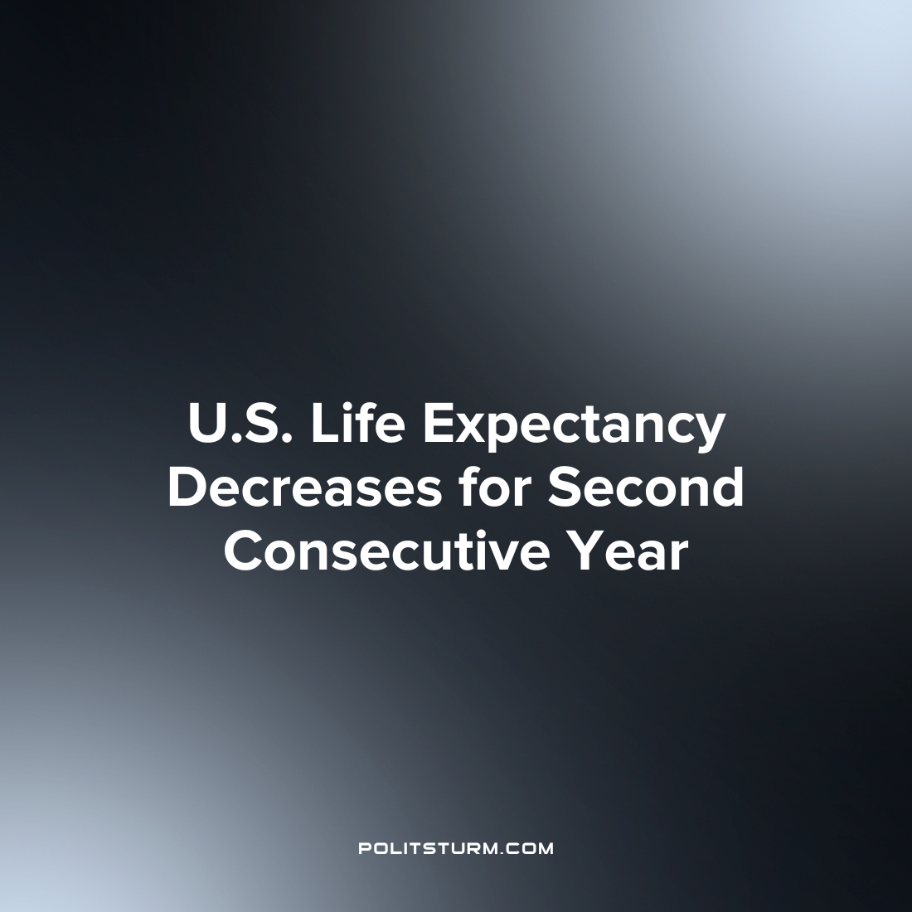

Original article
2022-12-27
1 min read

Life Expectancy in the U.S. continues to fall for a second year in a row with heart disease, cancer and COVID-19 being the leading causes of death. According to data from the national Vital Statistics System the average life expectancy in 2021 was 76.4, a 0.6 year decrease from 2020.
Life expectancy for males decreased from 74.2 years to 73.5 years whereas the life expectancy for females decreased from 79.9 to 79.3. The age adjusted death rate increased 5.3% from 835.4 to 879.7 deaths per 100,000 from 2020 to 2021.
There was a statistically significant increase in the death rate as a result of several conditions that occurred between 2020 and 2021. Heart disease, cancer, COVID-19, unintentional injuries, stroke, diabetes, chronic liver disease, and kidney disease all witnessed significant increases.
Despite rhetoric from the supporters of capitalism about the positive outcomes associated with capitalism, the stark reality in the U.S. is that the average lifespan is decreasing and not even staying constant. While the oligarchs continue to profit and live long lives of luxury, the average lifespan is decreasing. The capitalist economic system serves the interests of the oligarchs at the expense of the wider society and these results are disappointing but unsurprising.
Source: 1

Original article

