U.S. Life Expectancy Declines Over 2 Years From 2019-2021
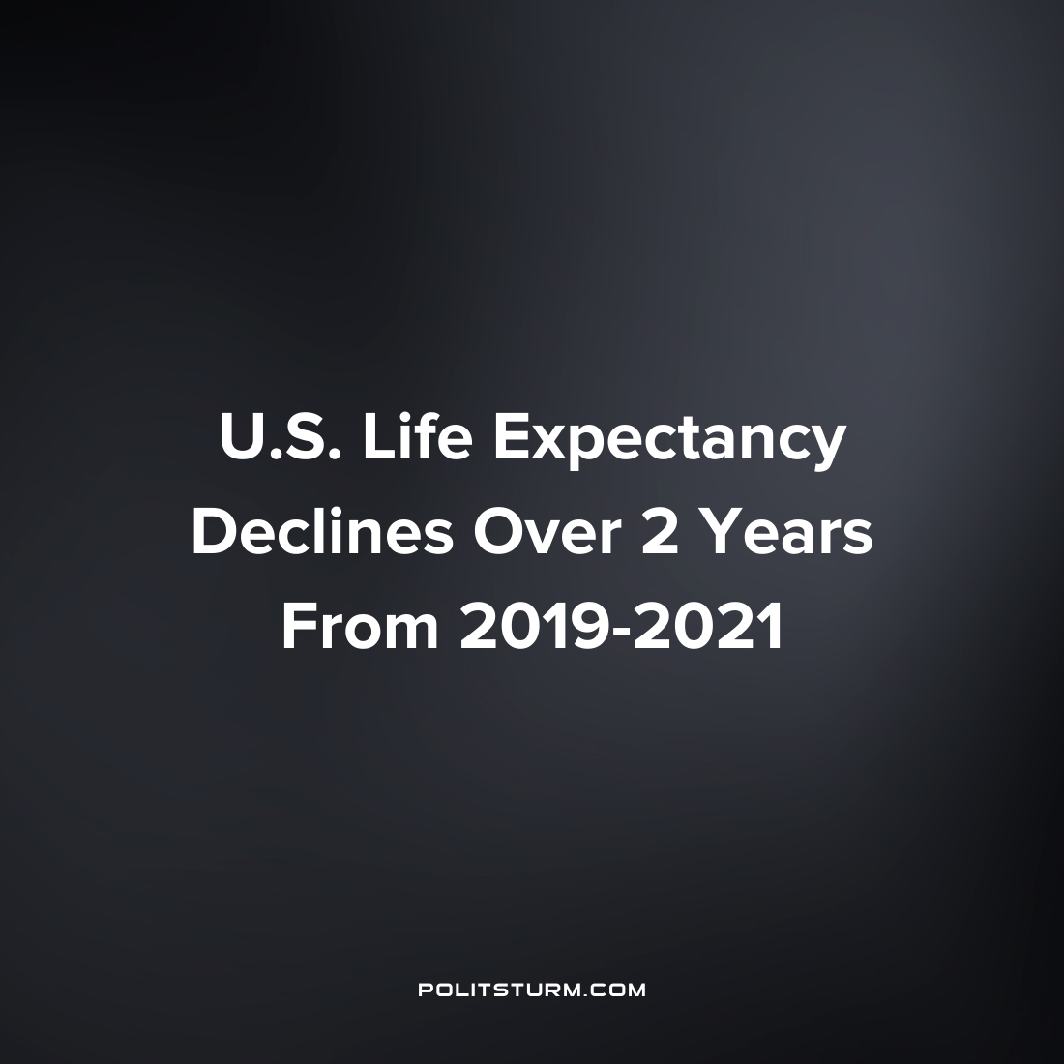

Original article
2022-05-24
1 min read

Life expectancy in the United States is on the decline according to a new study which is awaiting peer review. Researchers note that the decline in life expectancy is the largest drop since 1943 which was the deadliest year for Americans in World War II.
“US life expectancy decreased from 78.86 years in 2019 to 76.99 years in 2020 and 76.60 years in 2021, a net loss of 2.26 years. In contrast, peer countries averaged a smaller decrease in life expectancy between 2019 and 2020 (0.57 years) and a 0.28-year increase between 2020 and 2021, widening the gap in life expectancy between the United States and peer countries to more than five years”
The researchers concluded from the data that large declines in life expectancy for African American and Hispanic Americans were a reflection of “the legacy of systemic racism and inadequacies in the U.S. handling of the pandemic”.
It is important to note that as a class society not all Americans will have a decline in life expectancy. A long term study on the correlation between life expectancy and income found “The gap in life expectancy between the richest 1% and poorest 1% of individuals was 14.6 years (95% CI, 14.4 to 14.8 years) for men and 10.1 years (95% CI, 9.9 to 10.3 years) for women.”
The decline in life expectancy in the U.S. shows the failure of the capitalist economic system for the mass of workers at providing a longer, more fruitful existence. Rather, a class of parasitic oligarchs continue to exploit labor and natural resources for their own private profits whatever the social consequences may be.
Sources: 1 2

Original article

