U.S. Jobless Claims Increase by 1.3 Million
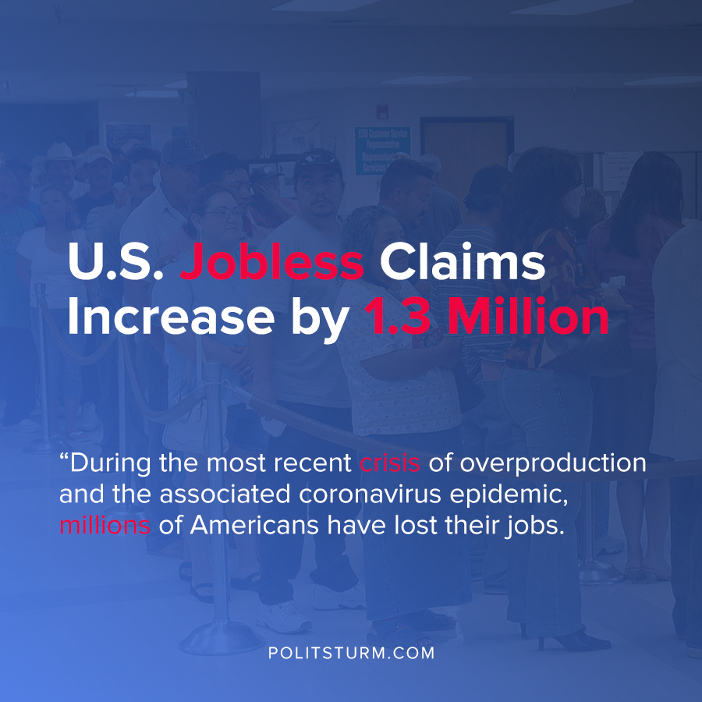

Original article
2020-07-17
1 min read

According to the most recent jobless claims data, 1.3 million more Americans filed initial unemployment claims. This is the 17th straight week where over 1 million Americans were filing for unemployment.
Last year during the same period, 243,261 people filed for unemployment. 32,003,330 were claiming unemployment from their state programs, which represents almost 10% of the entire U.S. population.
The highest insured unemployment rates in the week ending June 27 were in Puerto Rico (26.8), Nevada (20.9), Hawaii (19.9), New York (17.0), Louisiana (16.6) and California (15.9).
During the most recent crisis of overproduction and the associated coronavirus epidemic, millions of Americans have lost their jobs. With the extended unemployment benefits set to expire at the end of July, the objective living conditions of the workers on unemployment will get even worse.
The capitalist economic system is plagued with recurrent crises of overproduction that periodically throw workers out of their jobs. The capitalists benefit from having a massive pool of unemployed workers to hire at lower wages and with less benefits. For as long as the capitalist system exists, workers will be thrown out of work needlessly and will always be threatened by unemployment.

Source: 1 , 2

Original article

