U.S Infrastructure in State of Disrepair
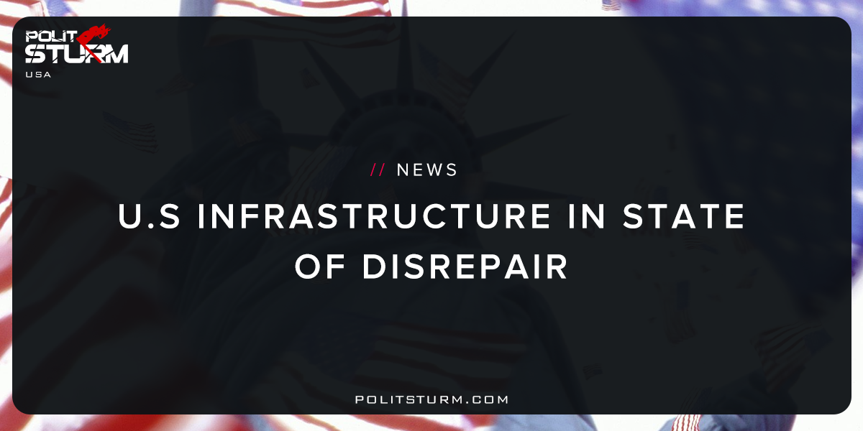

Original article
2018-01-26
2 min read

Getting Congress to pass what President Donald Trump hopes to be a $1 trillion package to fund U.S. infrastructure upgrades would be just the first step in a decadeslong endeavor, U.S. Chamber of Commerce CEO Tom Donohue told CNBC on Thursday.
Infrastructure in the United States is “25 years behind at least,” Donohue told “Squawk Box” from the sidelines of the chamber’s infrastructure summit.
The event brings together business leaders, policymakers and investors to discuss the modernization of the nation’s infrastructure. Donohue will reiterate his call for a bipartisan infrastructure deal at the summit Thursday.
“Potholes are everywhere,” he said.
Donohue believes fixes needed to U.S. infrastructure include, “bringing up our roads, our bridges, our transit systems and then on larger projects issues of ports and airports.” Waterways and energy systems need work as well, he added.
Politsturm: The infrastructure in the United States is in desperate need of repair and maintenance according to a recent report by the American Society of CIvil Engineers. The cost to repair the infrastructure stands currently at an estimated $4.59 trillion and has been steadily increasing over recent years. The infrastructure repair proposal by president Trump is for only $1 trillion in repairs which is funded through grants and “private activity bonds”. These bonds allow wealthy investors to lend money to the government to finance the construction of airports, rail, highways, etc. One of the great benefits to the oligarchs lending the money is that all of the earnings will be tax-free.
In essence, the proposed infrastructure bill will be financed through debt to the extremely wealthy and “public-private partnerships”. These capitalists be earning tax-free interest from their government bonds while taxpayer money is funnelled into private, capitalist ventures. The core principle of “public-private partnerships” is to enable private companies to apply for government funded grants for infrastructure projects. These companies would turn the improvement of Federal infrastructure over to the private sector and would need to turn a profit. This method of investment is of course rational to the bourgeoisie who will have more opportunities to profit and enrich themselves. However, to the working class this policy is absolutely irrational and egregious. We are entirely capable of improving the infrastructure of this country without this class of blood-sucking parasites profiting off it. A rational, planned economy of the workers would easily be able to allocate the materials and specialized labor to improve infrastructure. Under the capitalist economic system, this is just a pipe dream.
Sources: 1, 2, 3

Original article

