U.S. Imposes Tariffs in Boeing-Airbus Dispute
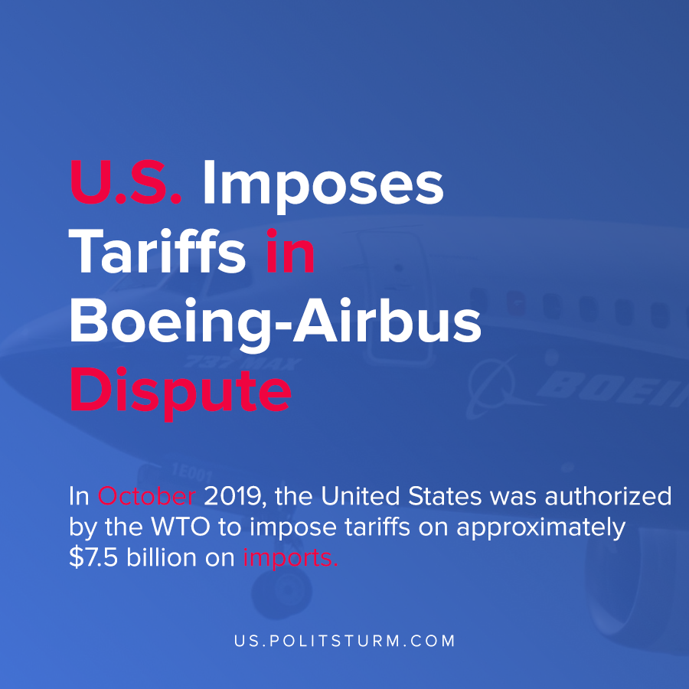

Original article
2021-01-02
1 min read

The U.S. Trade Representative announced that new tariffs are going to be imposed upon certain European commodities amidst an ongoing trade dispute. Competition between U.S. aircraft manufacturer Boeing and the European aircraft manufacturer Airbus has brought forth accusations of unfair competition at the World Trade Organization (WTO).
In October 2019, the United States was authorized by the WTO to impose tariffs on approximately $7.5 billion on imports. Likewise, the European Union was authorized to impose $4 billion in tariffs on U.S. imports.
The ongoing disputes and accusations of unfavorable trade conditions have led to the latest development in which the U.S. is imposing more tariffs. The commodities subject to the tariffs include aircraft manufacturing parts, wine, cognac, and brandy.
The most recent tariffs are another example of the way in which capitalist competition leads to retaliation between capitalist nations and their associations. Aircraft exports represent a substantial part of U.S. exports, and Boeing is a dominant monopoly in that sector.
Under capitalism, the U.S. monopolists will struggle against competitors using all available tools including tariffs. The continued existence of capitalist productive relations inevitably leads to uneven development, conflict, and war.
Sources: 1 , 2

Original article

