U.S. Has Worst Worker Benefits in Developed World
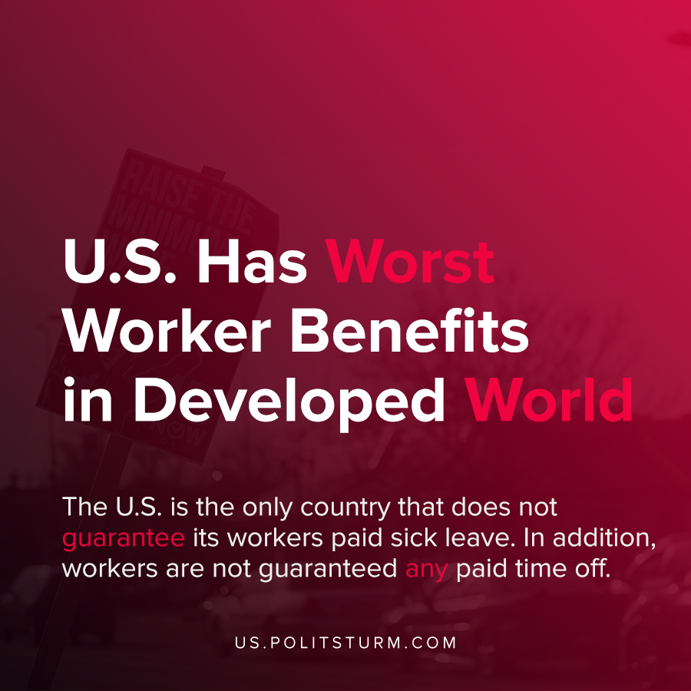

Original article
2021-02-27
1 min read

New data shows that the U.S. lags behind other countries in the benefits provided to workers, according to Zenefits. In ranking countries on employee benefits, a comprehensive view was taken based on workplace benefits, medical care, retirement, paid time off, and unemployment benefits which were all taken into consideration.
U.S. healthcare benefits lag behind other countries such as Canada, Denmark and Sweden due to the large number of uninsured and private insurance through employment.
Further, the U.S. is the only country that does not guarantee its workers paid sick leave. In addition, workers are not guaranteed any paid time off.
Along with Lesotho, Liberia, Papua New Guinea, and Swaziland there is no paid material leave in the United States, barring federal employees.
While there is variation in workers benefits at the state level, by-and-large the U.S. trails other capitalist countries. The loss of benefits to the workers subsequently enriches the U.S. capitalist class, and the politicians and judiciary ensure that this situation will continue. It is necessary for all workers to understand Marxist-Leninist theory and apply it to the current conditions to end the exploitation inherent in capitalism.
Source: 1

Original article

