U.S Has Lost Over 15,000 Steelworker Jobs Since 2007
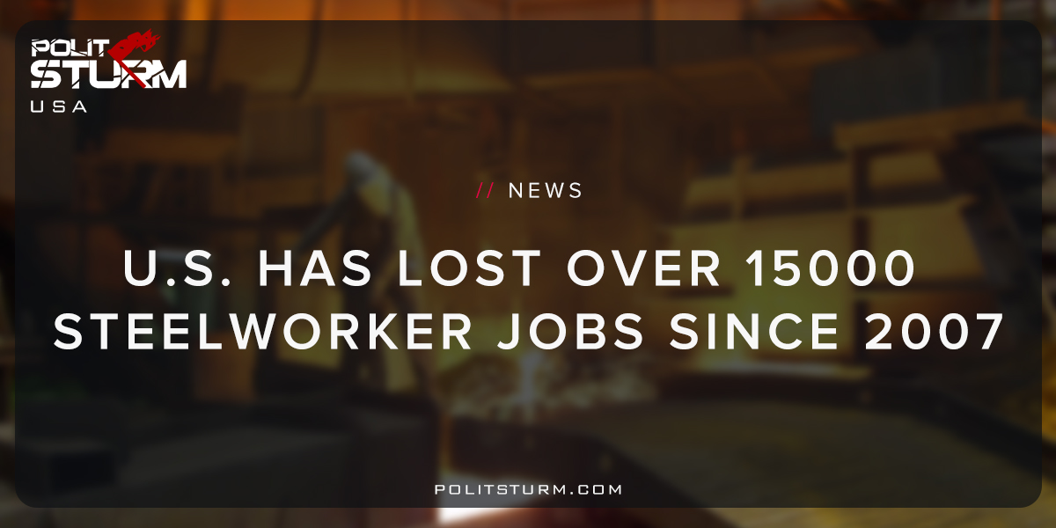

Original article
2018-05-05
1 min read

According to the Bureau of Labor Statistics, the United States has lost over 15,000 jobs in the production of iron and steel between 2007 and 2016. This amounts to a 16% decline in overall employment during this period. The global production of steel has increased dramatically while at the same time U.S steel production dropped both in relative global production and in absolute terms.
The global quantity of steel demanded is increasing, not decreasing. The United States produces less steel than in 1967 by weight. It also makes up a smaller percentage of the global market. It is quite obvious that one of the main components in repairing the declining infrastructure in the United States is steel. Rather than providing safe, stable employment and working to fix our infrastructure the capitalist system fosters rust, decay, and unemployment. The decline is due to the failure of capitalism, not the decline of the global steel industry.
While all of the negative consequences of social erosion are borne by the working class, the oligarchs benefit from unearned income and tax cuts. Under the dictatorship of the bourgeoisie it would be impossible to repair and once again expand our productive capabilities here in the U.S. It is entirely possible to achieve this goal under a planned, socialist economy, but not under capitalism. Under capitalism all of the productive gains of society are siphoned off by a class of parasites living off the unpaid labor of the working class. The steel industry is not becoming obsolete, the capitalist mode of production is.

Original article

