U.S. Food Prices Spike, Hunger Increases
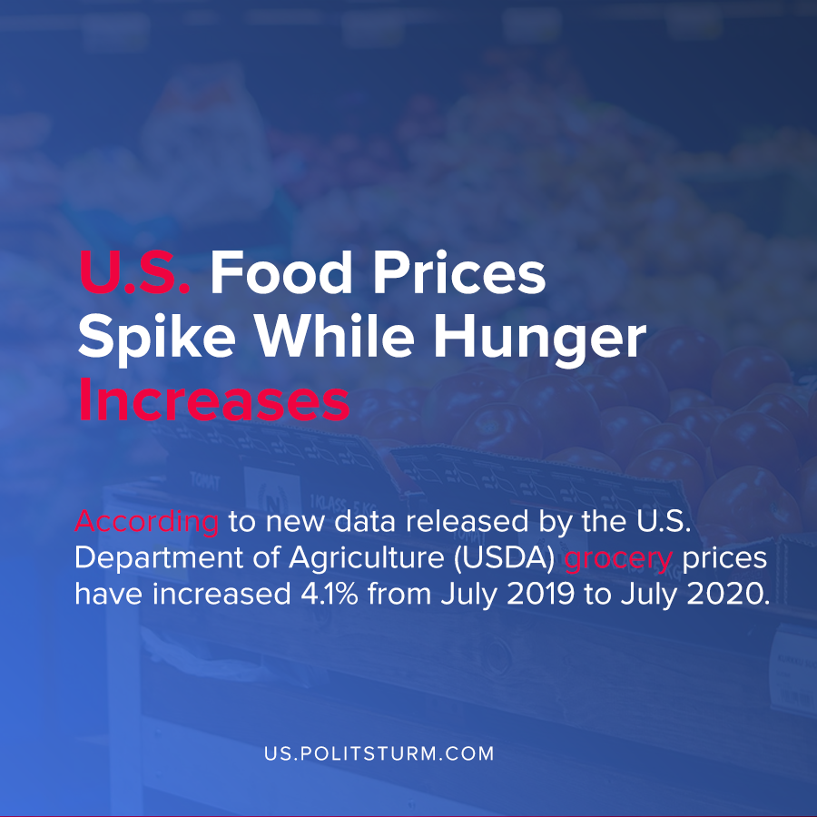

Original article
2020-09-09
1 min read

According to new data released by the U.S. Department of Agriculture (USDA) grocery food prices have increased 4.1% from July 2019 to July 2020. In the forecast for the next year, food prices are expected to increase by between 2-3%.
The increase in food prices comes amidst data that food insecurity is set to increase in the United States for 2020, which predicts more than 54 million people will experience food insecurity in 2020.
Families with children are more likely to experience food insecurity, with more than 11 million children living in food insecure households.
As the coronavirus and the most recent crisis of overproduction rage on, food prices have soared in response to the market mechanism. As workers are being displaced from their jobs at an increasing rate, the cost of necessities for workers such as food are even more unaffordable.
The logic of the capitalist system is based upon the production of profit for the capitalist class, not the well-being of the workers. As such, in the United States millions are subject to needless suffering from hunger and lack of necessities to produce profit for a small class of oligarchs, the capitalists. Only by organizing the economy upon Marxist-Leninist principles, such as planned production based on a social plan in the interests of workers, will the scourge of hunger be eliminated.

Sources: 1 , 2 , 3

Original article

