U.S. Food Prices Continue to Rise
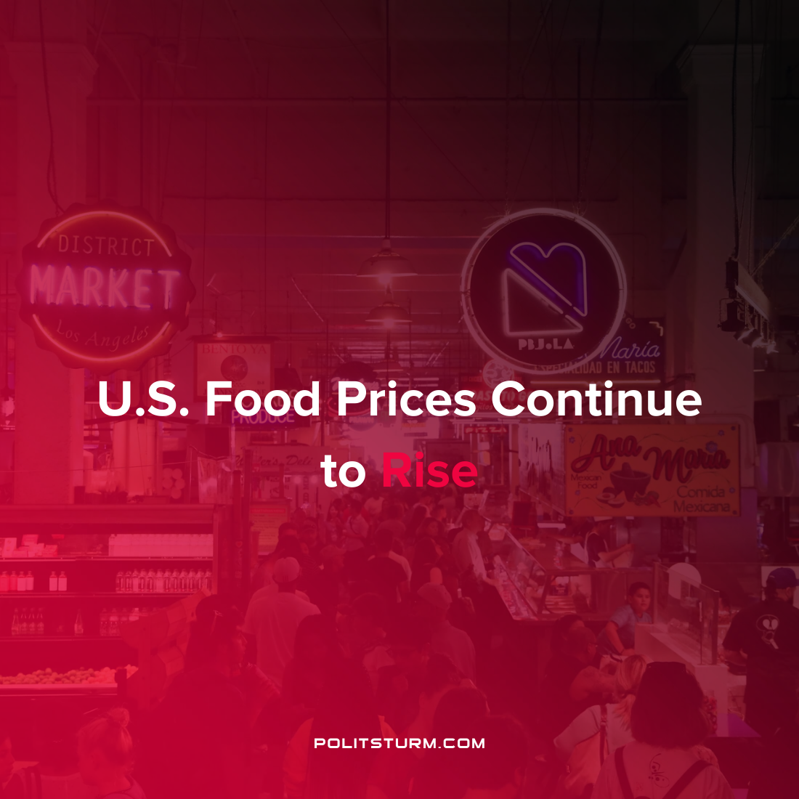

Original article
2022-01-27
1 min read

According to statistics published by the U.S. Department of Agriculture, the price of food has risen dramatically across the country. Food prices increased 6.3% between November 2020 and December 2021. Food purchased from restaurants went up 6% in price while food purchased from grocery stores increased by 6.5%. The increase in the overall inflation over the same period was 7%. The implications of rising food prices are a strain on low-income workers and the unemployed.
“What happens when food prices go up is food insecurity for those who are experiencing it just gets worse”, remarked COO of Feeding America Katie Fitzgerald. The organization has a network of more than 200 food banks across the country.
The instability of prices under the capitalist mode of production directly impacts the affordability of food and causes food insecurity. However, the pandemic has not negatively affected the condition of the capitalists who continue to profit.
“Kroger is executing against its key financial and operational initiatives and continues to invest in strategic priorities that will drive attractive and sustainable total shareholder returns. We believe our business is emerging stronger through the pandemic and is well positioned to grow beyond 2021″, said Kroger supermarket CEO Gary Millerchip.
As long as the capitalist system continues to exist and the capitalists own the means of production the working class will bear the brunt of capitalism’s instability.

Sources: 1 , 2 , 3

Original article

