U.S-China Sign Phase One Trade Deal
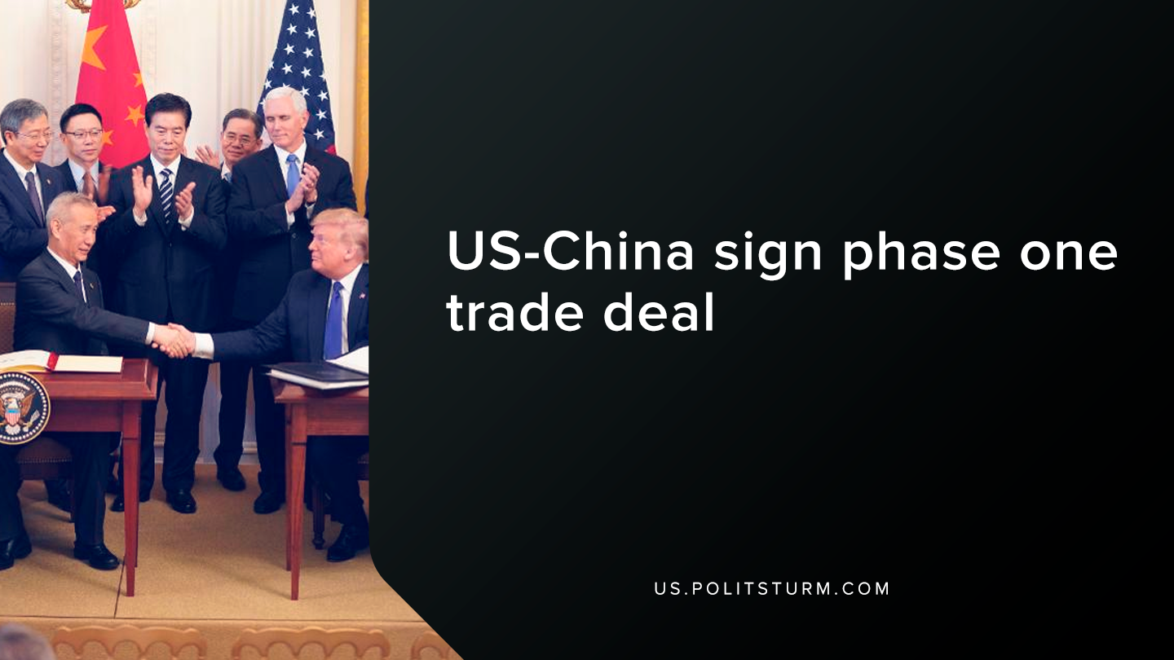

Original article
2020-01-18
1 min read

The United States and China recently signed a trade deal that outlined several topics such as intellectual property, technology transfer between the two countries, trade in agricultural products, among many other subjects. The agreement comes amidst the “trade war” between the two countries under the Trump administration.
Interestingly, the trade deal outlined many provisions that would impact the ability of U.S financial corporations to operate within mainland China. For example, the agreement has a provision to allow U.S. financial companies to “acquire non-performing loans directly from Chinese banks, beginning with provincial licenses”.
In addition, there is language in the agreement that shows that the Chinese are opening their economy to further investments from U.S. finance capital.
“No later than April 1, 2020, China shall eliminate foreign equity limits and allow wholly U.S.-owned services suppliers to participate in the securities, fund management, and futures sectors.”
As we can see, the trade agreement between the U.S. and China contains provisions for U.S. finance capital to extract surplus value through the direct participation in Chinese financial markets. From a class perspective, the objective of the trade agreement with China was to obtain favorable conditions for the U.S capitalist class.
When discussing the impacts of the China trade deal with J.P. Morgan Chase Chief Executive Officer Mary Erodes, Trump referenced the surge in bank earnings and stated, “I made a lot of bankers look very good”.
As we can see, the Trump administration and all previous administrations serve the interests of the bourgeois class. The Trump administration upholds the interests of the various capitalists and not the interests of the working class. The main beneficiaries of the trade agreement are the capitalist class and it is imperative that workers, armed with the knowledge of Marxism-Leninism, understand this.
Sources: 1, 2

Original article

