U.S. Budget Deficit Triples to $3.3 Trillion
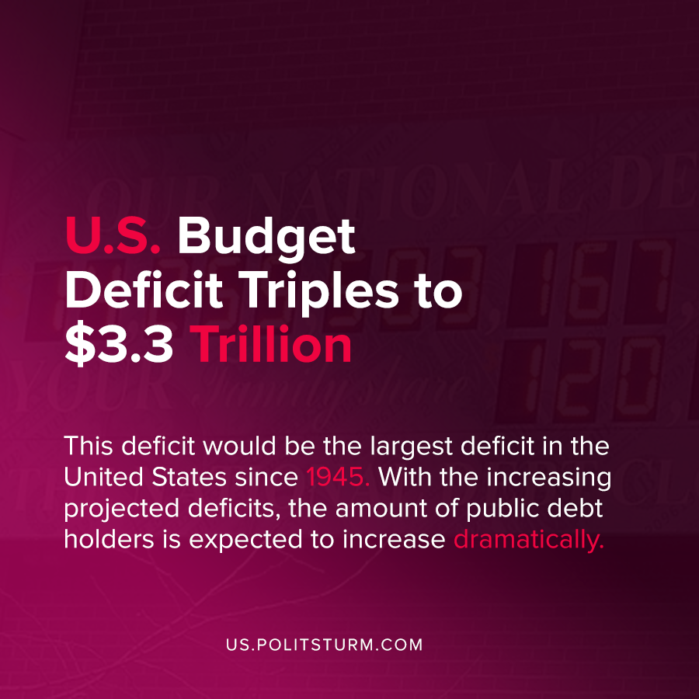

Original article
2020-09-12
1 min read

In a recent adjustment to their previous estimates, the Congressional Budget Office (CBO) now projects that the federal budget deficit will be $3.3 trillion in 2020. This figure is triple the budget deficit recorded in 2019.
This deficit would be the largest deficit in the United States since 1945. With the increasing projected deficits, the amount of public debt holders is also expected to increase dramatically.
“As a result of those deficits, federal debt held by the public is projected to rise sharply, to 98 percent of GDP in 2020, compared with 79 percent at the end of 2019 and 35 percent in 2007, before the start of the previous recession”, says the report.
While the report is nondescript in referring to national debt holders as “the public”, they are rather money capitalists who derive interest payments. As the public debt has dramatically increased since the onset of the latest capitalist crisis and coronavirus pandemic, the debt will come due.
The arguments surrounding the national debt resolves itself to two fundamental groups. Solutions to the problem of deficits and the national debt fundamentally revolve around the reduction of expenditures and increase in taxes. However, the reduction in expenditures will target social programs, and not the imperialist “defense” spending.
The national debt supports the functioning of the state, which always serves the interests of a particular class: the capitalists.
There is no solution to the issue of the public debt from the perspective of the working class within the confines of bourgeois parliament, as measures will ultimately support the capitalist class. Under a socialist system, the titles of ownership held by the bondholders would be eliminated and thereby their ability of government bondholders to profit off the national debt.
Note: The previous CBO estimate for the 2020 budget deficit was $1.1 trillion, which was just recently updated to the figure of $3.3 trillion.
Source: 1

Original article

