U.S. Budget Deficit Increases to $863 Billion In June
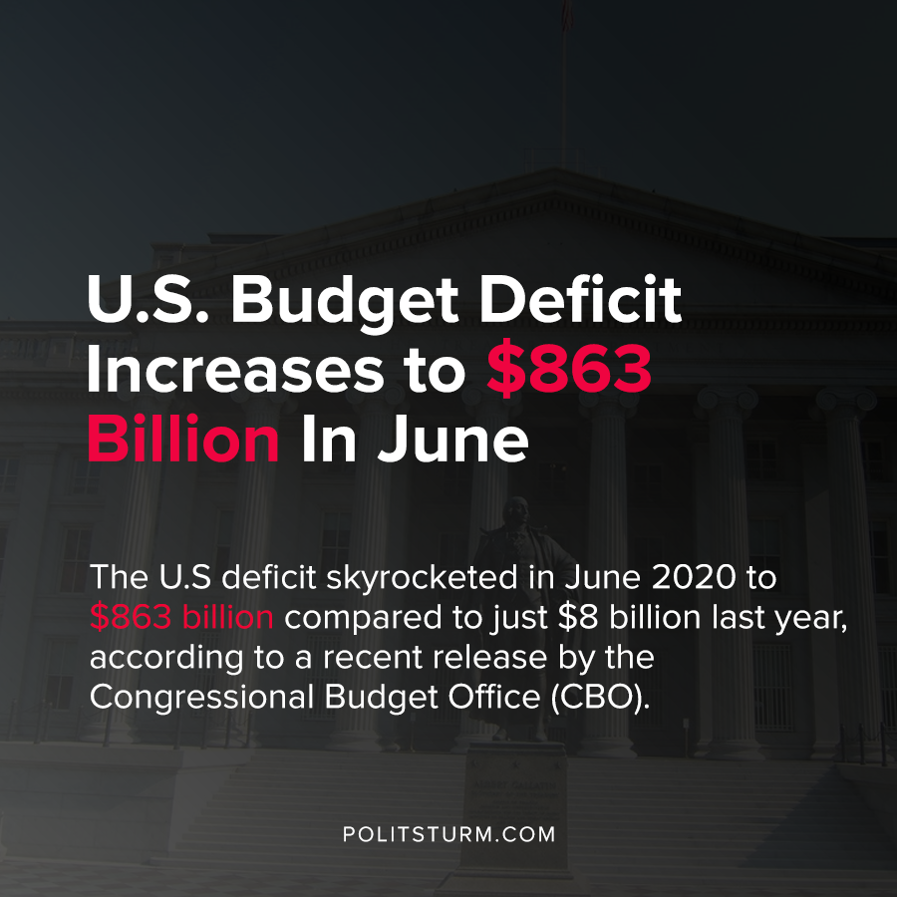

Original article
2020-07-14
1 min read

The U.S deficit skyrocketed in June 2020 to $863 billion compared to just $8 billion last year, according to a recent release by the Congressional Budget Office (CBO). The large deficits were a result of increased spending and decreased revenue.
As unemployment increased dramatically and wages lowered, less income was withheld in income taxes from workers paychecks who are now unemployed.
The government also pushed out the tax filing deadline to July 15th, 2020 which contributed to a collected revenue shortfall. Corporate tax revenues decreased by 88% due to the tax filing extension. The CARES Act also included provisions for employers to defer Social Security payroll taxes which further reduced government revenue.
Spending also increased as the government funneled loans to businesses through the Paycheck Protection Program (PPP), had larger outlays on unemployment insurance, and through increased equity investments in the Treasury Department Exchange Stabilization Fund which will “probably” be repaid in future years, according to the CBO.
As the government has increased spending dramatically in response to the coronavirus and the capitalist crisis of overproduction, the results have been dismal for the workers. Unemployment has been increasingly high and the centralization of capital increases as petty bourgeois proprietors can no longer stay in business.
The U.S government has been unable to prevent the spread of the coronavirus pandemic, and has been unable to prevent the economic fallout from the latest capitalist crisis of overproduction. The government, which represents the dictatorship of capital in the age of imperialism, will attempt to push the negative repercussions of the crisis onto workers in the United States and abroad.
Sources: 1 , 2 , 3 , 4

Original article

