U.S agricultural market shrinks under free trade
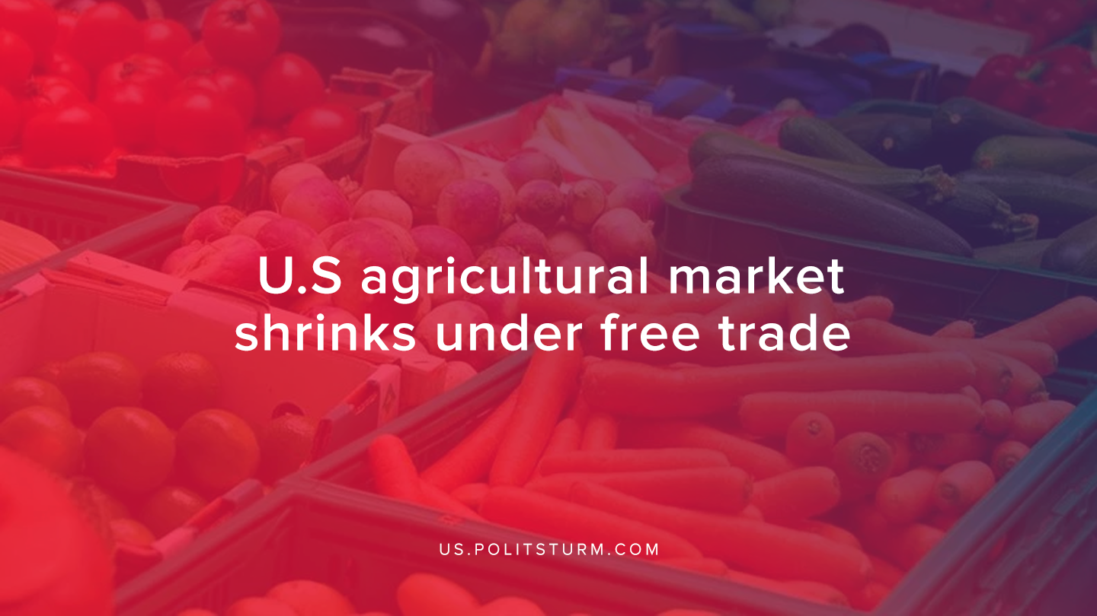

Original article
2020-01-09
1 min read

The question of free trade has become a subject of debate as its impacts to the workers in the United States has been scrutinized.
“Since NAFTA took effect—but especially in the past 15 to 20 years—the Mexican fruit and vegetable industry has carved out more and more of the U.S. market,” Lockridge states.”Securing fair, equitable trade terms that benefit all remains a high-stakes endeavor for Florida producers.”
Free trade is nothing but imperialism hidden under a pleasant name. The only aspect of free trade that makes it free is the freedom of capitalists to further exploit the proletariat of centre dependent countries.
Under noble sounding ideas such as comparative advantage, developed countries under free trade grant themselves the ability to further exploit the working class. From this concept we are presented with the idea that every country should do what is cheapest and easiest to produce, leading to semi-monoculture and/or monoculture economy.
The idea of free trade is perpetrated by the bourgeois educational system that aims to retain the economic system of capitalism. Such an educational system will preach about critical thinking while limiting the learning to the same bourgeois writers that paint the world in black and white.
As capitalism further progresses the educational system will further transform to be more reactionary and the social Darwinism of capitalist education system will grow. This further diverges the political consciousness of the proletariat, making them believe that the capitalist system is great, and only needs to be properly conducted or to be reformed.
However progress is no longer occurring under capitalism and we must accept that it is fundamentally flawed. In order to see progress and prosperity, not only for the working class of the developed world, but also in the over exploited countries, we must, through direct conflict, overpower the capitalists and bring prosperity to the world through the collective ownership of the means of production.
Source

Original article

