Tyson Supervisors Bet On Workers Getting COVID
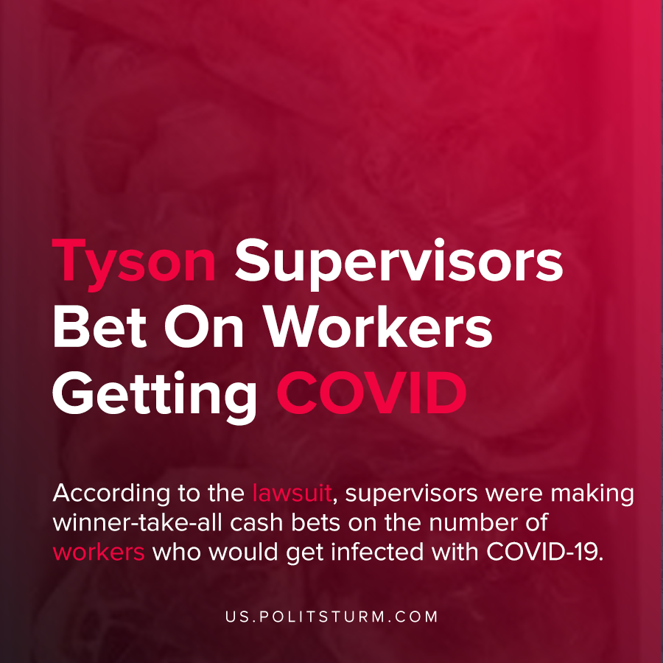

Original article
2020-11-21
1 min read

A new lawsuit brought on behalf of the estate of Isidro Fernandez, a former Tyson worker who tragically died of complications related to COVID-19, made disturbing allegations against Tyson supervisors and company practices.
More than 1,000 workers at the Tyson Waterloo meat processing plant were infected with COVID-19. According to the lawsuit, supervisors were making winner-take-all cash bets on the number of workers who would get infected with COVID-19.
The lawsuit also makes numerous statements about how Tyson rhetorically claimed to protect workers but took actions that jeopardized their health and prioritized profits.
“Despite an uncontrolled COVID- 19 outbreak, Tyson required its employees to work long hours in cramped conditions. Moreover, despite the danger of COVID-19, Tyson failed to provide appropriate personal protective equipment and failed to implement sufficient social distancing or safety measures to protect workers from the outbreak”, said the complaint brought in court”, said the lawsuit.
While companies say that they value the safety and wellbeing of their workers, in reality we see the barefaced maximization of profit above all other considerations. Workers were exposed to COVID-19 and even reasonable precautions such as protective equipment and social distancing measures were not enacted.
The reason these measures were not taken is because they impose either an expense on the company or would interfere with the maximization of profit.
Source: 1

Original article

