The Truth About The Molotov-Ribbentrop Pact
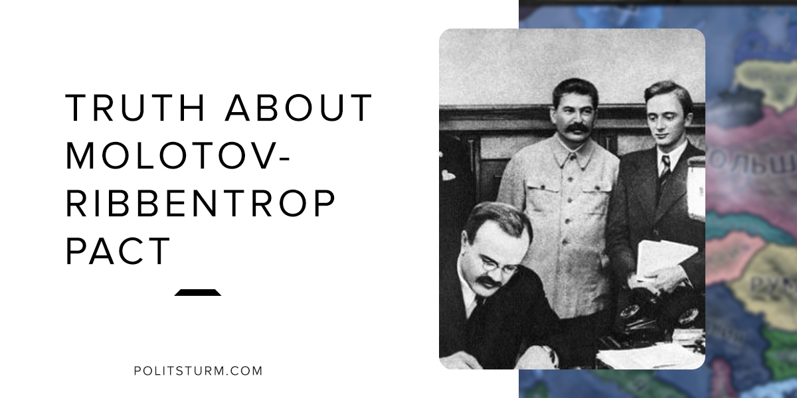

Original article
2018-05-09
4 min read

One of the most prevalent myths about the USSR in World War II surrounds the notorious Molotov-Ribbentrop pact. According to many western historians, the USSR signed this agreement with Nazi Germany in order to partition Poland between Germany and the USSR. The pact is seen as an agreement between two imperial powers who were expanding their respective spheres of influence to attain global dominance. The problem with this theory is that it completely ignores both the context under which the agreement was entered into, as well as the agreement itself.
Prior to the signing of the Molotov-Ribbentrop pact, western leaders were complicit in expansion of Nazi Germany. There were several agreements between Nazis and Western countries since 1933: Four-Power Pact (1933), Anglo-German Naval Agreement (1935), Anglo-German Non-Aggression Pact (1938), etc. The most striking example is the Munich Agreement under which the leaders of Great Britain and France ceded Czechoslovakia to Germany, Hungary and Poland. Western powers were either neutral or actively supporting the expansion of Nazi Germany. The cession of the Sudeten Czechoslovakia, a highly industrialized country, was instrumental in the production of armaments for the Nazi forces. The Czech Skoda factory produced tanks, airplanes, armored vehicles, and ammunition for the Germans. Prime Minister Neville Chamberlain proudly proclaimed that this act “is peace for our time”. This was certainly not the case. The western powers proved to be both unreliable, uncooperative, and at worst detrimental with respect to combating the growth of fascism on the European continent.
What about Poland? Modern historians like to portray Poland as an innocent country, «fallen under totalitarian agreement between Nazis and Communists». But in reality Poland had imperialist appetite. Polish nationalists dreamt of “Greater Poland from Baltic Sea to Black Sea” since 1920, when they occupied Soviet Western Belarus and Western Ukraine. They were interested in forming an “anti-communist crusade” together with neighbor countries and actively looked for an alliance. In 1934 Piłsudski-Hitler Pact was signed. It let Hitler to act freely on the West. In 1938 Poland took part in annexation of Czechoslovakia, capturing part of Teschen Silesia. Polish anti-communist dreams were shattered after they refused to allow Germany to annex Danzig. Hitler’s direction to the East became obvious.
USSR wanted to make an alliance together with France and Great Britain. Western diplomats refused to do it for about 6 years, but let Germany remilitarize and annex Austria and Czechoslovakia. It became obvious they are interested in war between Germany and USSR alone.
Faced with this impasse, the Soviet government after much consideration formed the non-aggression pact with the Nazi enemy. The Molotov-Ribbentrop was not intended to “partition” Poland and other Eastern European states in the way that the Munich Agreement partitioned part of Czechoslovakia to Germany. Rather it outlined and defined the German and Soviet spheres of influence, as outlined in the Secret Additional Protocol. This allowed for the outlining of clear national boundaries and gave the Soviets time to develop their defensive military capabilities. The western narrative which highlights the Soviets forming an agreement with the Nazi government completely ignores the concrete historical realities faced by the USSR and the refusal of western powers to cooperate with Soviet diplomats and defend against the threat of fascism.
On September 1, 1939 the Nazis invaded Poland and shortly thereafter the Polish government officials fled to Romania. At this point Soviet officials had observed that the Polish state and government had ceased to exist. With an invading Nazi army and a disintegrated Polish government on its western borders, the Red Army’s General Command issued troops to cross the western border to protect the populations of Western Ukraine and Belarus. Thus an actual examination of the historical conditions reveals that there was no “invasion” of Poland in 1939. Rather, the Soviet Union was protecting its citizens from the aggression of the invading German forces precipitated by the dissolution of the Polish state and liberating its territories, occupied by Poland after the Civil War in Russia.

https://www.files.ethz.ch/isn/125339/1393_Molotov-Ribbentrop_Pact.pdfhttps://www.files.ethz.ch/isn/125339/1393_Molotov-Ribbentrop_Pact.pdf
https://www.mzv.cz/file/198473/MunichAgreement.pdf

https://histdoc.net/history/FOFI1939-09-17.html

Original article

