Trump's Tariffs: America’s New Rules for 'Free Trade'
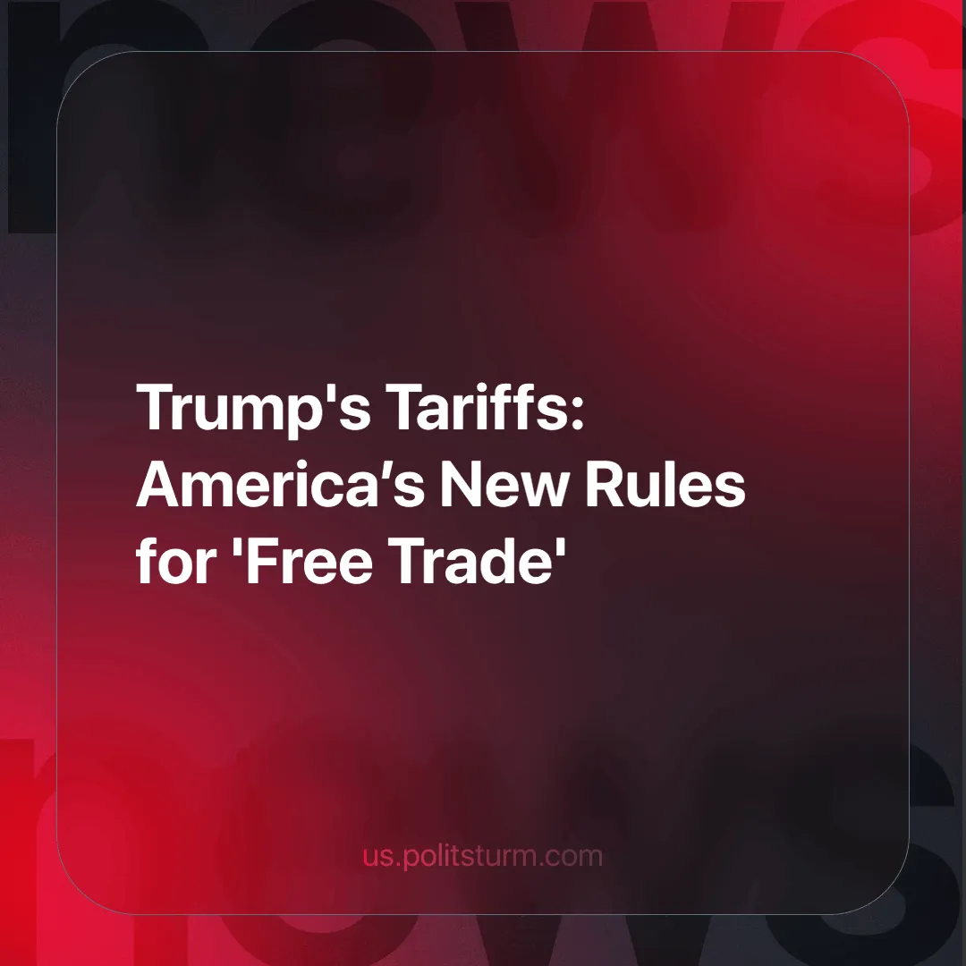

Original article
2025-02-08
8 min read

On February 1, 2025, President Trump signed an executive order imposing a 25% tariff on imports from Mexico and Canada and a 10% tariff on China [1], effectively dismantling the North American free trade framework. This prompted concern in all these countries, definitively shattering the long-standing liberal myth of free trade as the only path to development. Although, at the time of writing, Mexico's president [2] and Canada’s prime minister [3] have announced a pause in the implementation of the tariffs until March, along with Trump also pausing the tariffs on Mexico and Canada, but not China.
On January 1, 1994, the North American Free Trade Agreement (NAFTA later known as USTMC, T-MEC or CUSMA) entered into force. Mexico, Canada and China are the top trading partners of the U.S., as together they supplied 42.9% [4] of its imports in 2023. The hollow slogan “the freer the market, the freer the people” now stands in direct contradiction to the protectionist policies of the so-called “beacon of democracy”.
Tariffs are taxes imposed on imported goods, meaning the government collects a percentage of the commodity's price as revenue. And thus, run counter to the mainstream economic consensus; for the reason that as any other tax does, they distort the decision making of the consumer, altering the “freedom” of the market through government intervention.
For decades, the dominant narrative of the ideologues of capital has been that free trade is the only path to national wealth and development. This narrative also underpins orthodox liberal economics, which uses sophisticated mathematical theorems to "prove" that free trade maximizes everyone's welfare. Albeit the math itself is correct their suppositions and assumptions are not.
As we can see with our very eyes, the wealth and development promised to working people in general and especially those in the dependent countries has yet to come for most of them. And where it has come it enriched the few richest capitalists that profit from the sale of their nation, not the working masses. Far from the prosperity and universal development promised by “free market” dynamics.
It was Milton Freedman in “Capitalism and Freedom” (1962) who wrote “For most citizens of the country … the direct importance of economic freedom is at least comparable in significance to the indirect importance of economic freedom as a means to political freedom” [5].
Will liberals now conclude that the U.S. is not the so-called "land of the free"? If the emptiness and inherent self-contradiction of "liberal capitalism" as a means to freedom, development, and peace was not evident from the beginning, it certainly is now.

The Effects of Trump's Tariffs
From an accounting perspective, tariffs increase a firm's production costs. Although in theory, companies could absorb these costs by reducing their profit margins, in practice (especially with high tariffs) businesses pass the additional expense onto consumers through rising their prices. As a result, the increased price discourages the purchase of imported goods, making domestically produced alternatives more “competitive” (the price disparity between buying local and foreign is altered in favor of local producers).

Mexico-Canada Perspective
According to the Bureau of Economic Analysis, the United States imported a total of $1.52 trillion worth of goods and services in Q4 2024. Of this amount, Mexico and Canada accounted for $156.2 billion and $149.4 billion, respectively [6]. Making Mexico its biggest foreign supplier and Canada a close second.
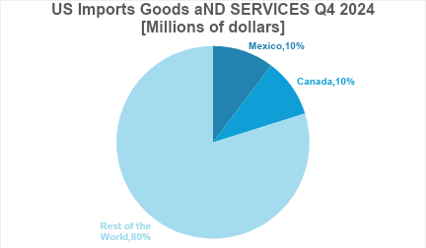
Data is from BEA [6]
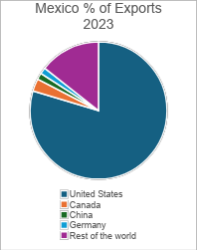
Data is from Santander foreign trade
According to data from Santander 79.6% [7] of Mexico’s total exports are destined for the United States, and 77.6% [8] of Canada’s. Although these figures are from different periods (1 year apart more less), they illustrate that both are deeply dependent on the U.S. market.
Does this validate Trump’s claims? Is the U.S. subsidizing Canada and Mexico? The short answer is no, categorically. The long answer, as you might have already guessed, involves free trade and imperialism (monopoly capitalism).
On the one hand, corporations migrate to regions with lower production costs. As an illustrative example: Mexico’s low-cost labor, largely due to nonexistent true labor unions, proved to be a highly attractive alternative to the costly and unionized automotive industries in the United States. As a result, companies flocked to Mexico, leaving cities like Detroit, previously famous for their car industry, in decline. In this case, free trade did not merely enable market expansion, and competition, cost cutting and lowering prices as its champions claim. It also increased the supply of labor, as capital could now move freely internationally to exploit other peoples in order to import the finished products and reap greater profits. This rather large sudden surplus of labor exerted constant pressure on the labor market, allowing the capitalists to reduce wages. Hence the relative and absolute impoverishment of the worker. As for the American standpoint Mexican labor is also even cheaper due to currency conversion.
This served two purposes: first, it greatly reduced the bargaining power of U.S. workers, and second, it cemented U.S. control over North America.

The Effects of Tariffs in General
Tariffs are used as a disincentive and punishing mechanism not only as a protectionist measure. Sanctions usually include them as the U.S. has the largest consumer market in the world, tariffing another country out of their market is usually a good deterrent. Yet it’s necessary to stress that the importer pays the tax, the export business would pay only if it were also importer itself.
For example: Ford makes its car in Mexico, then it exports it to the U.S. to sell at a dealership. This, from the state’s perspective, counts as an importation thus Ford, even as an American company, must pay the tariff.
Tariffs Effects
 | Importer Country | Exporter Country
Capitalists’ Business | More competitive goods/servicesHigher sales | Less competitive goods/servicesLower sales
Consumer/Worker | Higher pricesLower consumptionMight face unemployment due to exceptionally high tariffs | Might face unemployment due to a reduction of exports
As noted above, tariffs have been put on hold until at least March 2025, but some harm has already been done. As illustrated by the rising "egg prices" that heralded the end of the Biden administration, inflation has now begun to creep in even without tariffs. “… this is a time when some industries are trying to sneak in price increases because their customers will think it’s because of tariffs” [9].
With the U.S. imposing such high tariffs on its major trading partners (including the 10% on China), price increases are already being felt. Due to the highly integrated nature of production chains in north America, the price increase could be more than 25% for some goods, such as cars “Some parts cross borders multiple times — like, say, a wire that is manufactured in the U.S., sent to Mexico to be bundled into a group of wires, and then back to the U.S. for installation into a bigger piece of a car, like a seat.” [10]
However not all-American owners will benefit, since middle and small business, particularly family owned, usually are unable to sustain losses for very long or have slim profit margins. The resultant increase in the cost of imported inputs will be prohibitively high and they will be forced to close. Further centralizing capital while gradually dispossessing all but the largest possessing classes, increasing the monopolists control. As Marx clearly explains almost 200 years ago, in the 1844 manuscripts:
“The concentration of capital increases, the big capitalists ruin the small, and a section of the erstwhile capitalists sinks into the working class, which as a result of this supply again suffers to some extent a depression of wages and passes into a still greater dependence on the few big capitalists.
The number of capitalists having been diminished, their competition with respect to the workers scarcely exists any longer; and the number of workers having been increased, their competition among themselves has become all the more intense, unnatural, and violent.
Consequently, a section of the working class falls into beggary or starvation just as necessarily as a section of the middle capitalists falls into the working class” [11].
Given the dependence on U.S. exports both Canada and Mexico could face an unpleasant future due to the loss of exports. As it might trigger a crisis of overproduction in both countries. As tariffs would reduce their demand, and since much of their production is aimed at the U.S. market, companies would be unable to sell their products, at home or abroad. As consumption lowers (in the form of less exports), inventories rise and production is cut, unemployment goes up and consumption is lowered even more...

Who Really Pays For The Cost of Tariffs?
Today tariffs are “the most beautiful word in the dictionary” [12]. They expose the contradictions of capitalism, the Illusion of it being a synonym of free trade: while cloaked in nationalist rhetoric, they serve the interests of capital, not workers. Under capitalism any restructuring of the state and its policy is tailored for the benefit of capital, of the capitalist class over the detriment of the working class. From Reagan’s free trade to Trump’s protectionism, these are not ideological U-turns, but tactical adjustments to maintain their class hegemony. As we've shown, it's not workers in the U.S., Canada or Mexico who benefit from these policies, but capital, and primarily big capital at that.
Capital, however, is not a single, unified beast. While capitalists share concrete material interests arising from their ownership of the means of production, they exist in constant rivalry-both at home and abroad. The world is being carved up by monopolies on an ongoing day-to-day basis, whether it's under China's Silk Road or Trump's America First.
At home, tariffs like those signed under Trump are just one tool in this struggle. Others include trade wars - already being waged between the two - or even military conflict, as Trump has also threatened in Panama and Greenland. However, we also recognize that these measures do not serve all capitalists equally. Small and medium capitalists are often ruined, while the monopolies, who’s representatives are normally in government, consolidate their power.
As the crisis of capitalism deepens, and contradictions increase, the imperialists resort to “classic” tools like tariffs and war. The solution lies not in protectionism or free trade, but in the international struggle of the workers for a system that represents their independent interests - socialism. Only by dismantling capitalism can we build a world where trade serves people, not profit. Concretely this requires, not just deepening crises, but also the subjective factor - the party of the working class - the communist party, in order to lead the workers down this route. However, unfortunately in most countries, such a party does not yet exist. We are working towards the formation of such parties - join us.

Sources:
[1] CNN — “Mexico, Canada and China tariffs: Trump announces new tariffs on Mexico, Canada and China | CNN Politics” — 02/02/2025
[2] Claudia Sheinbaum - “https://x.com/Claudiashein/status/1886434747238514776” – 03/02/2025
[3] Justin Trudeau – “https://x.com/JustinTrudeau/status/1886529228193022429” – 03/02/2025
[4] Santander – “American foreign trade in figures - Santandertrade.com” –/01/2025
[5] Milton Freedman. Capitalism and Freedom. The University of Chicago Press: 1962. pp.8
[6] Bureau of Economic Analysis “International Transactions, International Services, and International Investment Position Tables” – 18/12/2024
[7] Santander – “Mexican foreign trade in figures - Santandertrade.com” - /02/2025
[8] Santander – “Canadian foreign trade in figures - Santandertrade.com”- /02/2025
[9] USA TODAY – “Is egg shortage causing new stockpiling panic?” – 03/02/2025
[10] NPR – “Trump’s tariffs on Canada and Mexico would hurt the auto industry : NPR” - 03/02/2025
[11] Karl Marx. Economic & Philosophic Manuscripts of 1844. Marxists.org: 2009. pp.4,5
[12] The Guardian – “‘The most beautiful word in the dictionary’: Donald Trump’s tariff plan – podcast | Donald Trump | The Guardian” – 16/12/2024

Original article

