Trump’s Cult of Personality?
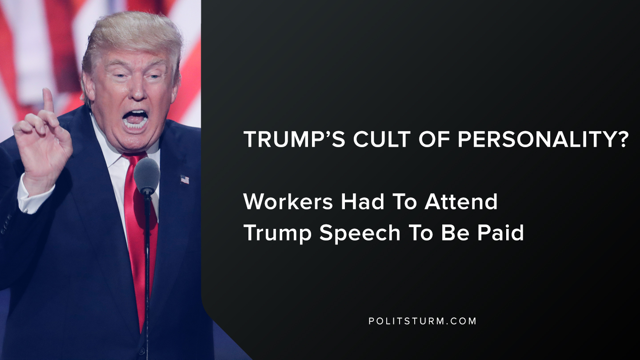

Original article
2019-08-18
1 min read

Shell workers at a Pennsylvania plant had to attend a recent speech by Donald Trump in order to be paid. Also, workers were not allowed to protest the president and were ordered “No yelling, shouting, protesting or anything viewed as resistance will be tolerated at the event”.
The business manager of the workers union Steamfitters local 449 said, “This is just what Shell wanted to do and we went along with it”. The business manager for the union also said that regardless of whether one personally likes the president, he must be respected for his title as President.
During the speech, Trump said that if union presidents are not supporting him politically that they should, “vote them the hell out of office because they’re not doing their job.”
While the corporate spokesperson from Shell said that the workers were free not to attend, workers would not be would be disadvantaged. The workers union stayed in line with the corporation and did not challenge the policy in any meaningful way.
The workers were essentially being used as paid to stand in support of the president and the actions of the workers were being coerced by company policy into being docile and supportive.
The union, lacking any theoretical basis in Marxism-Leninism, went along with the company policy and did not challenge the company. This event demonstrates the necessity of having representatives of the working class who have a strong theoretical basis in Marxism-Leninism who do not bend to the will of the capitalist class and their leaders.

https://www.post-gazette.com/business/powersource/2019/08/16/Trump-speech-union-crowd-Shell-ethane-plant-natural-gas-beaver-county-pennsylvania-attendance-pay-overtime/stories/201908160113

Original article

