Trump's Approval Rating Rises After Missile Strike
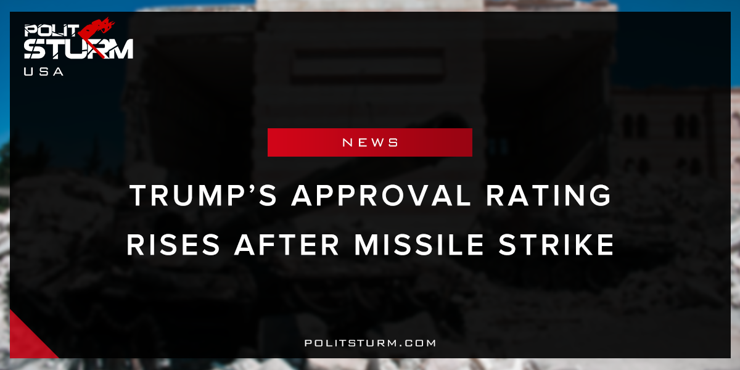

Original article
2018-04-19
2 min read

What do you do if you are the most unpopular sitting President in recent history? You’ve significantly cut spending for needed social programs and lowered taxes for your rich buddies, you’ve targeted vulnerable communities within the country for deportation, and your administration is filled with corruption and authoritarian personalities. The people are pretty upset with you and your approval ratings are at record lows. What do you do to escape this predicament?
If you are Donald Trump, the answer would be to bomb another country. Since destroying targets in Syria after an alleged chemical weapons attack, Donald Trump’s approval ratings jumped to 40%, the highest point since his first 100 days in office (According to the conservative-leaning Rasmussen polling group US President Donald Trump’s approval rating has increased to 51%).
The “rally around the flag” effect is a useful tool for Presidential administrations if they decide to use it. Take George H.W. Bush for example who in February 1991 ended the Gulf War with an 89% approval rating, or his son George W. Bush, who met with mass discontent similar to Trump’s following the 2000 election but then increased to an unprecedented 90% approval rating after the September 11 attacks. He then used this popularity to launch two wars, create the mass surveillance state, Time has shown that nothing is better for campaigns and political administrations than a good old war to rally the people behind you and make the other party look weak against foreign enemies of the “national interest.” At the same time, you can throw a bone to your friends in the weapons industry and media conglomerates who benefit from these operations. Everyone wins…
…except, of course, the workers of the world. Distractions such as these are a useful technique to the bourgeoisie who use them to cover up the social injustices of their rule perpetrates at home. By pitting our poor boys against other poor people around the world, the rich keep us fighting amongst ourselves, preventing us from our common interest, while they profit off of our backs. Instead of seeing our own economic and political elite as the problem, they continue to perpetuate the myth that the average Syrian, Korean, or Russian are our enemies when instead, we all hold the same interests, that of abolishing capitalism.
Military actions are framed so as to be patriotic, “apolitical”, and in the “national interest”, something everyone should rally around regardless of everyday political differences. But war is a very political act. There is nothing patriotic about sending our brave men and women to die in a war for the benefit of the rich.
Ironically, the very same people who complain about political correctness will be the first to question others’ patriotism when the bombs start falling. Using the veil of the American flag to hush dissent in a time of conflict is liberal nationalism and contrary to democratic politics. Democracy is not about placing blind faith in and “trusting” one’s leader as many American citizens do all too often. It’s about distrust, controversy, debate, and argument. It’s about questioning and challenging decisions that are made.
Sources: 1, 2, 3

Original article

