Trump's Reconciliation with Musk Highlights Problems with Presidential Policies
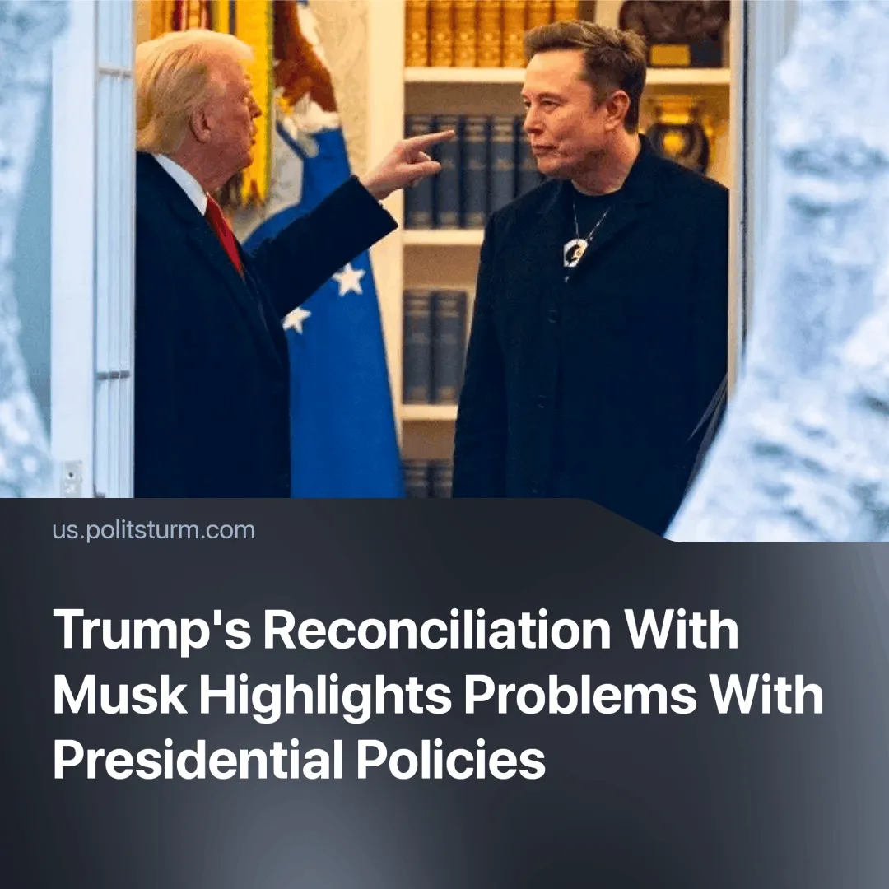

Original article
2025-06-11
2 min read

Trump and Musk's post-fight rapprochement is intended to obscure the most recent in a series of setbacks for the U.S. President.
Details. Trump announced the “Big Beautiful Bill” (BBB), a major tax break and spending package. The act extends tax cuts, introduces immigration fees and provides for a significant reduction in spending on virtually all non-military needs, primarily medical care.
► This provoked a backlash from Musk, who believed that the bill increases the federal budget deficit by about $2.5 trillion. He began to oppose the bill through posts on X, in which he claimed it was “disappointing”. Musk previously headed the Office of Government Efficiency, which was designed to reduce government spending.
► The bill would repeal federal tax credits for electric vehicles, stripping away one of the industry’s primary purchase incentives.
► This dispute reached a climax when Musk accused Trump of “ingratitude” and took credit for his 2025 election victory. Whilst the President threatened to cut SpaceX federal contracts, Musk claimed Trump to be in the “Epstein files”, and then floated the idea of creating his own party.
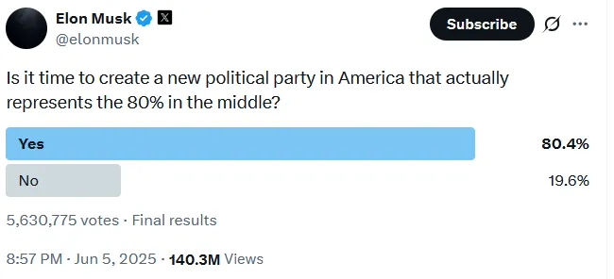
► In several days after the incident both sides announced a settlement of their differences. Some social media posts were deleted and the feud has publicly cooled down.
Context. Elon Musk was Trump's largest donor in 2024, spending an estimated $270 million on the campaign. Trump was in danger of losing the support of one of the richest men on the planet.
► Trump’s foreign-policy goals are also falling short. He claimed he could wish to end the war in Gaza “as quickly as possible,” yet it continues. He vowed to “crush” Yemen’s Houthi rebels, but announced a halt to U.S. strikes after limited success. He also promised to resolve the conflict in Ukraine within “24 hours” of taking office, but ceasefire talks show no meaningful progress.
► Trump’s domestic policy is also struggling. Tariffs have caused huge market turmoil, Multiple orders have been stalled in the courts, and his approval ratings have fallen quickly to 44%.
► Musk likely expected preferential treatment – NASA contracts, regulatory leniency, and fresh subsidies – but his over-promotion pitched him into conflict with Rubio, Trump, and other “old” capitalist clans, who have since moved to sideline him.
Important to know. Contradictions within the US ruling class produced this spectacle. Both Trump and Musk are billionaires operating within the same capitalist system.
► Trump, as president, serves the general interests of the U.S. capitalist class, though certain sectors – such as fossil fuels and defence – have received particularly favourable treatment during his administration. During his campaign, he promised benefits for oil companies and opposition to electric vehicles.
► Musk sought privileged access to the state, expecting influence, contracts, and protection. But his erratic behaviour and inflated self-importance have cut him off from direct political influence. Given his volatility, further reckless or destabilising moves remain a real possibility.

Original article

