Russia and The US Failed to Agree on a Ceasefire in Ukraine This Week
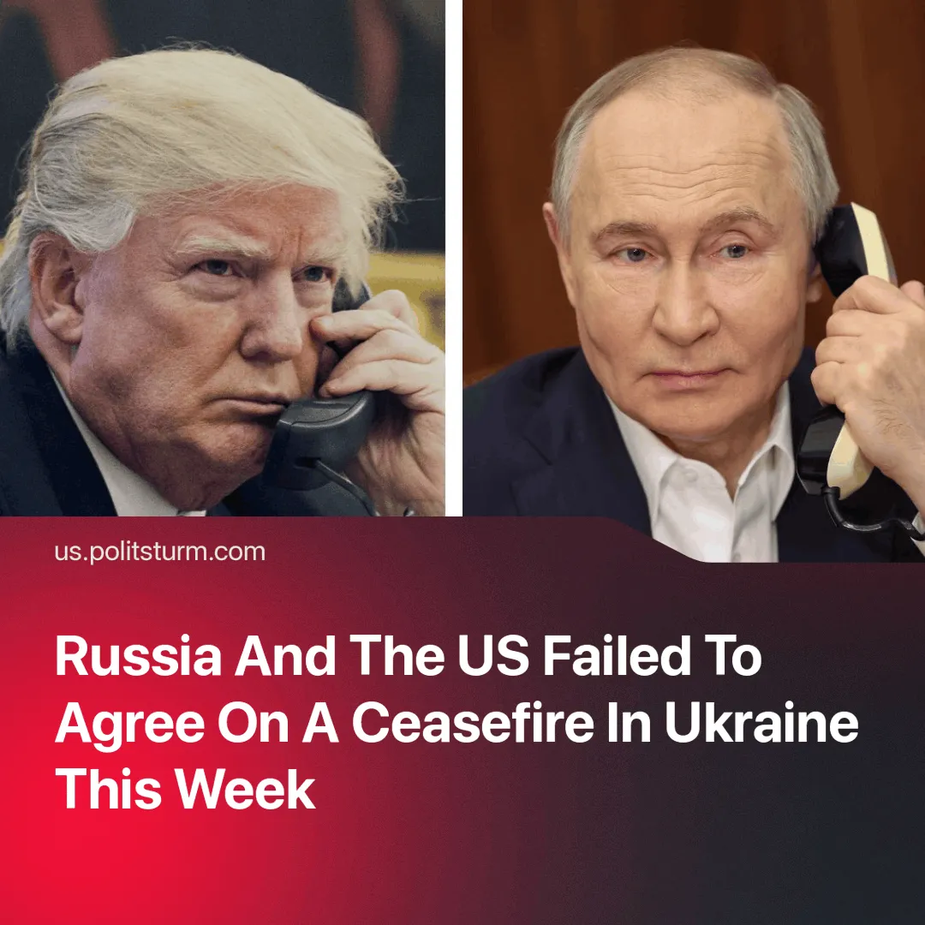

Original article
2025-03-23
2 min read

The phone call between Putin and Trump and subsequent statements from the American and Russian leaders indicate little progress in peace talks.
Details. A March 18 phone call between U.S. President Donald Trump and Russian President Vladimir Putin concluded without a comprehensive ceasefire agreement, falling short of expectations for a 30-day cessation of hostilities. The conversation, lasting approximately two hours and described as "productive” by both sides, resulted in limited outcomes.
► A verbal agreement to halt strikes on both Russian and Ukrainian energy and infrastructure for 30 days is in limbo. Almost immediately, both sides accused each other of violating the agreement.
► A prisoner exchange was implemented shortly after the call, with both sides releasing 175 prisoners each, and Russia returning 22 severely injured Ukrainian soldiers. Such exchanges are largely symbolic and have occurred repeatedly throughout the conflict.
► Both sides agreed to initiate talks in the Middle East to explore steps toward a broader ceasefire and eventual peace agreement. However, no timeline or agenda for these discussions has been finalized.
► The Russian side emphasized that halting U.S. and European support for Ukraine is a key condition for resolution. This condition directly contradicts the interests of American, European, and Ukrainian capitalists.
Context. Following the collapse of Trump's Gaza ceasefire efforts, his administration is under pressure to secure a foreign policy “success” story. During his campaign, Trump promised to end the conflict in Ukraine in "24 hours.”
► The U.S. was actively seeking a 30-day ceasefire, with President Trump engaging directly with both Russian and Ukrainian leaders to facilitate such a ceasefire. Putin did not agree to the full 30-day ceasefire proposal that Ukraine had previously accepted.
► Trump has publicly expressed concern over Russia being pushed into China’s sphere of influence and has hinted that U.S. diplomacy could help draw Russia away from Chinese dependency.
Important to Know. Behind-the-scenes bargaining is underway, with all parties to the conflict trying to negotiate better conditions for themselves.
► For various reasons, both sides are presenting the negotiations as "serious progress". The course towards rapprochement between the Kremlin and the White House continues, as both presidents have shown.
► American capital aims to integrate Russian resources into its sphere of control and use Russia as leverage in its growing confrontation with China. The Kremlin’s eagerness to signal progress is driven by growing pressure from Russian capitalists discontent with Chinese economic dominance and to leverage the current desires of the US administration to their own interests.
► China will seek to hinder this rapprochement between Russian and
American capital. It needs Russia as a subordinate state — a market for its
goods and cheap resources, an instrument of pressure against the EU and an ally in its intensifying confrontation with the United States.
► Europe has found Trump’s peace plans not in their interest and has begun increasing military spending. EU leaders have agreed on plans to raise an additional €800 billion for defense.
Conclusion. The Trump-Putin phone call did not produce tangible results but served as a performance to manage appearances on both sides. Under imperialism, the talks of peace are negotiations over market control, resource access, and the subjugation of weaker states.
No conflict lasts forever, and a peace agreement will be reached sooner or later. However, this agreement will only freeze events and serve as a breathing space for the unfolding of more global conflicts around the world.

Original article

