Trump Promotes Budget Cuts Across the Board
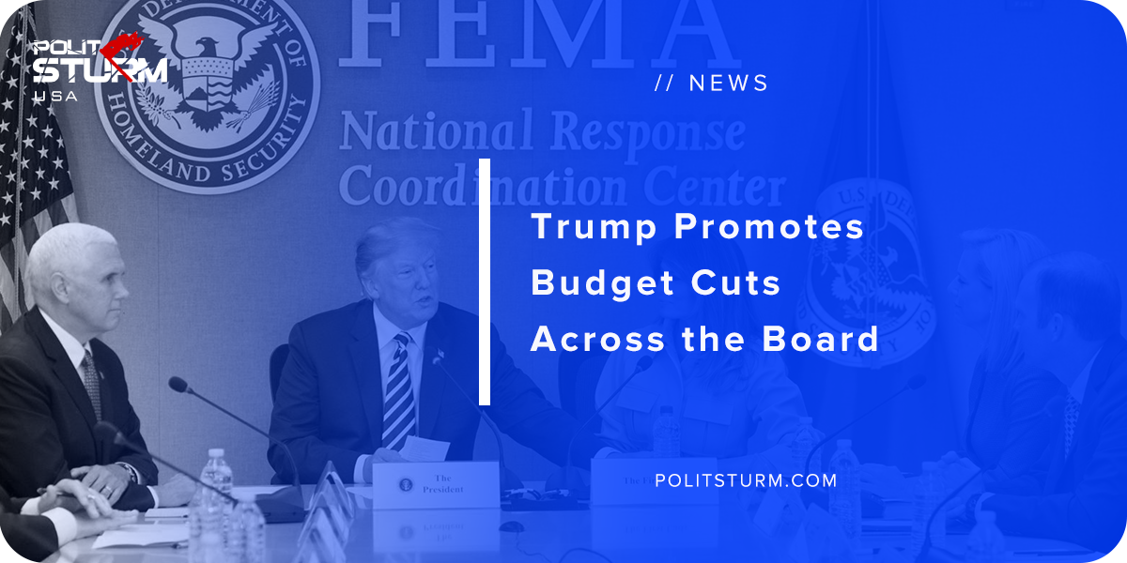

Original article
2018-10-23
1 min read

After passing a massive tax cut for the wealthy, the U.S Federal budget deficit has reached $779 billion for fiscal year 2018. As a result, Trump has asked each of the Cabinet secretaries to cut their budgets by 5%.
“It’s not as tough as you think, and frankly there’s a lot of fat in there,” Trump added while noting that “we had to get the military done last time.”
The military budget was $716 billion and was signed into law as part of a spending bill last August. Trump stated that this was necessary as an effort to “rebuild the military”.
The Trump administration has been bolstering U.S military spending and neither the Democrats nor the Republicans oppose the expansion of U.S imperialism. The tax cuts benefited the national bourgeoisie. The tax cuts have increased the deficit, and now the Republican “fiscal conservatives” are focusing on cutting entitlements such as Social Security, Medicare, and Medicaid.
This tactic is not coincidental and reflects the fact that the government serves the interests of the bourgeoisie, not the working class. Imperialism is not up for debate or discussion, but austerity for working class Americans clearly is.
Source

Original article

