Trump Extends Immigrant and Work Visa Limits
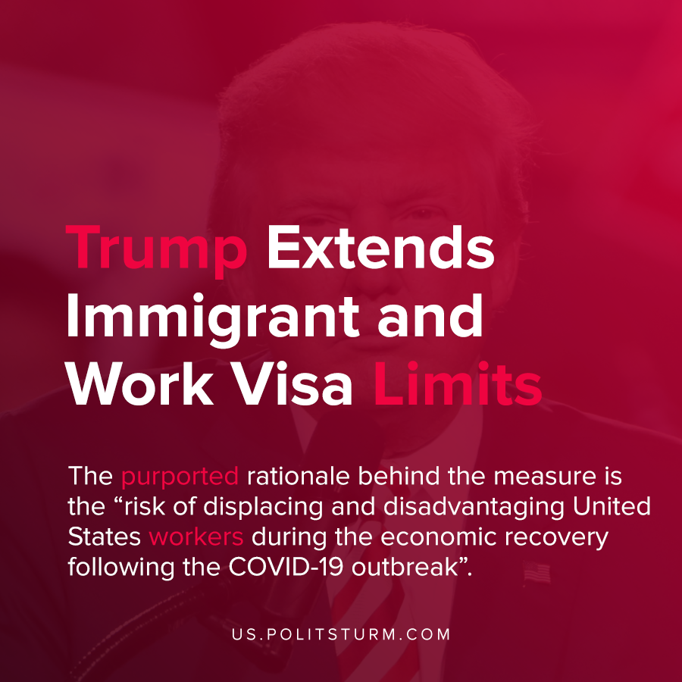

Original article
2021-01-02
1 min read

Donald Trump signed off on a proclamation that will suspend the entry of immigrants and non-immigrants into the United States until at least March 31, 2021.
The purported rationale behind the measure is the “risk of displacing and disadvantaging United States workers during the economic recovery following the COVID-19 outbreak”.
After the coronavirus pandemic and economic crisis, Trump barred entry of nonimmigrant visas through December 31, 2020. The current proclamation will serve as an extension to restrict new immigrants and temporary workers, barring certain exclusions.
Following the onset of the pandemic and economic crisis, the unemployment rate soared and millions of jobs have been lost as a consequence.
The Trump administration, under the guise of protecting American workers, is rather promoting and reinforcing the chauvinistic nationalism of his political base.
The problem of unemployment exists under the capitalist mode of production as labor is only demanded to the extent that is profitable for the capitalist class. The claim that the Trump administration supports the interests of unemployed Americans is categorically false. The Trump administration and all other bourgeois politicians support the interests of the oligarchs and merely use nationalism and pro-labor rhetoric as tools to further their class interests.
Source: 1

Original article

