Trump Was Found to Have Launched a CIA Propaganda Campaign Against China
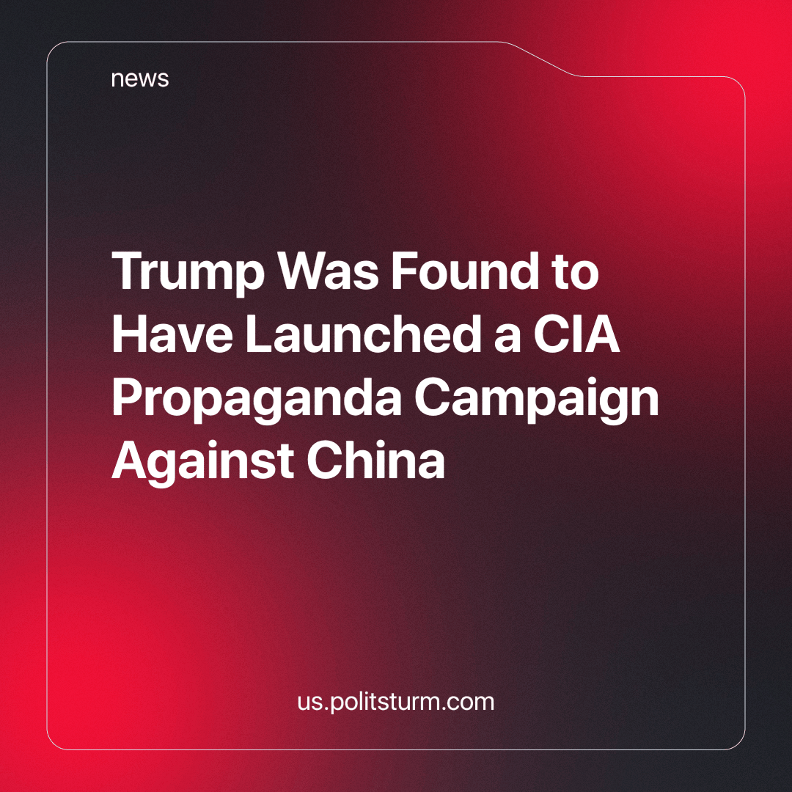

Original article
2024-03-24
2 min read

Former U.S. government officials revealed, under the directive of Donald Trump, the Central Intelligence Agency (CIA) assembled a task force to manipulate narratives of China and its government among other American foreign adversaries. The operation began in 2019 and was tasked with taking down the Chinese government's reputation by bashing its leadership and the Belt and Road initiative.
The spokesperson for the CIA declined to comment on this situation following the discovery of this task force. The spokesperson for China’s Ministry of Foreign Affairs, on the other hand, found this abuse of power as devious, demonstrating the U.S. government’s use of “public opinion space and media platforms as weapons to spread false information and manipulate international public opinion.”
Trump’s recently uncovered task force was part of a larger operation that had a string of recurring use of CIA agents against American foreign adversaries such as Russia and China dating back to 2018. The newest task force was uncovered having been influencing public perception in Africa, Southeast Pacific, and South Pacific against the larger perceived threat of China. Further details have not been disclosed by officials at this time.
The use of the CIA to manipulate foreign politics, historically has been and continues to be used as a tool of the U.S. Government to propagandize and manipulate foreign nations. It is not something exclusive to the US as an imperialist power, nor the modern day. Russia has a similar program to disseminate positive views about its so-called “Special Military Operation” called “Cyber Front Z” which we have previously written about. Additionally, this form of propaganda against competing imperialists was ubiquitous during the First World War.
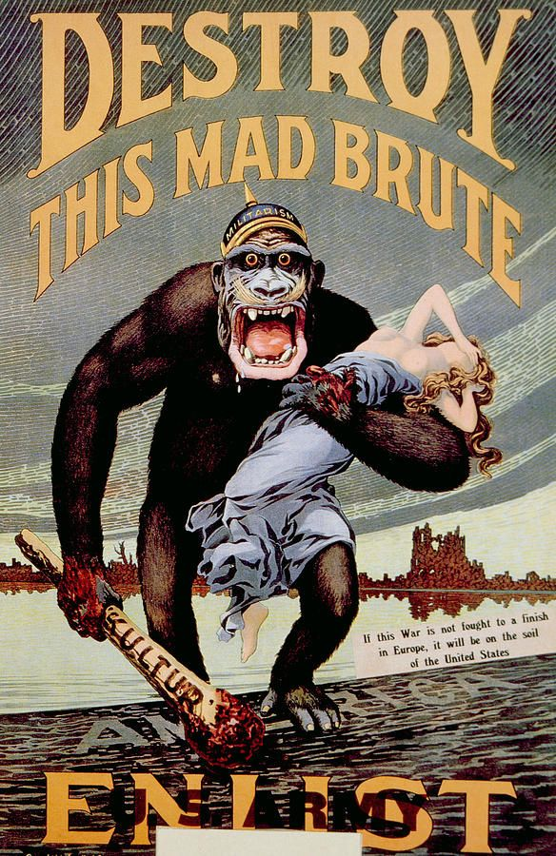
An example of WW1 era propaganda. While the content and methods of the propaganda have become more sophisticated over time, the essence remains the same.
The Report has set clear precedents by the U.S. for fearmongering and manipulation against China has set a clear message, The United States would do anything to undermine the new rising imperialist power. Chinese capitalists have recently been expanding their markets through the Belt and Road initiative. This initiative has created new markets favorable to the Chinese capitalists, creating a sphere against the current global imperialist hegemony of America. To combat the rise of a new power, the American state and capitalists set out a plan to disrupt or destroy this competing power, involving all means at their disposal, be it military provocation, sanctions and indeed propaganda and manipulation.
This leads to conflicts of great powers against one another, setting the stage for vast global manipulation campaigns. Thereby crushing the working class of the world in a war of lies and manipulation between the two great imperialist powers who seek nothing but to expand the profits of these projects of destruction. The conflicts between these rivals, do nothing but destroy the worker who is forced to both produce the means of military conquest and suffer from the destruction. The worker must not pick a side of the two imperialist parties, with which none of their interests align, but rather fight for their own independent interests.
Source:
https://www.reuters.com/world/us/trump-launched-cia-covert-influence-operation-against-china-2024-03-14/

Original article

