Trump Puts Pressure on Ukraine by Calling Zelenskyy a “Dictator”
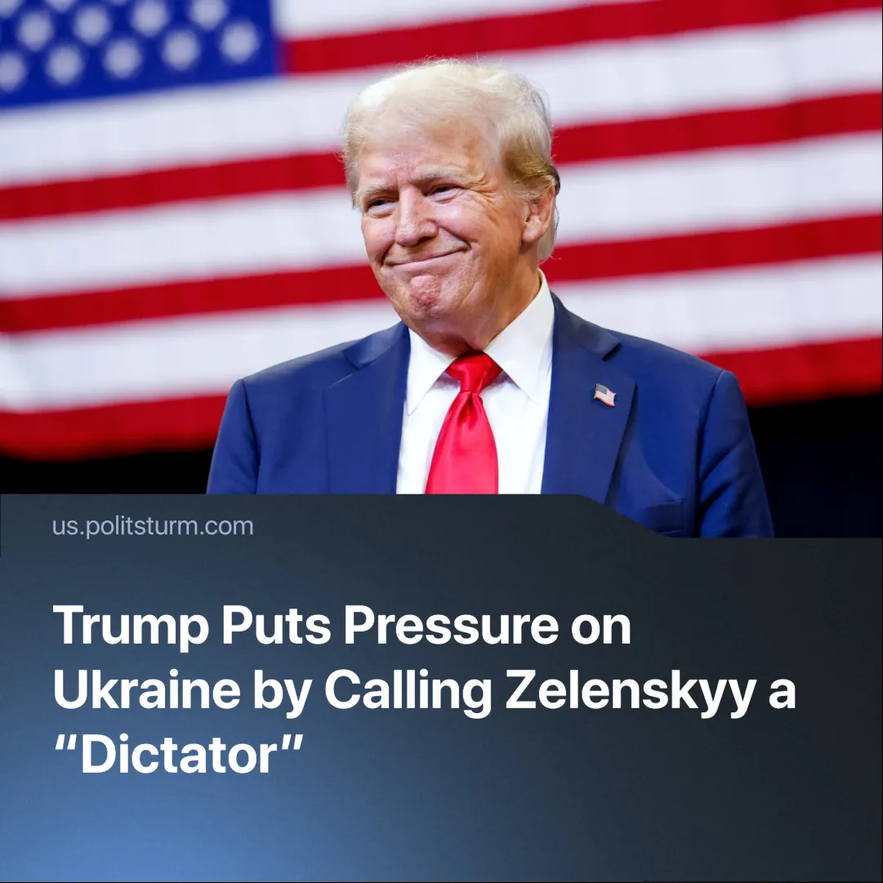

Original article
2025-02-23
2 min read

In an effort to pressure Ukraine into a peace deal favourable to U.S. interests, President Trump openly referred to Ukrainian leader Volodymyr Zelenskyy as a "dictator without elections."
Details. Since the 19th of February, U.S. President Donald Trump has begun to openly put pressure on Ukraine, both on social media and in press conferences.
► Trump initially posted on Truth Social: “A Dictator without Elections, Zelenskyy better move fast or he is not going to have a Country left,” in reference to Russia’s special military operation’s land captures.
► Zelenskyy claimed Donald Trump was “living in a disinformation space” fuelled by Russia.
► While addressing investors and executives in Miami, Trump doubled down on his remarks, again calling Zelenskyy a "dictator" and suggesting that the Ukrainian president was prolonging the war to "keep the gravy train going" — referring to U.S. military aid.
► U.S. Vice President JD Vance warned Zelenskyy against "badmouthing" Trump.
► Trump falsely claimed Zelenskyy’s approval rating was just 4%
Context. Tensions between U.S. and Ukrainian leadership emerged after the U.S. restored relations with Russia and excluded Ukraine from ceasefire negotiations.
► High-level negotiations regarding a ceasefire in Ukraine between US and Russian officials in Saudi Arabia proceeded without Ukraine’s involvement, reflecting a US policy shift favouring a deal with Moscow.
► Zelenskyy previously refused to sign a U.S. agreement on rare minerals—covering 50% of its mineral resources—citing the lack of security guarantees.
► Amid disagreements with the US, some EU leaders are trying to pursue a policy of supporting Ukraine’s military separately from the US. Still, talks concluded with agreements to increase domestic military spending.
Important to know. This open negative rhetoric toward a supposed “allied” leader marks a significant change in U.S. foreign policy.
► It is the first time the U.S. has taken an openly hostile position toward Ukrainian leadership since the conflict began.
► Trump has previously emphasized that both sides should make concessions. Regarding Ukraine's pre-2014 borders, he stated, "Some of that land will come back," implying that concessions should include reversing Russian gains. In response to Zelenskyy’s pushback against ceding land to Russia, Trump has intensified his pressure.
► Zelenskyy’s term expired on May 20, 2024, but due to martial law, elections have been postponed. Despite this, his popularity is declining — currently, his trust rating stands at 57%, a significant drop from the 90% approval rating at the start of the conflict.
► Additionally, when martial law was declared, television news was nationalized and "pro-Russian" opposition parties were banned.
► Given the recent thaw in U.S.-Russian relations, Trump might be inclined to support a pro-Russian candidate in future Ukrainian elections—one who could "fairly" divide resources between Russian and American capitalist interests and their Ukrainian representatives.
Conclusion. As the U.S. reorients its foreign policy to an "America First" agenda, the nature of imperialist "alliances" and "rivalries" is revealed. Namely, they are based solely on a policy of profitability. The U.S. wants to restore its former hegemonic position and is willing to use both economic and rhetorical pressure to secure what is favourable to its imperialist interests.

Original article

