Trump Denies USSR and Western Allies' Contribution to Victory in World War II
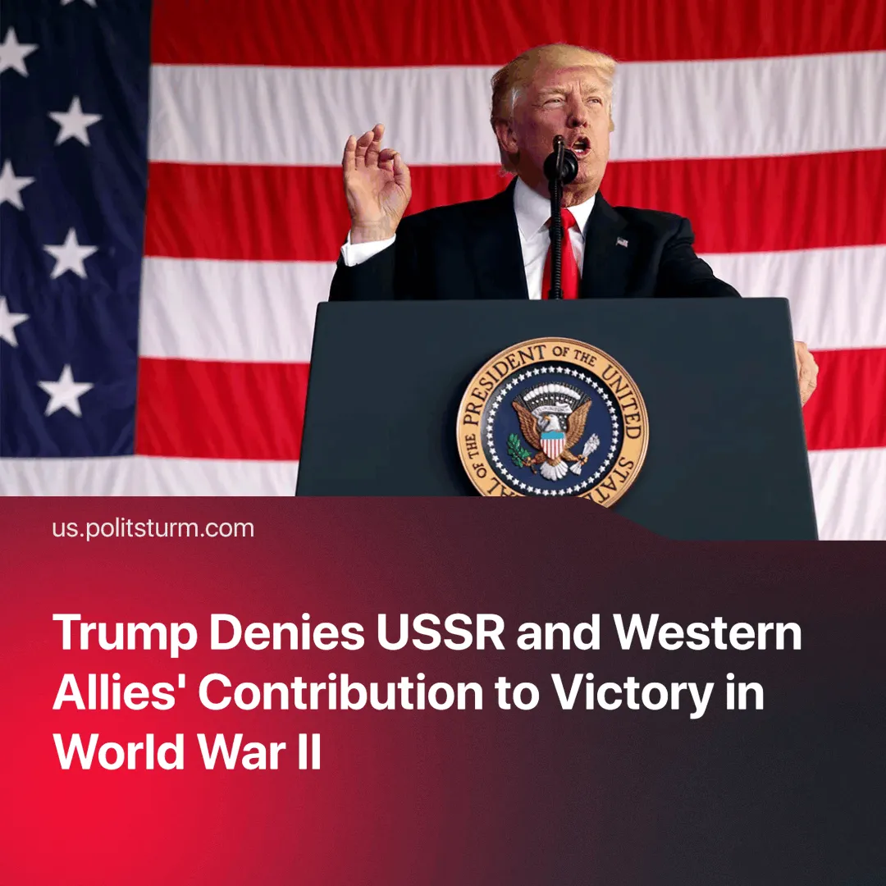

Original article
2025-05-07
1 min read

Trump believes that the US did "the most" to win WWII. The facts contradict him.
On May 2, 2025, President Donald Trump posted on Truth Social that the United States would officially recognise May 8 as "Victory Day" to commemorate the Allied victory in Europe during World War II. He asserted that the U.S. played the most significant role in defeating Nazi Germany, stating,
Quote: “We did more than any other Country, by far, in producing a victorious result in World War II… We won both Wars, nobody was close to us in terms of strength, bravery, or military brilliance”
Context. Trump's statement is aimed primarily at a domestic audience and is an example of cheap pro-patriotic propaganda that promotes exaggerated narratives of ‘U.S. supremacy’.
In reality, it was the Soviet Union that bore the heaviest burden in the defeat of Nazi Germany.
► Soviet forces faced the most intense combat of the war, sustaining approximately 11.4 million military deaths — far exceeding the 400,000 total U.S. casualties, only 250,000 of which occurred in the European theatre.
► U.S. Lend-Lease aid made up only 5–10% of Soviet supplies and arrived largely after the turning point at Stalingrad in 1943, when the Red Army had already begun pushing west.
► The Soviet Union inflicted an estimated 76% of total German military losses during the war, and it was the Red Army that ultimately captured Berlin in May 1945, delivering the decisive blow that ended the war in Europe.
► The United States aided the USSR, primarily through Lend-Lease, and bore the brunt of the fighting in several theatres of war. However, these efforts cannot be considered more decisive than the Soviet Union's contribution.

Original article

