Trump Bans Investment In Military-Linked Chinese Companies
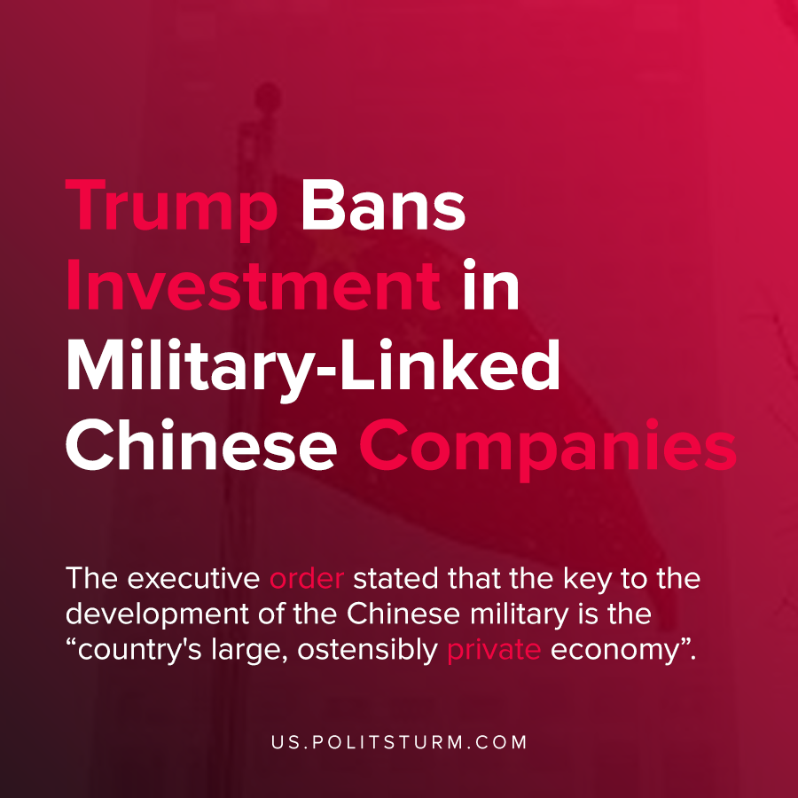

Original article
2020-11-28
1 min read

Outgoing U.S. president Donald Trump has taken another executive action directed at Chinese companies and the government in light of an ongoing trade war.
Donald Trump signed an executive order that is aimed at limiting U.S. investment in Chinese companies that are associated with the Chinese military. Trump declared a national emergency and stated that the People’s Republic of China (PRC) was “exploiting United States capital…to enable the development and modernization of its military”.
The executive order stated that the key to the development of the Chinese military is the “country’s large, ostensibly private economy”. It is further stated that the Chinese government compels these private enterprises to support the development of the military.
The order goes on to prohibit investment by any U.S. person into a list of companies that were identified, including Huawei.
The intent of the executive order was to limit the flow of finance capital to companies who support Chinese military operations from the U.S. capital markets and private investment.
Trump is therefore attempting to limit the access to capital for Chinese enterprises under the auspices of protecting national security. In reality, uneven capitalist development has caused the flow of finance capital to invest in Chinese enterprises in search of the maximum profit, which has led to capitalist development in China.
The deindustrialization of the U.S economy was the logical long-term implication of this development.
While the order can potentially be reversed by the Biden administration and only targets certain companies, the order directly reveals the imperialist nature as the U.S. capitalists target the economic and military development of the PRC.
The Trump administration demagogically claims to support the American working class but rather is solely the representative of the American bourgeois class. As such, the goal for the U.S. capitalists is the continued exploitation of the Chinese workers while limiting the economic and military development.
The solutions to the contradictions presented by uneven capitalist development can only lie through the public ownership over the means of production and the dictatorship of the proletariat.
Source: 1

Original article

