Trump Administration Eviction Guidance Favors Landlords
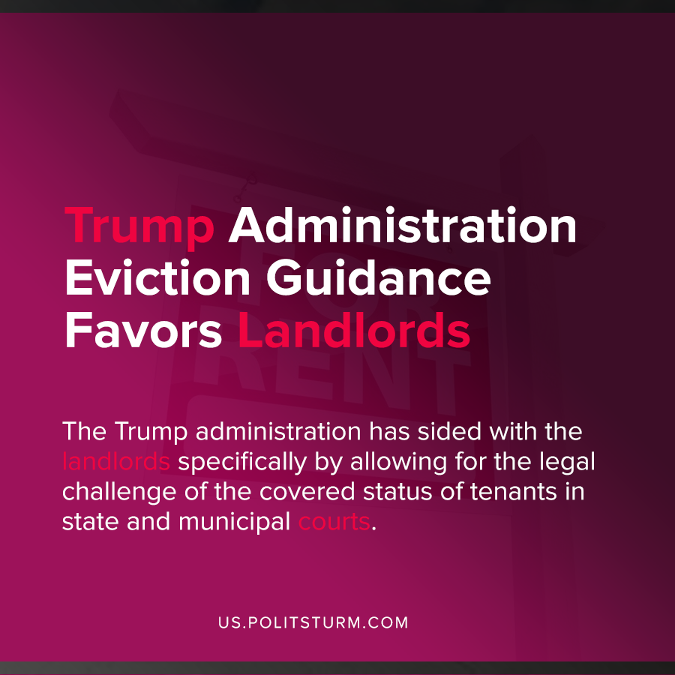

Original article
2020-10-22
1 min read

The Trump Administration CDC issued new guidance on October 9,2020 which favors landlords over tenants. The CDC order temporarily protects “covered” tenants from residential evictions for the nonpayment of rent during the period of September 4, 2020 to December 31, 2020.
In order to be protected from eviction, tenants must have a signed declaration under threat of perjury to several terms, not limited to seeking government assistance and making partial rent payments.
Tenants who are covered still owe back-rent to the landlord during this period, and potentially fees, interest, and penalties assessed by the landlord.
The Trump administration has sided with the landlords specifically by allowing for the legal challenge of the covered status of tenants in state and municipal courts. This potential threat of legal proceedings will put the task of gathering evidence on tenants to prove they are covered, and will increase pressure on tenants to vacate the premises.
The bourgeois government serves as a mechanism through which the dominant classes in society, namely the capitalists and landlords, can suppress the mass of workers and the unemployed. Unless additional actions are taken, landlords will be able to resume evictions in 2021 which will increase homelessness and further exacerbate the crisis.
Only a socialist government which represents the class interests of the workers will be able to end the scourge of homelessness and poverty and end the class dictatorship of the capitalists and landlords.
Sources: 1 , 2

Original article

