Trade wars push the world toward violent redivision
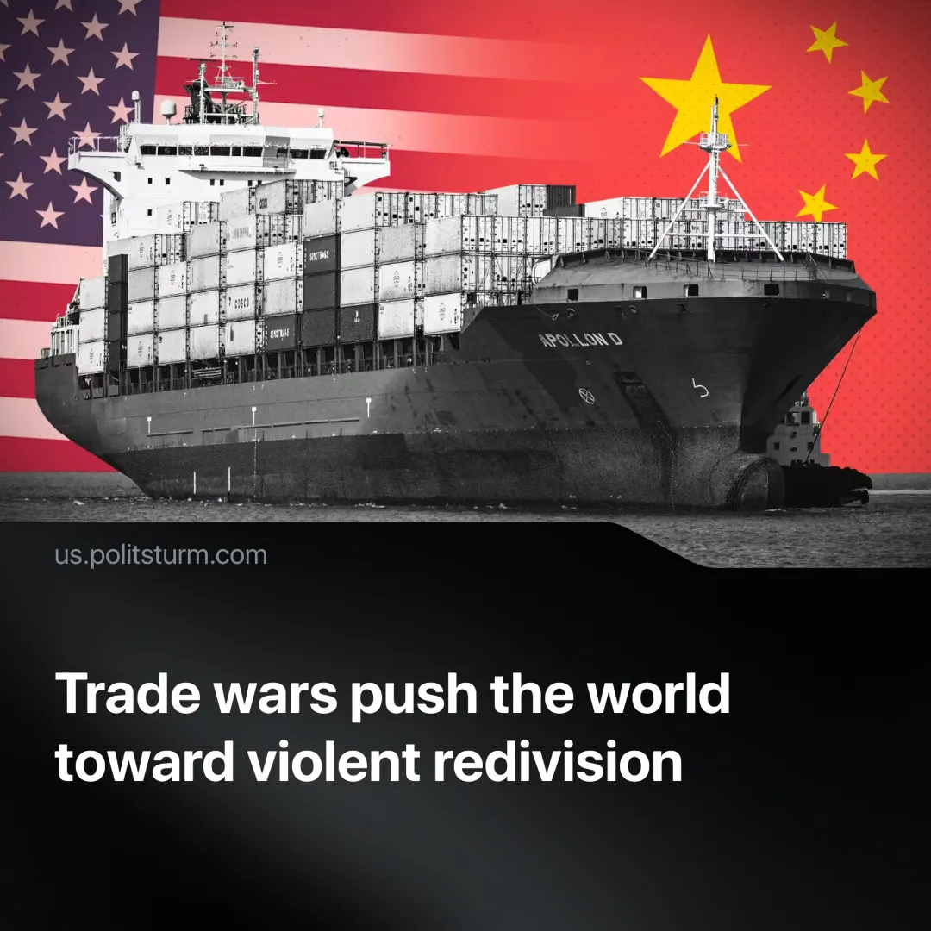

Original article
2025-04-17
2 min read

Trump’s tariffs expose the instability of the imperialist system. What began as “trade disputes” has escalated into open economic warfare between the U.S., China, and other powers, signalling a new phase in inter-imperialist rivalry and protectionist trade.
Details. Following Trump’s tariffs on nearly every country, the U.S. and China have erupted into a trade war, exchanging retaliatory measures.
► After Trump raised tariffs on Chinese imports to 145%, China responded with 125% tariffs on U.S. goods, targeting key exports such as soybeans, automobiles, and electronics.
► Simultaneously, the U.S. announced a “pause” on further hikes. This meant a 90-day 10% baseline tariff on all countries (excluding China), giving nations a chance to negotiate with the administration.
► Other countries are preparing for potential U.S. tariffs and have announced they will retaliate with their own tariffs if necessary.
► China has imposed export licensing on rare earth minerals and other critical materials. Effectively halting critical exports to every nation.
Context. The U.S. is justifying tariffs as a way to fix trade imbalances, revive domestic industry, and protect national sovereignty. China, meanwhile, is countering these moves while managing its internal economic difficulties.
► Canada and Mexico have likely been used as examples for other nations to follow—both were previously threatened with tariffs but are now exempt from the 10% base tariff due to their willingness to negotiate and align with U.S. demands.
► Chinese President Xi Jinping is touring Southeast Asia, urging nations to join China in resisting U.S. “unilateral bullying” and embrace “free trade.”
► China is facing slow growth, weak domestic consumption, declining import demand, and an overreliance on export-driven production, maintaining its role as the capitalist “workshop of the world.”
► Rare earth minerals, vital for weapons, vehicles, and electronics, are dominated by China, which produces 90% of the global supply. U.S. interest in Greenland and resource access in Ukraine reflects growing concern over this strategic dependence.
Important to Know. These trade conflicts reflect a deepening crisis of capitalism, driven by overproduction and shrinking markets. Trump’s trade war is fundamentally a bid to re-industrialise the U.S., subordinate allies, and destabilise China.
► The crisis of overproduction is intensifying, especially in China, where now blocked exports will force a scramble for new markets. If U.S. tariffs succeed in limiting Chinese exports, the resulting shock will ripple through the global supply chain, accelerating worldwide economic instability.
► The U.S. is demanding submission through coercive tariffs, attempting to push weaker nations into dependency, while subordinating stronger rivals into economic vassals. At the same time, it is using economic pressure to force production back home, rebuild key industries like electronics, shipbuilding, and machinery, and massively increase military spending in preparation for direct conflict.
► Trade wars are giving way to open militarisation, as each bloc positions for the violent redivision of the world. As U.S.-China ties fracture, Beijing may move on Taiwan—once unthinkable under trade interdependence—while Washington pushes a Ukraine ceasefire to secure mineral access and escalates pressure on Denmark over Greenland’s Arctic resources. These moves echo past world war preludes: encirclement, rearmament, and imperialist blocs preparing for violent conflict.
Conclusion. The peaceful “end of history” is over. The deepening crisis of imperialism reveals the objective needs of capital: expansion, war, and the violent redistribution of markets. As economic instability and military confrontation loom, capitalist classes in every country are forming regional blocs to defend their profits, as Marxism-Leninism has predicted. Unless the working class organises independently along class lines—free from all imperialist camps—it will pay the price through austerity, war, and repression.

Original article

