Toys "R" Us bankruptcy: 31 000 workers will be fired
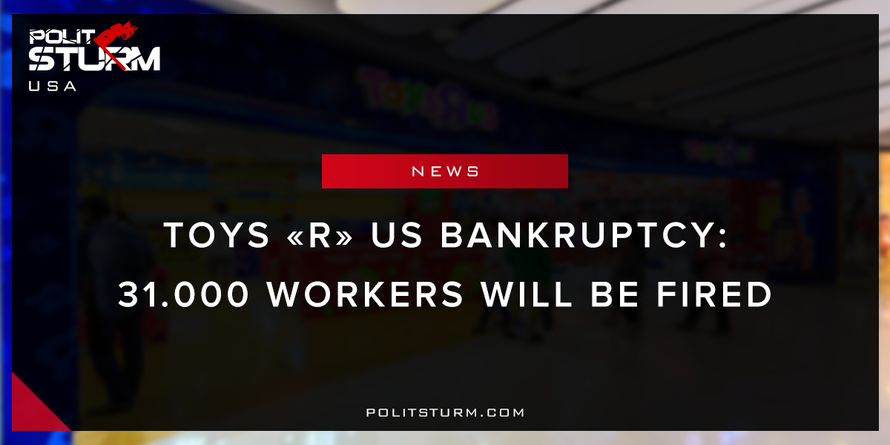

Original article
2018-03-25
1 min read

As the major toy retailer prepares to liquidate its inventories and wind down operations workers will have to adapt to the implications of Chapter 11 bankruptcy. Stores across the country will be closing down which means that approximately 31,000 employees will be laid off as a result. Due to U.S bankruptcy laws employees are not going to be receiving a severance package and will only be receiving wages and certain benefits for the next two months. Many of these workers will be forced to look for new employment as bankruptcy proceedings seek to protect affected investor firms Bain Capital, KKR and Vornado and not the interests of the working class.Under capitalism employment is always precarious for the working class as only the interests of the oligarchs are legally protected.
As long as the capitalist economic system exists, workers will continue to be at the mercy of their employers and investors. Toys R US was acquired by Bain Capital, KKR and Vornado back in 2005 as part of a leveraged buyout. These companies have collected over $470 million in fees over this period due to their ownership stake in the company. These investment firms were able to extract the value produced by the workers. Now faced with increased competition from retailers Amazon and WalMart, management has decided to file bankruptcy to protect investors interests. Tens of thousands of workers will be put into a precarious position all to protect the interests of a small group of capitalists.

Original article

