Kazakhstan's Tokayev Proposes Tax Increase for Commodity Exporters
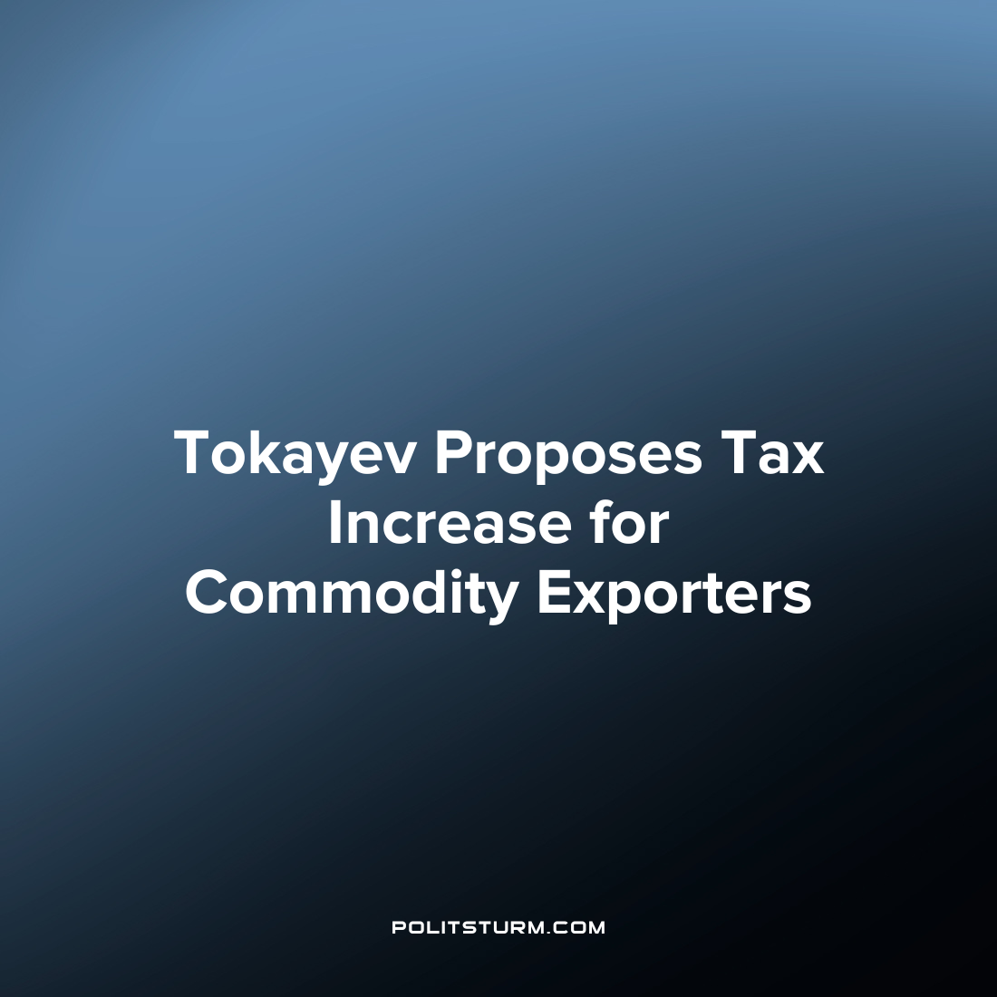

Original article
2023-04-25
1 min read

Kazakhstan's President Kassym-Jomart Tokayev speaking to the new parliament, said that companies exporting raw materials from Kazakhstan should pay more taxes to the budget.
“This practice has long and successfully proven itself in the world. And this is fair” said the president .
Tokayev also proposed to differentiate rates for corporate income tax (CIT) and value added tax (VAT). According to him these payments "form the lion's share of the state budget."
"The model of the new tax policy as a whole is aimed at "the optimal distribution of national wealth", precise support for priority sectors of the economy and a high level of economic activity" Tokayev stated.
According to the president, the tax code and tax policy of the country should be “understandable and stable”, and the process of interaction between business and tax authorities should be digitized. This will ensure the growth of tax revenues to the budget and make life easier for entrepreneurs.
It may seem that we “finally came”, because in theory, raw material exporters will pay more to the budget according to the new plan and more money will be spent on citizens by the state. However, rejoicing ahead of time is not worth it. So far, this proposal has only been voiced, but has not yet been adopted. In addition, it is unlikely that this money will go to those in need in the form of social programs. Most likely, some of them will be received by other representatives of the oligarchic clan in the form of subsidies, while the rest will be extended by officials for personal enrichment.
The common worker will be left with only an illusory joy, from the fact that they will start “shaking more money” from the oligarchs, however, this will not please everyone. After all, the oligarchs, who are forced to give away more money, will gladly make up for their losses by increasing the burden on workers and reducing their wages.
Source: RBC - “Tokayev proposed to raise taxes for a large commodity business” from March 28, 2023

Original article

