Thousands March in Far-Right Protest in London
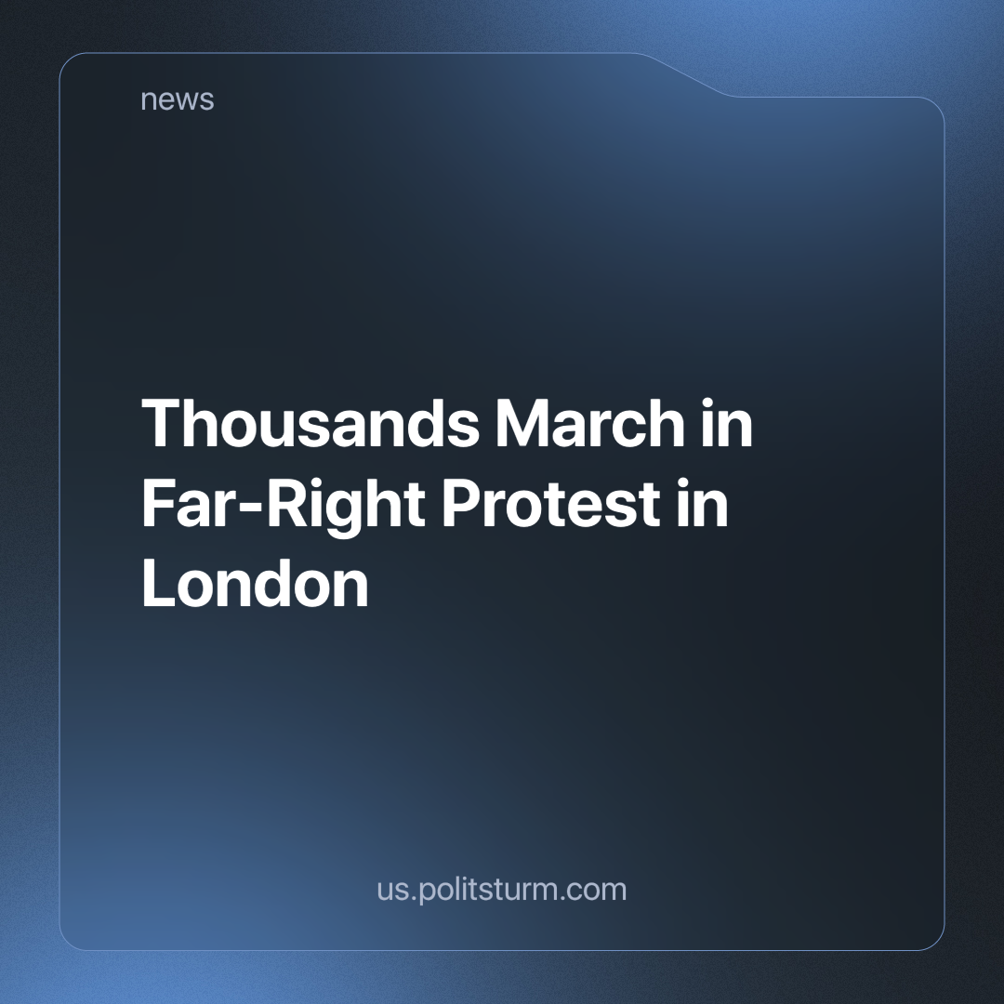

Original article
2024-06-14
2 min read

A far-right protest was organised on 1 June 2024, called by Tommy Robinson, whose real name is Stephen Yaxley-Lennon, a high-profile figurehead of the right and founder of the Islamophobic group English Defence League (EDL). Estimates vary on the size of the march from 5,000 to tens of thousands.
The protesters marched from Victoria Station to Parliament Square in central London, where two arrests were made. More than 2,000 police officers were deployed at the protest, and police said they had identified several people in the crowd who had a 'history of violent disorder'.
Protesters chanted and called for the resignation of Met Police Commissioner Mark Rowley. Tommy posted on social media site X that:
Unsupported element
He also said the protest was about 'celebrating our culture and values', while Urban Scoop, his 'independent journalism' website, said it would be a 'brilliant and peaceful pro-British event'. However, the true nature of the event could be seen with signs that read 'This is London, not Londonistan' next to the face of British-born Muslim London Mayor Sadiq Khan. The event also featured anti-vaccination, far-right and Islamophobic conspiracy theories. Furthermore, Tommy is an outspoken Zionist and supporter of Israel's war.
A separate counter-protest was organised by pro-Palestinian activists, with around 300 people in attendance and nine people arrested for leaving the pavement. Tommy's loud and bombastic statements about 'two-tier policing' appear to be true but for the other side. The pro-Palestinian demonstrators were disproportionately arrested compared to the far-right, chauvinist sloganeering protesters.
At the moment there is majority popular support for an end to the genocidal war in Palestine [1]. These protests will inevitably fizzle out, having achieved nothing or very little without a leading revolutionary party able to organise the working class. This has been the case with other spontaneous mass protests such as the Black Lives Matter movement. We have written in detail about this before.
While Tommy's march may not have been as large as some of the pro-Palestinian marches, it is still a symptom of the difficult times ordinary people are going through, as well as the increasing reaction by the capitalists, and it serves as an attempt to divert British workers' frustration at their growing immiseration towards Muslim immigrants or other easy targets. The right's ability to stay organised and never fade away is also no surprise, as Tommy receives financial support from US billionaires and think tanks [3] who benefit from distracting workers from the real sources of their problems, and instead sowing the seeds of division and hate between them.
With the recent European elections showing an increase in the strength of the far-right [4], it signals that the capitalist system not just in Britain but across Europe is failing to maintain the worker's living standards and is entering a crisis. The far-right will serve as a tool of the capitalists to enforce reaction and nullify revolutionary sentiment. The "left wing" of the capitalist class will never be able to defeat the right (nor does it intend to) because the capitalist system inevitably leads to recurrent crises. Instead, they are two wings of the same beast, a beast with an unquenchable hunger for the value created by labour. Only a genuinely communist party can organise the working class and oppressed people to break this cycle and end exploitation, crises and unnecessary wars for good, by establishing socialism and ending class distinctions.
Sources: 1,2,3,4

Original article

