The War of Spartacus
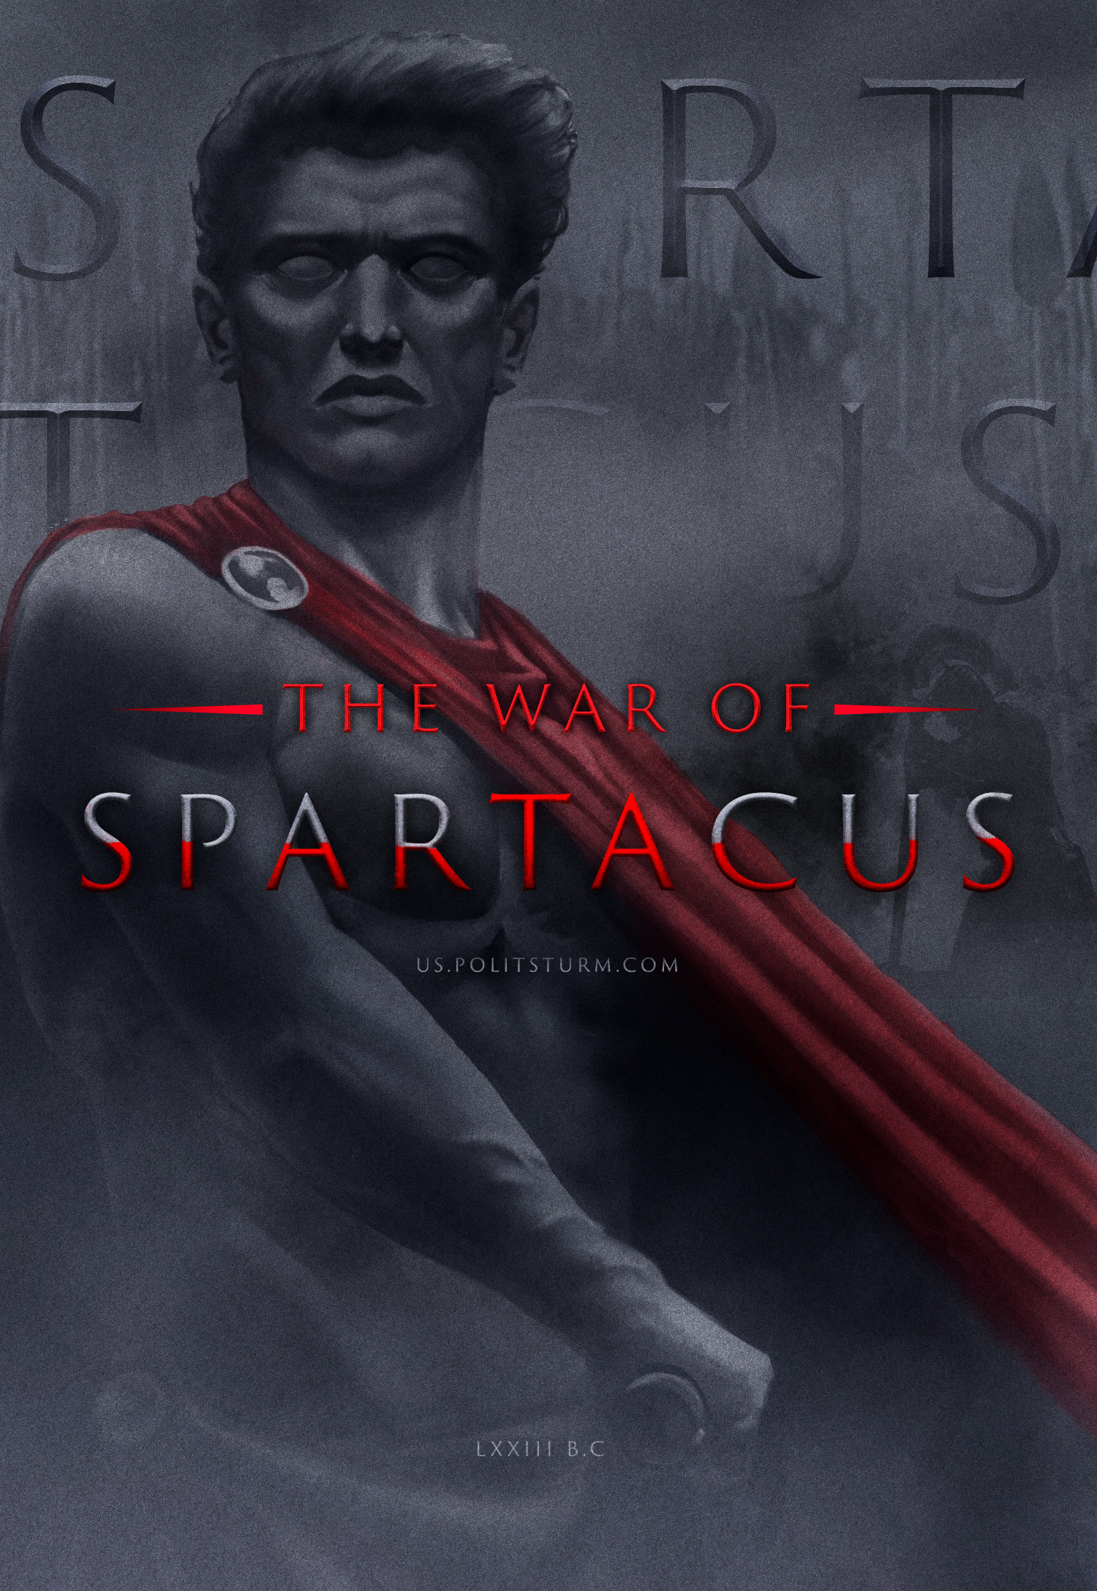

Original article
2022-10-13
14 min read

More than 2000 years ago a slave revolt led by Spartacus broke out on the Italian peninsula. The army of thousands of former slaves gripped Rome with fear and threatened to put an end to its undivided rule of the Mediterranean. Although many centuries have passed, the memory of the hero and leader Spartacus, like a phoenix, resurfaced during the Great French Revolution. He remains a symbol of resistance up to this day.
Spartacus still continues to excite historians and inspire artists. Spartacus was a legendary figure, books were written and films were made in his honour. Today, however, the bourgeoisie seeks to distort the image of this fighter for liberation in every way. In particular, in the recent TV series “Spartacus: Blood and Sand”, which sterilises the uprising of its class essence while, at the same time, displays an abundance of scenes featuring cruelty and erotica.
As early as the beginning of the twentieth century, Lenin described Spartacus in the following terms:
“Spartacus was one of the most prominent heroes of one of the greatest revolts of slaves some two thousand years ago. For a number of years the seemingly all-powerful Roman Empire, based entirely on slavery, was shaken and battered by a huge uprising of slaves who armed themselves and gathered under the leadership of Spartacus, forming a huge army “[1].
Why does the image of Spartacus continue to serve as an example to millions of oppressed people in their struggle for liberation? What caused the uprising and why was it defeated? To answer these questions it is necessary to dive into the past and examine the historical era from the perspective of historical materialism.

Historical era
Ancient Rome, as one of the most advanced civilizations of the Ancient World, experienced several eras in its history. The reign of the monarchy was succeeded by the republic, which in turn was later succeeded by the empire. Spartacus’ rebellion took place in the late period of republican rule, where the contradictions inherent in the slaveholding mode of production were beginning to become more acute.
The slave system was based on the antagonism of two opposing classes, the slave-owners and the slaves as the main productive force. The Roman Republic was the most powerful state built on slave labour.
The patricians and slave-owners had full ownership not only of the means of production, but also of the slaves themselves. The slave was not a member of society, had few rights and belonged entirely to his master. The master had the right to sell their slave, kill them, or purchase a new one. Slaves hated the labour they were forced to do and consequently had no interest in it. The master appropriated not only all the surplus product, but also part of the necessary product that the slave produced, leaving him with less than the bare minimum to subsist and continue his work. Enriching themselves at the expense of the slaves, the ruling class spent the value they appropriated to build palaces and temples, to maintain their luxurious lives and to equip and feed their army to seize new lands and new slaves.
In “Wage Labour and Capital“, Marx wrote:
“The slave did not sell his labour-power to the slave-owner, any more than the ox sells his labour to the farmer. The slave, together with his labour-power, was sold to his owner once for all. He is a commodity that can pass from the hand of one owner to that of another“[2].
The Roman scholar, writer and contemporary of those events, Marcus Terentius Barron, spoke of the tools used to cultivate the fields and divided them into three types: speaking tools – slaves; unintelligible tools – oxen; dumb tools – carts [3].
Of course, slaves were involved with different kinds of work, depending on the whims of their masters. Some of them became actors, artists, philosophers and even small businessmen, i.e. peculia. These slaves undoubtedly had a more privileged position than that of a slave on a building site, a farm or a latifundium. However, it was the latter group of slaves that created the surplus product, thereby enriching their masters.
Despite the position of the Roman state and its capital in particular as a metropolis, where all the resources extracted from the conquered colonies were gathered, production relations gradually came into conflict with the productive forces, as slave labour gradually became economically unprofitable.
The formation of latifundia and the concentration of land in the hands of the richest families required a constant influx of labour. To replenish it, bloody wars were fought in which entire peoples were enslaved.
In such a situation the free peasants and artisans could not stand the competition and were forced to enter into the debt bondage of the usurers. Unable to repay their debts, these once free people joined the ranks of slaves.
Endless military campaigns in outlying territories kept soldiers away from home for long periods which hindered farming. In Italy itself, war broke out between Rome and the subject tribes (Italics, Samnites, Latins and others) who attempted to liberate themselves from Roman oppression. Allied wars for recognition of the rights of Italian citizens grew into civil wars. The power struggles in the Senate heated up as many Senators believe that Rome needed a dictator with a strong hand to impose order.
Riots broke out on the farms. Slaves ran away and tampered with and sabotaged property and in some cases even murdered their masters. Prior to the great uprising of Spartacus, history knows of two Sicilian uprisings that resulted in the island being occupied by rebel slave leaders who called themselves kings of the new state. But they both ended the same way: The well organised Roman army was dispatched to forcibly regain control of the island, and the new kings were thrown into prison.
This crisis and strife did not prevent those in power from enjoying a life of leisure. One such Roman pastime was the gladiatorial fights, which were bloody duels fought between slaves who were known as gladiators. These fighters entered open-air arenas and fought a struggle to the death for the amusement of rich nobles and free citizens.
Spartacus, a Thracian, was one such fighter.

Spartacus and the beginning of the rebellion
Little information has survived about Spartacus to this day. It is not known where he was born or how he died. The most likely version is that Spartacus was born a free man in Thrace – which is now part of modern Bulgaria.
The Roman state attacked the Thracian state in order to gain more manpower and Spartacus was one of many taken prisoner. Due to his knowledge and skills he was enlisted in the auxiliary units of the Roman army. There he meticulously learnt the military tactics of the Romans. Spartacus later deserted the Roman army and joined his countrymen, but he was later captured and sold to a gladiatorial school in Capua, owned by the teacher Lentulus Batiatus.
There, Spartacus quickly gained recognition amongst his comrades due to his character, outstanding physical strength and proficient handling of weapons. Spartacus’s charisma and tactical skills enabled him to unite the other gladiators and prepare an escape from the school.
It appeared as if the gladiators’ plot was foiled, when only seventy of the two hundred fighters managed to escape. In 74 BC, or – according to some reports – in 73 BC, this band of gladiators escaped first from the school and then from the city of Capua. To rest and regain their strength, the group fortified themselves on the heights of the dormant volcano Vesuvius.
At first, Rome took the rebellion fairly
lightly and sent a force of three thousand led by Gaius Clodius Glaber. He occupied all the approaches to Vesuvius in order to starve the fugitives, but Spartacus’s detachment, descended using vines like ropes and came in from the rear and defeated the unprepared Glaber’s detachment [4].
Spartacus’s name then echoed across Italy. Inspired by this example, slaves rebelled against their masters on the estates all across the republic and began to flock to Spartacus. In addition to the slaves, many free people of southern Italy – especially the impoverished small farmers – began to join Spartacus. Spartacus’s rebellion was no longer just a slave rebellion. It had become an uprising of all the oppressed!
Spartacus’ army became swollen with many of these runaway slaves and impoverished farmers. By early 73 BC their number had risen to 10,000. Spartacus himself commanded the army, assisted in his leadership by his closest associates: Oenomaus and Crixus.
Former service in the Roman army helped Spartacus organize his army along the same lines. The camp had a clear chain of command and the strictest discipline. Commanders appointed by Spartacus himself from a pool of the most experienced soldiers.
The next victories were not long in coming. Publius Varinius was defeated in two battles. By 72 BC the army of Spartacus already numbered around 120 thousand with some estimates has high as 200 thousand men and women[4]. Realizing that fighting Rome on its own territory was an excersise in futility, Spartacus decided to take his fighters into territories not yet conquered by Rome, i.e. beyond the Alps. Thus Spartacus wanted to give the Gauls, Germans, Thracians and other peoples who made up his army a chance to return to their homelands.
Such events began to worry the Senate in no uncertain terms. A local rebellion was escalating into a real civil war.

Putting down a rebellion
However, no army made up of slaves and ruined smallholders, could remain disciplined for long.
According to the research of the Soviet historian A. V. Mishulin, disagreements began because of social contradictions within the army. While Spartacus’ detachment of the army consisted of slaves and wanted to free themselves from the oppression of their masters, Crixus’ detachment consisted mainly of free ruined farmers from southern Italy, who wanted their lost property back [5].
The Roman Senate at this time assembles two armies led by commanders Lentulus and Gellius. Crixus’s detachment splintered off from the main army and was defeated by Gellius’s forces at Mount Garganus. In this battle Crixus himself was killed. Despite this loss, Spartacus’s army launched a counter-attack and defeated the consuls one by one, taking advantage of their disunity. In response, the Senate began to assemble a new army led by the experienced and brutal general – Marcus Crassus, one of the richest men in Rome.
The rebel slaves had the opportuninity to cross the Alps and settle in Gaul and Germany as free men and women, but for reasons unknown, the army turned around and headed south. According to one version, the slave army wanted to spark a revolt on the island of Sicily; according to another, they wanted to capture the city of Rome itself.
After a while, Spartacus’ army clashed with Crassus’ army. According to Roman historians, Spartacus died heroically in the battle, in an attempt to get close to Crassus himself, killing two Roman centurions on his way. Deprived of their leader, his army was defeated. Spartacus’ body was never found and those who were captured were crucified along the Appian Way. Scattered groups of surviving rebels were still active in parts of Italy for some time, but these too were soon crushed.
The uprising, which lasted practically three years, shook the whole world and the slave system that existed at the time. These events hastened the transition of the Roman state from the republican to the imperial form of government, as the most reactionary form of government.
The form of exploitation also changed later. The maintenance of large latifundia, based on slave labour, were no longer economically profitable. The large estates were thus broken up into smaller ones and transferred to former slaves or free citizens under certain conditions. The new toilers of the estates were attached to the land and could be sold with it. This was an intermediate step between free people and slaves, as they now had some self-interest in their labour, which marked the beginning of the feudal mode of production [6].

Conclusion
As exploitation and wars of conquest intensified, the contradictions in Roman society increased. The lack of interest in labour, and the prospects of a lifetime of brutal servitude, encouraged slaves to flee, deface property and even kill their masters. According to the dialectical law of the transition of quantity into quality, this struggle was transformed into a large-scale revolt against the ruling class, which was Spartacus.
The Spartacus uprising was not a fortuitous coincidence, but a logical result of the insoluble contradictions in society and was the culmination of the class struggle in its scope and significance.
Subsequent generations can appreciate Spartacus’ organisational and tactical talents: his courage, dedication to the cause of liberation, courage and ability to unite and rally the oppressed masses.
However, even at the height of its power, Spartacus’ army was not a force that indended to destroy exploitation and build a more just society. Because of their lack of consciousness, organisation and spontaneity, which had as its source only a thirst for revenge, Spartacus’ slaves were not capable of changing society.
Lenin wrote: “Slaves, as we know, have rebelled, staged revolts, opened civil wars, but have never been able to create a conscious majority, guiding the struggles of parties, unable to clearly understand the goal they are heading towards…” [7].
Along with the slave revolts, the struggle of the peasants against their masters also took place, but the peasantry at this stage of historical development did not raise the question of abolishing the slave-owning relations. The two centres of struggle against
domination could not merge into a single fist because of ideological and class differences
[8]. The defeat of the Spartacus rebellion shows that the shackles of the slave-holding system were not yet so weak that they could be broken.
Unlike the revolutionary class of Antiquity, the modern proletariat has weapons in the form of the scientific theory of Marxism-Leninism. Today’s revolutionary class does not act blindly, but with full awareness of social laws, a materialist understanding of history and the tactics of struggle.
The British Marxist Maurice Cornforth, in his work Dialectical Materialism, wrote: “A passive slave is simply a slave, but a rebellious slave acts as a free man, even though he still wears chains. Such people are the pioneers of human freedom.”[9]
References:
- V. I. Lenin. Complete Works. V. 39. Moscow: Politizdat, 1970. p. 77
- K. Marx. Wage Labour and Capital. Geneva: Socialist Library Press, 1894. p. 20
- USSR Academy of Sciences. Institute of History. Leningrad department. Varron Marcus Terentius. Moscow-Leningrad: Academy of Sciences of the USSR. 1963. p. 19
- E. M. Staermann. The flowering of slave-owning relations in the Roman Republic. Moscow: Nauka Publishing House, 1964. p. 239
- A.V. Mishulin. The Spartacist Uprising. Moscow: State Socio-Economic Publishing House, 1936. p. 138 – 139.
- K. V. Ostrovitianov. Political Economy. Moscow: State Publishing House of Political Literature, 1954. Chapter 2, p. 34.
- V. I. Lenin. Complete Works. V. 39. Moscow: Politizdat, 1970. p. 82
- A.V. Mishulin. The Spartacus Uprising. Moscow: State Socio-Economic Publishing House, 1936. p. 140 — 141.
- M. Cornforth. Dialectical materialism. V. 3. Moscow: Foreign Literature Publishers, 1956. Chapter. 14, p. 474.

Original article

