The War in the Middle East
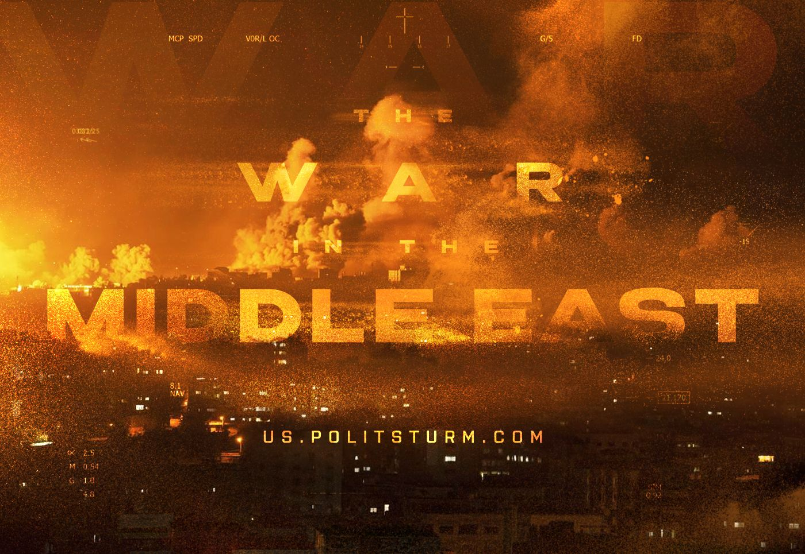

Original article
2023-10-14
19 min read

On Friday, October 7th, Israel was subjected to massive rocket fire from the Gaza Strip. The Islamist movement Hamas, which controls Gaza, had announced the “Al-Aqsa Flood” military operation. Soon, armed attacks were carried out on military checkpoints and the Israeli border area.
A number of Israeli cities and settlements were captured. Hundreds of civilians were killed, dozens of Israelis were kidnapped as hostages. Having regained control of the border area and repulsed Hamas attacks, the Israeli armed forces announced a complete blockade of Gaza, preparing a ground operation against the Palestinians, and began carpet bombing residential areas. The consequence was the death of thousands of civilians and a humanitarian disaster in the Gaza Strip.
Western powers immediately supported Israel, turning a blind eye to the war crimes of the IDF. A number of Arab countries, as well as Iran, Turkey and the Russian Federation, condemned Israel and re-emphasised the idea of an independent Palestinian state.

I. General situation in the Middle East‌
The basis for the armed conflict is the unresolved dispute between Jews and Arabs over control of Palestine.
The emergence of Israel. Having ousted Turkey from the Middle East following the First World War, the UK established its control over Palestine under the mandate of the League of Nations. Formally, by decision of the League, Great Britain pursued a policy of settling the territory of Palestine with the Jewish population. The lands were bought by Zionist Jews, guided by the idea of returning Jews to their historical homeland and establishing a Jewish state.
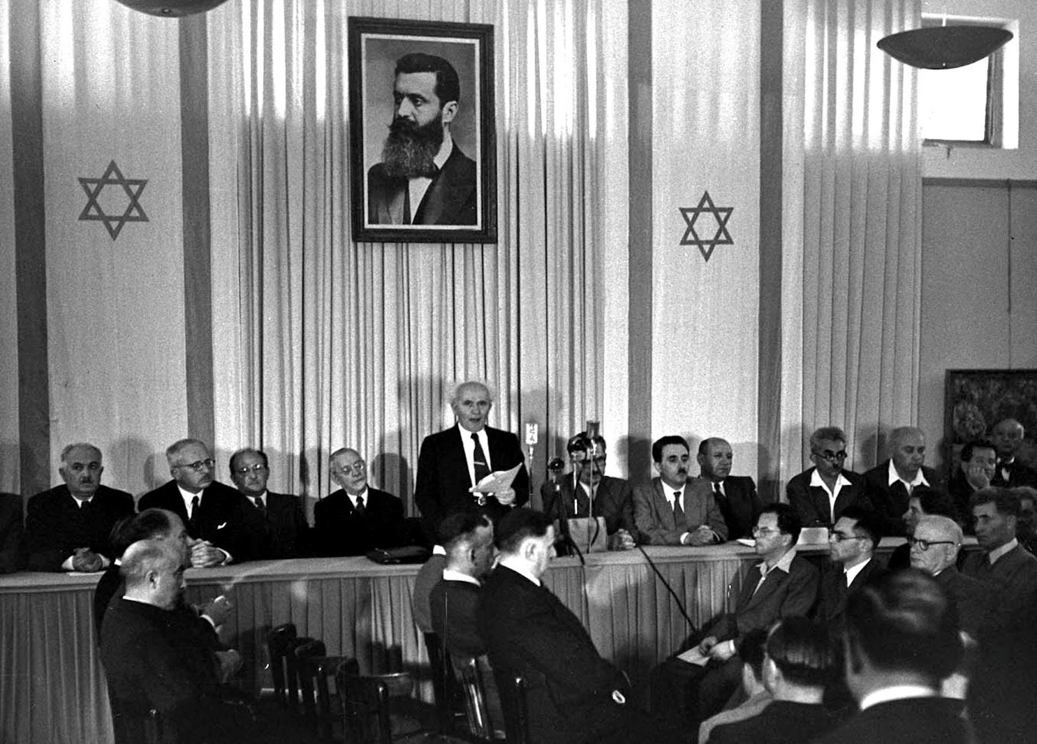
David Ben Gurion proclaims Israeli independence
At first, the Arab population of Palestine was not hostile to the Jews. But over time, due to the economic rivalry between Jewish and Arab households, an ethnic conflict began to flare up. Large landowners in the region redirected the class hatred of the ruined Arab peasants towards the Jews and contributed to the spread of racism against them, presenting the Jewish settlers as the main culprits of the poverty of the Arabs. The conflict escalated but the British authorities did nothing.
After World War II, the UN proposed the creation of two separate states in Palestine: Arab and Jewish. However, this plan was not popular among the Arabs, since it would have placed a significant portion of the land under the control of the Jewish state. On May 14, 1948, following the end of the British Mandate for Palestine, the Jewish National Council proclaimed the creation of the State of Israel. Neighboring Arab countries and the Arab population of Palestine itself responded with armed struggle — a series of Arab-Israeli wars had began.
During the 1947-1949 war, the Six Day War of 1967, the Yom Kippur War of 1973 and subsequent armed conflicts, Israel increasingly conquered the territory of Palestine, and hatred between Jews and Arabs increased.
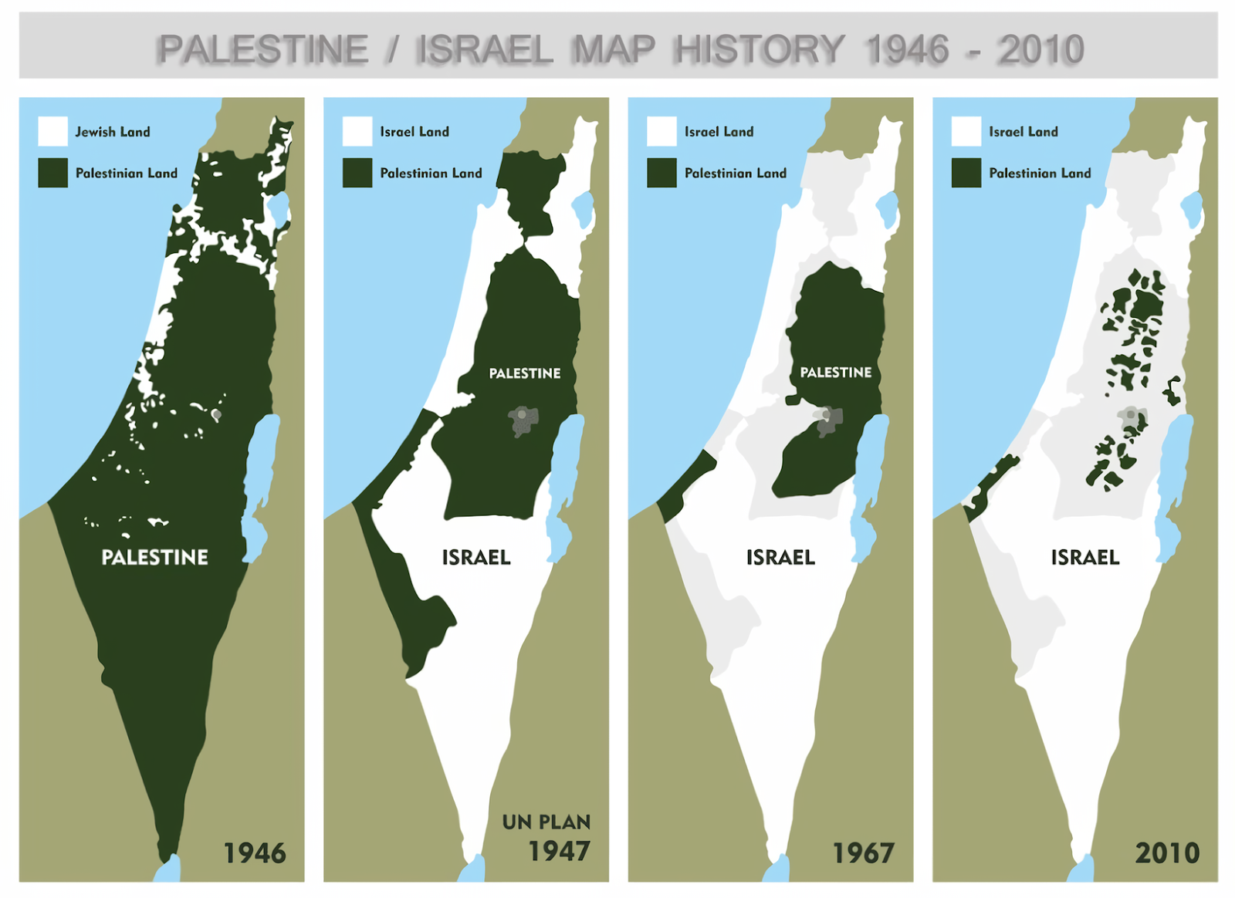
What is Palestine? In fact, there is no single state in Palestine.
The part of the West Bank not under Israeli occupation is controlled by the autonomous Palestinian National Authority, formed in 1994 as a result of agreements between Israel and the Palestine Liberation Organization and controlled by the Fatah movement (Palestine National Liberation Movement).
Fatah has dismantled its militant groups, gained partial recognition, and is now heavily economically dependent on Israel. The lands in the southwest make up the Gaza Strip, controlled by the radical Islamist movement Hamas, which seized power in Gaza in 2007.
Israel gained control of Gaza as a result of the Six-Day War, knocking out Egyptian forces from this territory, and began a policy of populating this territory with Jewish settlers. In 2005, during the implementation of the Unilateral Disengagement Plan, Israel withdrew its troops from the strip and liquidated Jewish settlements, Gaza was formally transferred to the control of the PNA.
In 2007, as a result of an armed coup, control over the Gaza Strip was established by the right-wing islamists of Hamas, which declared its goal to be the elimination of the Israeli state and the creation of a theocratic Islamic state on its territory.
Israel declared Hamas a “hostile state entity” and began a partial economic blockade, periodically cutting off electricity, stopping the supply of water, food and energy. All this time, the Gaza Strip was in a constant humanitarian disaster, experiencing high unemployment and poverty.
In 2013, the PNA declared itself the “State of Palestine”, but this decision was not universally accepted, and the UN granted Palestine observer-state status. Regardless of recognition, Palestine exists as a state mostly as a formality: it does not control the vast majority of its territory (even within the West Bank and Gaza Strip).
Since the withdrawal of the Israel Defense Forces from the Gaza Strip, Hamas has regularly carried out terrorist attacks in Israel. Both sides regularly shelled each other's territories.
Since 2007, Israel has carried out several military operations against the forces of Palestinian groups. The largest operations were “Summer Rains” (2006), “Autumn Clouds” (2006), “Hot Winter” (2008), “Cast Lead” (2008-2009), “Pillar of Clouds” (2012), “Line of Defense” (2014), "Wall Guardian" (2021) and Operation "Shield and Arrow" (2023). These military operations killed tens of thousands of people, mostly Palestinians.

II. Escalation in October 2023‌
Hamas leadership cited the desecration of the Al-Aqsa Mosque in Jerusalem by the Israeli authorities, as well as Israel's refusal to exchange prisoners, as the formal reason for the outbreak of hostilities. In real fact, the current clash is a continuation of the same struggle of the Arabs for control over the region and at the same time, another manifestation of the rivalry between groups of imperialist capital.
Hamas actions. The Islamists resorted to tactics of violence and brutal terror against the civilian population of the territories over which they had established control in the first 24 hours of their operation. Masses of evidence of extremely cruel and indiscriminate reprisals against civilians have circulated in the media.
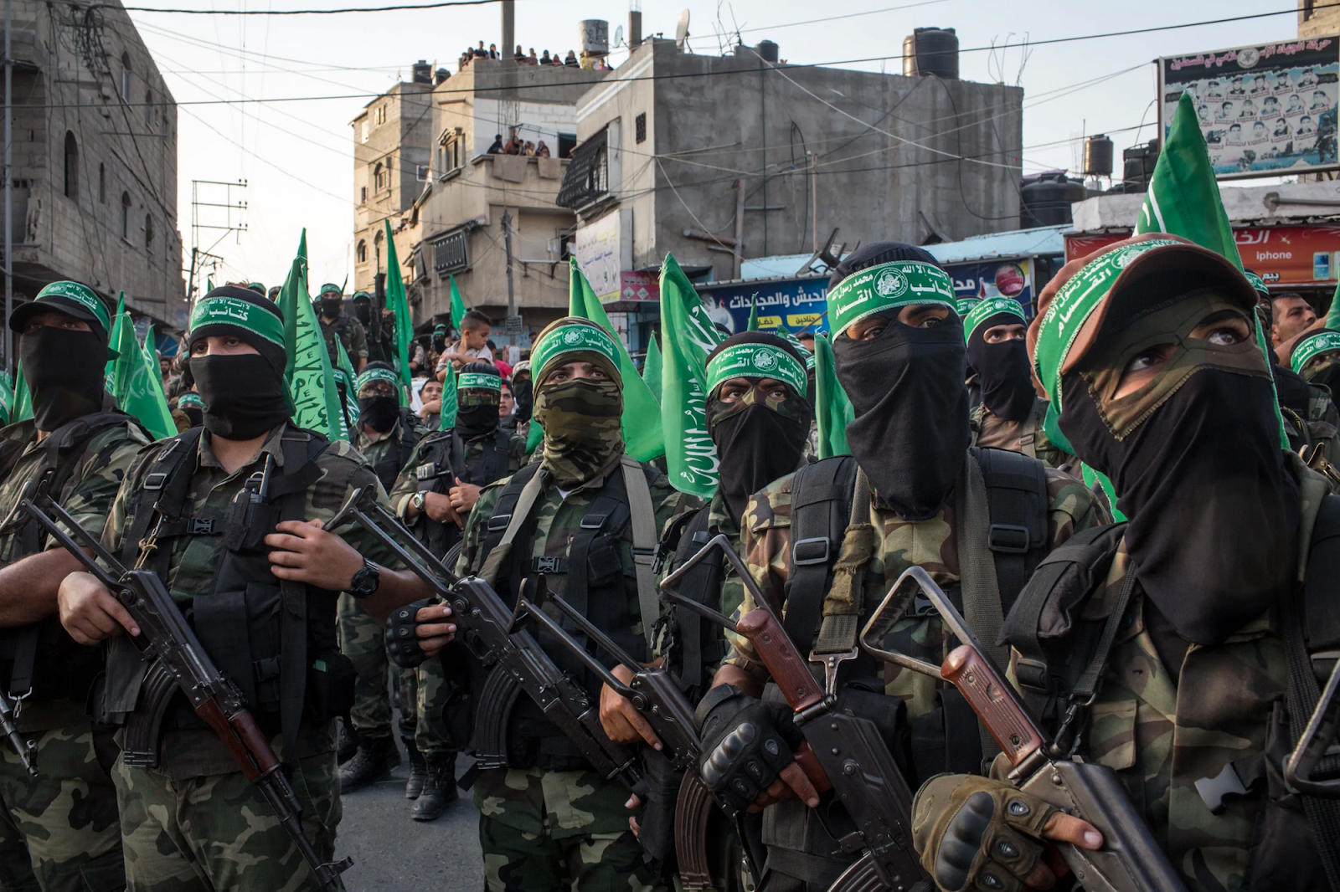
Hamas – “the Islamic Resistance Movement“
In addition, dozens of Jews were taken to Gaza as hostages. Hamas said it was going to use them to exchange them for Palestinians in Israeli captivity. The plan to use captured Israelis as human shields against Israeli bombing of Gaza is also obvious.
Israeli actions. Having regained control over the lost territory, Israel began a complete blockade of the Gaza Strip, cutting off the supply of water and electricity there. At the same time, the Israeli armed forces began carpet bombing the Gaza Strip, completely ignoring the factor of the presence of civilians. Thousands of rockets were fired into Gaza during the first night of bombing alone.
Neither the threat to the lives of millions of civilians nor the threat of the death of hostages stopped Israel from the mass-shelling of Gaza.
The hypocrisy of the official Israeli authorities is indicative: While subjecting the Gaza Strip to horrific bombings, putting hundreds of thousands of innocent lives in mortal peril, Israel constantly brings up the topic of the Holocaust, and tries to impose collective responsibility on the Palestinians for the actions of Hamas.
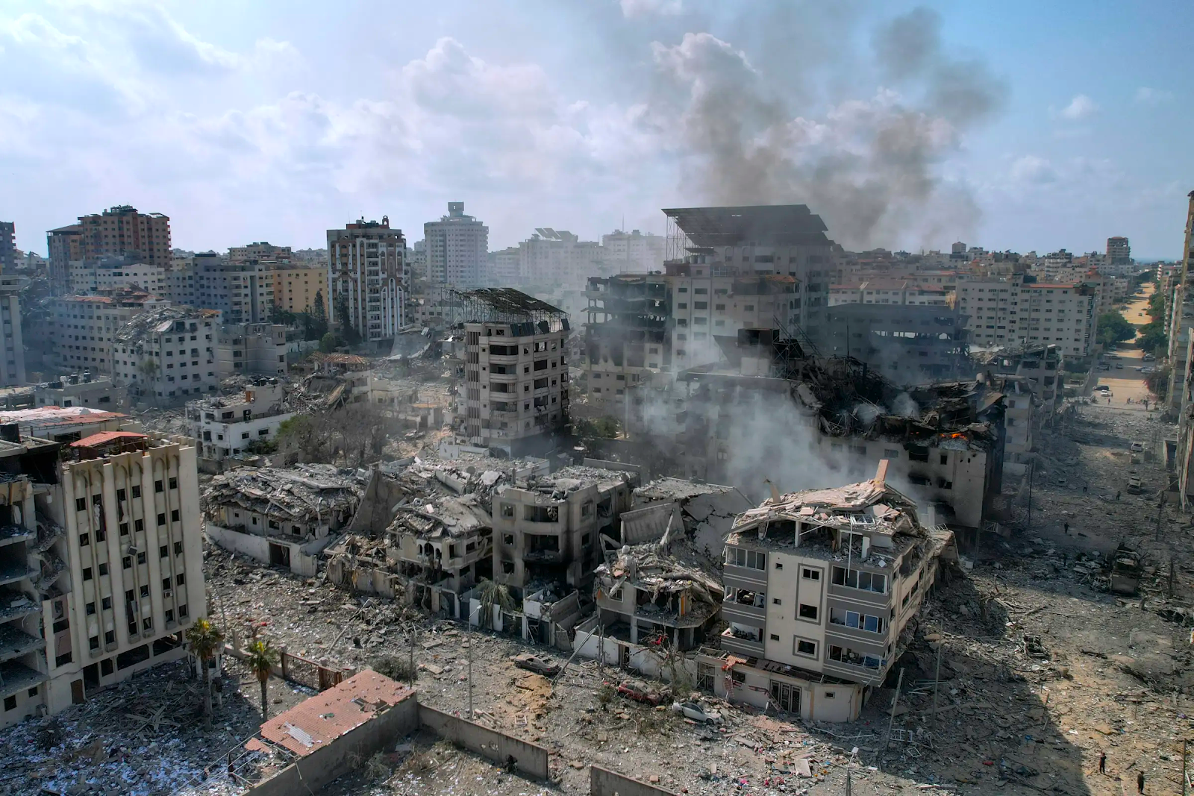
Gaza Strip after the bombing
No less significant is the fact that Israel’s allies among the Western imperialists turn a blind eye to obvious war crimes: the European Commission declares that it cannot condemn the blockade of the Gaza Strip, and limits itself to calling Tel Aviv to “respect international law”. It was only after the visit of US Secretary of State Blinken that Israel called on the Gaza population to evacuate the northern part of the strip before their planned invasion.
Who benefits from the war in the Middle East? In the battles between Israel and Hamas, not only the interests of Israeli capital and Islamists collided. Behind each side are major powers with their own interests in the region.
Israel is backed by large American and European capital; it is a bulwark of NATO and the conduit of Western capital interests in this region. During the G20 summit in India last month, Biden announced a project to create a new trade route from India through the Middle East to Europe. It was announced that a sea corridor would be created from India to the UAE, and a railway corridor from the UAE to Saudi Arabia, Jordan and Israel for the further movement of goods by sea to Greece. This route would link India and Europe for freight and energy supplies, bypassing China and its New Silk Road.
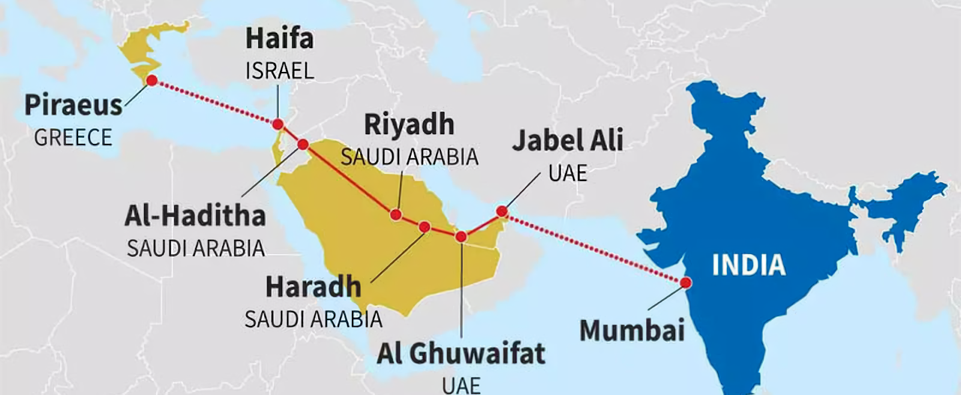
Alternative new trade route‌
An alternative to the Chinese Belt and Road project is beneficial not only to Europe and the United States, which, in the face of growing rivalry with China, are striving to weaken their own economic dependence on China and its influence in the world, but also to India itself, which is increasingly acting as a competitor to China in the world market. If this project is implemented, India's economic and political role will increase significantly both at the international and local levels.
However, the blazing conflict in the Middle East and the shadow of a major war are creating new conditions. The expansion of hostilities and the entry of other Islamist organizations and states into them on the side of Hamas in the long term could significantly destabilize the situation in the region for decades. All this jeopardizes the implementation of the India-Europe transport route project.
China. The first consequences of the escalation of the conflict had a negative impact on Chinese initiatives in the region. Shares of Chinese Belt and Road Initiative projects in Israel have fallen sharply this week. Both Israel and the Palestinian Authority signed BRI trade and cooperation agreements in recent years. New Silk Road infrastructure contractors, from steel producers to railroad builders, are suffering market losses as their projects take a pause.
However, this does not mean that what is happening is not at all beneficial for China. The reaction of the PRC was limited to an ordinary call for the preservation of calm and restraint on both sides. Unlike Western countries, China has not condemned Hamas for its crimes. The Chinese media focused their coverage of the events on footage of the bombing of Gaza by Israel and the growth of the US military presence in the region.
In addition to China, Turkey and Iran traditionally have their own interests in the region.
Iran. The weakening of Israel's position as a key US ally in the Middle East significantly strengthens Iran's position, making it easier to carry out its own policy in the region.
Iranian officials were quick to express support for Hamas' actions. Advisor to Iranian leader Ayatollah Ali Khamenei congratulated the “Palestinian fighters”: “We will stand together with the Palestinian fighters until the liberation of Palestine and Jerusalem”. Iranian Foreign Ministry spokesman Nasser Kanaani said: “This operation used the element of surprise and other combined methods, which show the confidence of the Palestinian people in the face of the occupiers”, and Iranian TV showed members of parliament chanting the slogans “Death to Israel” and “Palestine will win, Israel will destroyed".
Despite sectarian divisions, Iran has increasingly supported Hamas in recent years. Iran not only reportedly supplied weapons to the Islamists through Yemen, Sudan and Egypt, but also actively helped establish its own production base in the Gaza Strip.
In April of this year, Hamas representatives met in Beirut with Hezbollah leadership to coordinate actions against Israel. On October 3, 4 days before the escalation, the Iranian leader said: “all countries that are trying to normalize relations with Israel are betting on a losing horse”.
Turkey. Despite its formal affiliation with the bloc of Western powers through NATO membership, Turkey has its own interests in the Middle East. Erdogan has long laid claim to the role of spiritual and political leader of Muslim countries, through ties with which Turkey pursues its interests. The weakening of the powerful anti-Arab and anti-Muslim stronghold in the form of Israel plays into the hands of Turkey.
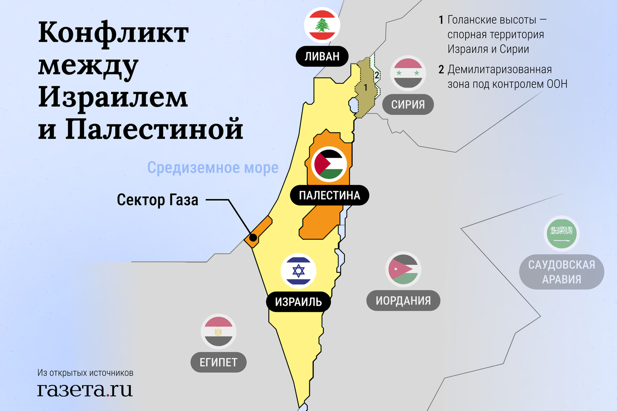

III. The erroneous position of some communist parties
Behind the unfolding conflict, the inter-imperialist contradictions of the various capital groups in the region are clearly visible. After the outbreak of the conflict, many communist parties rushed to make statements directed against Israel and formally in support of Palestine, but almost completely hushing up the responsibility and actions of the Hamas Islamists in the current escalation.
For example, the Communist Party of Turkey published a post on X (Twitter) in which it called the actions of the “Palestinian people” legal until Israel renounces its occupation of Palestine. The TKP advocated the creation of a Palestinian state and support for the Palestinian people.
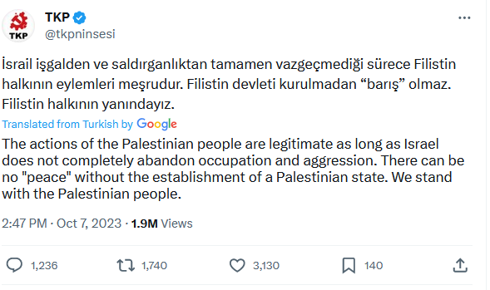
Statement by the Communist Party of Turkey
An essentially similar position was published by the Communist Party of Greece. In it, the KKE condemns the occupation of Palestine by Israel, war crimes against Palestinians and proclaims the right of the Palestinian people to defend themselves and their rights. The KKE called for popular support and solidarity and came up with the slogan of restoring Palestine to the 1967 borders with its capital in East Jerusalem.
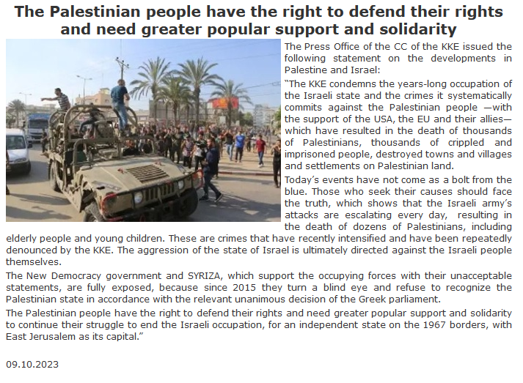
KKE statement on the party's official website
Both KKE and TKP made the same mistake. Abstract phrases “for Palestine and the Palestinian people” do not provide a class analysis of the ongoing conflict and the fighting parties. This analysis is all the more necessary because it is precisely the “Palestinian people” that are not represented in the current conflict. The escalation was started by the reactionary organization Hamas, covertly founded for the purposes of provocation by the Israeli state. This group was ready to strike civilians and has been hiding behind the residents of Gaza for many years.
This position seems rather hasty and does not take into account the actual situation in the conflict: the lack of control of the Palestinian government over the Gaza Strip, the dominance of Islamists in this territory, the killings and abductions of civilians by Hamas militants.
Statements of support for the Palestinian people without a clear and unequivocal condemnation of Hamas actually mean support not for the Palestinian people, but for this reactionary organization.
The Islamists who started these hostilities are not and cannot be representatives of the Palestinian people and their interests. The goal of the Islamists comes down not to the liberation of the Palestinians, but to the creation of an Islamic state on the territory of Palestine, i.e. the same stronghold of reaction as bourgeois Israel. Hamas is backed by a whole group of imperialist states, like Iran. Hamas' tactics amount to terror, massacres and kidnapping of civilians, which Israel happily accepts as an excuse for its own butchery.
All these facts were ignored by communist organizations, which portray communists as supporters of the Islamists. In essence, “support for Palestine” comes down to supporting a religious Islamist sect, which is backed by large imperialist forces, and the communists are asked to turn a blind eye to these inconvenient facts, just as the bourgeois propaganda of Western countries seeks to turn a blind eye to the crimes of the IDF.
Such a position is an example of false anti-imperialism, especially since, as discussed above, the conflict in this region is beneficial for certain groups of the international bourgeoisie. In addition, this position is very similar to supporting a similar Islamist movement in Afghanistan under the slogan of fighting against “American hegemony”.
“...it is not every struggle against imperialism that we should support. We will not support a struggle of the reactionary classes against imperialism; we will not support an uprising of the reactionary classes against imperialism and capitalism.” – Vladimir Lenin, “A Caricature of Marxism and Imperialist Economism”
The positions presented do not clearly distinguish between the working people of Palestine and the political force that has usurped the right to represent and act on their behalf. This position, which amounts to a false identification of Palestinians and Islamists, is erroneous, plays into the hands of reactionary and imperialist forces in the region, and discredits the international communist movement.

IV. What should be the position of communists?‌
1. Reactionary forces are involved on both sides in the conflict, pitting the working citizens of Israel and Palestine against each other, pursuing the goal of establishing their own domination in the region.
Behind each of the rival parties are imperialist powers with interests in this region. Israel is supported by American and European capital; it is a pillar of NATO in the region. Hamas and Palestine are supported by Iranian, Turkish and Chinese capital, which seeks to strengthen their own positions by weakening Israel's. The Russian Federation is also interested in weakening the positions of Israel and Western capital.
2. Neither side can be supported by workers and communists. The working people of Palestine and Israel were not the initiators of the conflict, but they are the ones who are paying for the chauvinist and xenophobic rhetoric of both ruling elites. While supporting the genuine struggle of the Palestinians for a secular Palestine, communists must in every possible way resist attempts to turn this struggle into support for the Islamists. The blind and one-sided position of a number of “Marxist-Leninist” communist parties plays into the hands of the imperialists, simplifies and obscures the situation, and pushes workers towards the false position of supporting certain imperialist forces in the region.
3. The real tasks of the communists and the working class boil down to an open struggle against chauvinism, racism and religious reaction on the part of both Israel and the Palestinian Islamists. Communists must oppose Israel's militarism and hypocrisy, but they must also sharply disassociate themselves from the Islamists and condemn their actions.
4. Communists and class-conscious workers on both sides of the front need to seek contacts with each other, build cooperation, agitate for international worker solidarity, and reveal the truth about the true nature of the warring parties.
5. The main goal of the peoples of Israel and Palestine at the moment is to create and strengthen their own communist parties, which could lead the movement of the workers of these countries in the struggle to overthrow capitalism and build a socialist system.
Specific tactics for resolving the Arab-Israeli issue will be prompted by circumstances and conditions. This tactic will be jointly developed by the communist parties of Israel and Palestine with the support of communists of other countries. The main thing for them is to launch a fight against chauvinistic and religious propaganda, establish contact with each other and create powerful communist organizations.
Ultimately, the conflict between Israel and Hamas is in line with the general crisis of the imperialist system and the growing contradictions between competing blocs. Once “extinct” conflicts are flaring up with renewed vigor, large states are participating in proxy wars, secretly and openly supplying the warring parties with weapons, money and information. One local conflict after another breaks out in the world. As the struggle further intensifies, the number of such conflicts will only grow.
Events in Ukraine, Kosovo, Karabakh, the Middle East and other “hot spots” reflect the crisis of the imperialist system. The confrontation between various blocs and individual countries is intensifying, showing the complete inconsistency of statements about the progressive nature of a “multipolar world.”
As before, on both sides ordinary people have died, are dying and will continue to die: workers and their families. The bourgeoisie strives to strengthen chauvinism and nationalism, prevents the peaceful resolution of national conflicts and pits working people against each other.
Only socialism can change the situation.

Original article

